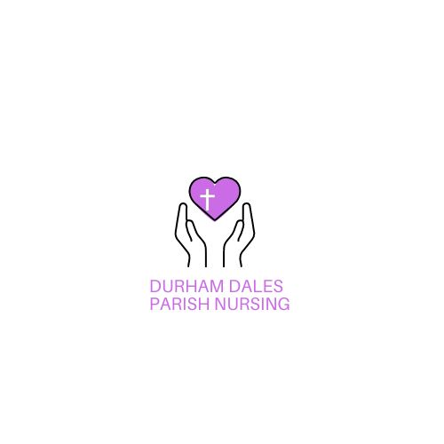
Application Form

Important: This form must be completed in full. You may supply a CV as a supporting document, but it will not be accepted as an application without this completed form. You may attach additional sheets of paper should you need to do so. Each should be headed with your surname and initials, and the section the information refers to.

Please complete this form electronically and return to maddy.fisher@durham.anglican.org

Office Use Only | Job Title  Mental Health Parish Nurse
Surname |  | Initials-
Part A: Current Employment

Present employment (most recent if unemployed)
Employer’s name, address and nature of business: |  | Job Title:
 |  | Full-Time or Part-Time & Salary:
 |  | Date started:
 |  | Date left:
 |  | Notice required:
Please provide a brief description of your duties and your achievements relevant to the post you are applying for. Please give your reason for leaving if you are unemployed.

Part B: Previous employment history

From/To  Month/Year | Name and address of employer and nature of business | Position held, brief description of responsibilities and achievements | Reason for leaving

Part C: Education, training and professional qualifications/membership

Please list all education and qualifications gained from Secondary school, college, university or equivalent | Qualifications | Grade | Dates  (From / To)
Training and Development – list relevant training and development undertaken
Place of study | Qualification | Grade | Dates  (From / To)
Current membership of professional bodies and professional qualifications
Name of professional body/qualification | Class/Grade of membership | Method of study | Dates  (From / To)

Part D: Information in support of your application
Please use this section to explain your reasons for applying for this position and to describe how you meet the person specification. Examples can be taken from your employment, volunteering, community, extra-curricular activities. It is a genuine occupational requirement that the post-holder be a practicing Christian – as part of this section please tell us how your faith influences your working life.

References
All appointments with Durham Dales Parish Nursing include consideration of two satisfactory references. Please provide the names and addresses of two people who know you well and who will be able to comment on your suitability for the post you are applying for. We will not contact your referees until after interview. We may wish to contact additional employers identified on your application form but will only do so with your permission.
Referee Number 1: Current/Most recent employer
Name
Job Title
Phone
Email
Address including postcode

How do you know this person?

Referee Number 2: Employer, tutor, priest or similar
Name
Job Title
Phone
Email
Address including postcode

How do you know this person?

Part E: Equal Opportunity Monitoring
In accordance with our policy on equal opportunities in employment, Durham Dales Parish Nursing will provide equal opportunities to any employee or job applicant and will not discriminate either directly or indirectly because of race, sex, sexual orientation, transgender status, marital or civil partnership status, age, disability, or pregnancy and maternity.

The information requested in boxes 1-10 (inclusive) will be treated in the strictest of confidence and will be used only to provide statistics for equality monitoring purposes. The information will be detached from your application form, stored separately and will not be seen by staff directly involved in the appointment. There is no obligation on you to provide this information. All applicants will be treated the same whether or not they provide this information. Thank you for your assistance.

Please complete all sections that apply:

1. Age

2. Gender assigned at birth
Female | Male | Prefer not to say

3. Which of the following best reflects how you would describe your gender identity?
Female | Male |  | Prefer not to say
In another way:  If you would like to, please say how you describe your gender identity |  | Other:  If you would like to, please describe

4. Does your gender identity align with the gender assigned to you at birth?
Yes | No | Prefer not to say

5. Marital Status
Single | Married |  | Civil Partnership
Separated | Divorced |  | Widowed
Prefer not to say |  | Other: please describe

6. What is your sexual orientation?
Heterosexual/straight | Bi/bisexual |  | Gay/lesbian
Prefer not to say |  | Other term: please describe

7. Disability
Following implementation of the Equality Act 2010, employers are committed to providing people with an opportunity to compete fairly for jobs. The Equality Act provides that ‘a person has a disability for the purpose of this Act if s/he has a physical or mental impairment which has a substantial and long-term adverse effect on his/her ability to carry out normal day to day activities’.
Do you consider that you meet this definition? | Yes | No
If ‘yes’, please provide details.

Please outline any reasonable adjustments you may need if invited to attend an interview.

8. Nationality

9. Ethnic Origin
(Relates to a sense of identity/belonging on the basis of race/culture, not place of birth or citizenship.)
I would describe myself as (choose ONE section from (i) to (v), and then tick the appropriate box to indicate your cultural background):

(i) White:
British | English | Scottish
Welsh | Northern Irish | Irish
Gypsy or Irish Traveller | Prefer not to say | Other White Background:  please specify

(ii) Mixed/Multiple ethnic groups:
White and Black Caribbean | White and Black African |  | White and Asian
Prefer not to say |  | Other Mixed/Multiple ethnic background:  please specify

(iii) Asian, Asian British:
Indian | Pakistani | Bangladeshi
Chinese | Prefer not to say | Other Asian background:  please specify

(iv) Black, African, Caribbean, Black British:
African | Caribbean
Prefer not to say | Other Black, African, Caribbean background:  please specify

(v) Other ethnic group:
Arab | Prefer not to say | Other ethnic group:  please specify

10 Religion or belief
Buddhist | Christian | Hindu
Jewish | Muslim | Sikh
No religion or belief | Prefer not to say | Other:  please specify

Data Protection
Information from this application may be processed for purposes permitted under the General Data Protection Regulation. Individuals have, on written request, the right of access to personal data held about them.

Durham Dales Parish Nursing treats personal data collected during the recruitment process in accordance with its statutory obligations on data protection and its data protection policies. Information about how your data is used and the basis for processing your data is provided in the our Privacy Notice and further information is available by contacting maddy.fisher@durham.anglican.org

Declaration
To the best of my knowledge and belief, I declare that the information supplied by me in each section of this form is complete and correct. I hereby consent to Durham Dales Parish Nursing processing the data supplied in this application form for the purposes of recruitment and selection activities, including monitoring.

Please note: Any false, incomplete or misleading statements may lead to dismissal.

Applicant’s signature: | Print name:
Date:

Please email your completed application form by the closing date to:
Maddy.fisher@durham.anglican.org
Please note: Your application form must be returned in a Microsoft Word or compatible format to enable part E to be detached from the rest of your application. Failure to return this form in a Microsoft Word or compatible format may prevent your application being progressed to the shortlisting stage.

