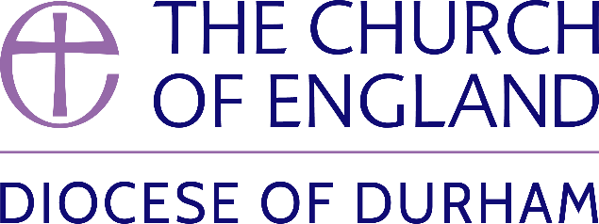 | DIOCESE OF DURHAM  Movement of Clergy: July-August 2024
Name | Current Post | New Post | Effective Date
(1) MOVEMENT TO OR WITHIN THE DIOCESE:
Ross, The Revd Heather | SSM Curate, Upper Weardale Benefice | SSM Associate Priest, Upper Weardale Benefice | 14.07.24
Sweeting, The Revd Susan | SSM Curate, The Group Ministry of The Annunciation, Sunderland | SSM Associate Priest, The Group Ministry of The Annunciation, Sunderland | 30.07.24
Cleugh, The Revd David Robert | PTO, Diocese of Newcastle | 0.5 Priest in Charge, Hebburn St Cuthbert and St Oswald | 25.08.24
(2) MOVEMENT FROM THE DIOCESE:
Grundy, The Revd Simon | Priest in Charge, Consett | Priest in Charge, Bywell and Mickley (Newcastle) | 14.07.24
May, The Revd Timothy Paul | Curate, Monkwearmouth Team Ministry | Incumbent of Hemingford Abbots and Hemingford Grey in plurality (Ely) | 22.07.24
Long, The Revd Katherine Claire | Curate, The Boldons | Team Vicar, Watling Valley Benefice (Oxford) | 20.08.24
(3) RESIGNATIONS:
Croft, The Revd Jennifer Sara | Vicar, Blackwell All Saints and Salutation and Coniscliffe in Plurality |  | 21.06.24
(4) RETIREMENTS:
Jones, The Revd Elaine Edith | Vicar, Peterlee St Cuthbert |  | 31.07.24
Bryan, The Revd Dr David John | Principal, Lindisfarne College of Theology |  | 31.08.24

Published 11 July 2024| Bishop of Durham’s Office

