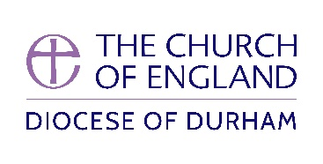

CONTINUING MINISTERIAL DEVELOPMENT FOR CLERGY

Basic Clergy Development Grant
A limited sum of money is available to clergy to help fund attendances at courses, conferences, retreats etc. Clergy may claim up to £175 per year by means of this simple form.

Please complete and return the form on the reverse.

Please return the completed form to
Mrs Pamela Wilson
Mission, Discipleship and Ministry
Cuthbert House
Stonebridge
Durham
DH1 3RY
Tel; 0191 374 6024
Email: pamela.wilson@durham.anglican.org

Name

Address

Tel. No.

Email

Position

Amount applied for: Date:

Signature:

Countersignature:
(where appropriate*)

Approved

Date:

* Curates must have the form countersigned by both their Training Incumbent and the Director of IME 4-7. Diocesan Officers, lay or ordained, must have the form countersigned by their line manager or head of department.
BASIC CLERGY DEVELOPMENT GRANT

Maximum Grant: £175
It is not possible to carry grants forward

Details of proposed conference, course, retreat, etc., including total cost and dates.

