Welcome - A Message from the Bishop of Durham
Thank you for considering the role of Priest-in-Charge of Christ Church Consett (and Team Rector designate of the Derwent Valley Team Ministry) in the Diocese of Durham. Please do think and pray about whether God is calling you to come and work with us here in the diocese, as we seek the growth of the church in every place, and the parish of Consett, and look to the future with hope.

This is a time of both continuity and change for us in Durham. We continue to be committed to the mission of the church in every parish and place. However, we also know that to proclaim the gospel afresh involves both the renewal of traditional forms of worship and mission and the willingness to explore new approaches. We have an ongoing diocesan Transformation programme, supported by national grants, through which we are working prayerfully to see new life and growth in our parishes, expecting to see God at work through both existing patterns of worship and mission and the creation of new worshipping communities. There are many challenges here, but we are determined – by the grace of God, and through his work among us – to see the development of healthy, sustainable, mission-focussed local churches. We would expect to see such churches growing younger, challenging poverty in their communities, and engaging creatively and hopefully with environmental issues.
The Church of England is committed nationally to becoming a church of missionary disciples, and this is central to our vision in the Diocese of Durham. We are asking how our churches, schools and chaplaincies can increasingly become places where people can come to faith and grow in a journey of discipleship. We are seeking to appoint and to grow the leaders – lay and ordained – that we need to enable this.
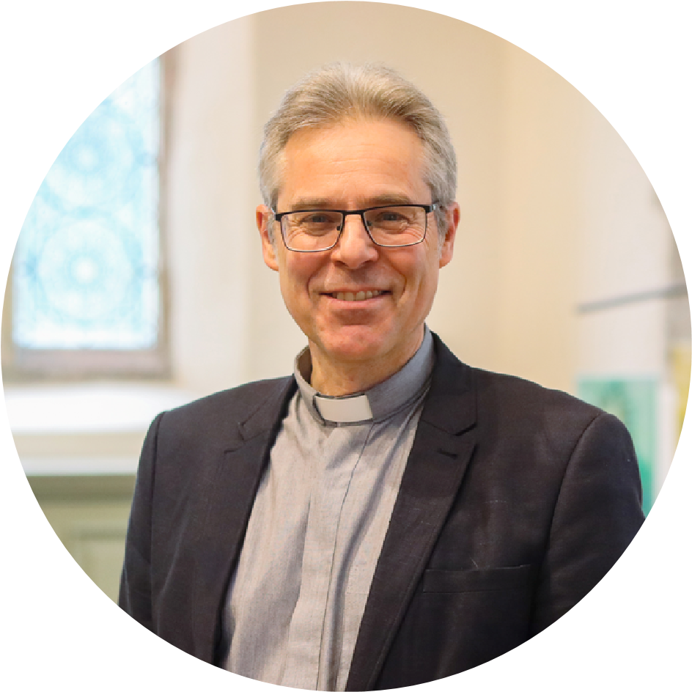
So please pray about whether this might include you by coming to serve in Consett and joining us to work together for the building of God's kingdom through the work of the church in this diocese.

With my very best wishes and my prayers for you in this discernment process,
Rick Simpson,
Bishop of Durham

