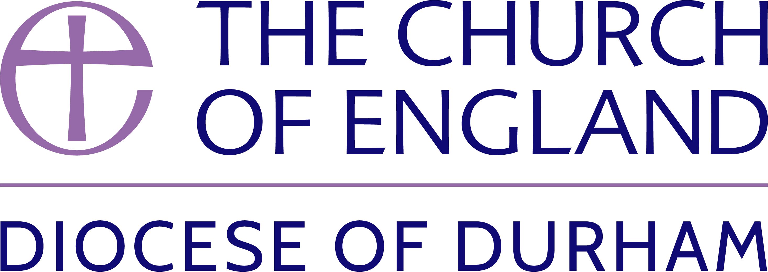

Notice of preparation of new
electoral roll for the parish of:

Notice is hereby given that under the Church Representation Rules a new Church Electoral Roll is being prepared. All persons who wish to have their names entered on the new Roll, whether their names are entered on the present Roll or not, are requested to apply for enrolment not later than:

The new Roll will come into operation on:

NOTE: The new roll must be completed not less than 15 days or more than 28 days before the Annual Parochial Church Meeting.

The new Roll shall be published for not less than 14 days. Forms of application for enrolment can be obtained from the undersigned. In order to be entitled to attend the annual parochial church meeting and to take part in its proceedings, forms of application for enrolment must be returned by the earlier of the dates given above.

Under the Church Representation Rules any lay persons are entitled to have their names entered on the Roll, if they:  (i) are baptised and aged 16 or over;  (ii) have signed a form of application for enrolment;  and either  (iii) are members of the Church of England or of any Church in communion with the Church of England being resident in the parish or (not being resident in the parish) having habitually attended public worship in the parish during | the six months prior to the application for enrolment;  or;  (iv) are members in good standing of a Church (not in communion with the Church of England) which subscribes to the doctrine of the Holy Trinity declaring themselves to be also members of the Church of England and having habitually attended public worship in the parish during the period of six months prior to enrolment.  Any error discovered in the Roll should at once be reported to the undersigned.

Dated this _________________ day of ______________________ 20_____.

Church Electoral Roll Officer

Address

Note: In this Notice ‘parish’ means an ecclesiastical parish.

2022

