General Synod Election Address 2026 – Kate Mayes

Dear Synod member
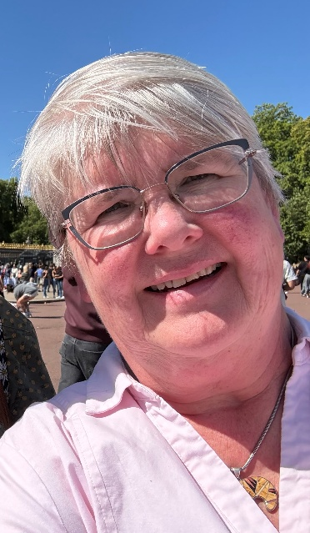
Following a period of prayer and reflection I feel called to stand for election to be your representative on General Synod and I am seeking your vote.
I was christened, confirmed and married in St John the Evangelist Church, Gateshead Fell and am currently Churchwarden, Parish Safeguarding Officer and organist there and lead Services of the Word with my fellow Churchwarden.
I have also worshipped at Holy Trinity, Platt and Holy Innocents, Fallowfield in the North West, St Nicholas Sutton and St Andrew’s Hove in the South East, where I was a member of the PCC as well as some time at St Alban’s Tokyo, so I have experienced much of what the Church of England and the wider Anglican Communion has to offer its worshipping community.
I would strive as your representative to promote the following:
An outward-looking church in which Jesus Christ is central and is focussed on the five marks of mission in proclaiming the good news of the kingdom.
A church that is genuinely warm, loving and kind which publicly celebrates, affirms and welcomes all people without discrimination, where the overlooked, excluded and unseen are embraced.
A safer church where the vulnerable are protected from harm and exploitation and which responds to survivors and victims of abuse.
A church which recognises the importance of a priest for every parish, where the occasional offices of the church provide a bridge between the parish church and the people of the parish. A continuous local Christian presence and direct pastoral care for every resident regardless of whether they attend church.
A church which actively encourages the involvement of laity in worship and promotes lay leadership alongside appropriate and proportional training.
A church with a heart for the poor and excluded, where social justice is central to the way we operate and act.
A church with a generosity of spirit that values the contributions of our different traditions and encourages all who want to participate as disciples of the Gospel.
In addition, I would seek to represent the needs and aspirations of the church and the people of Durham and the North East to the wider church and effectively communicate to the people in our churches regular, accessible, and relevant presentations and updates on what happens and decisions made by General Synod.
Who is Kate?
I have always gone to church. My father was a Methodist and my mother worshipped at St John’s where she served as PCC Secretary and Churchwarden. My brother and I were brought up in a home where Christian values and the love of Jesus were at its heart.
I was educated at an all-girls school in Newcastle where girls were encouraged to be anything they wanted and instilled with a belief that any role can be undertaken by a girl. I studied Geography at Manchester University and worked for the Civil Service in London for 10 years before returning to Gateshead to take over the family business when my father died. I am a fourth-generation funeral director running the business my great grandfather established in 1884. I have been married to John, a chartered engineer and SSM Associate Priest for 38 years and we have a 21-year-old daughter, Hannah.
I came to St John’s Gateshead Fell as a child and have worshipped there for much of my adult life. We are a welcoming, inclusive church, part of a two-church benefice and are about to go into vacancy but blessed to have an SSM priest and a retired priest with PTO as well as enthusiastic and Spirit-filled lay people. We have embraced the four Diocesan priorities particularly in challenging poverty. Our parish ranks in the bottom 1500 in terms of overall deprivation and is outward looking with a real heart for the local community. We minister to schools and care homes in our parish through services and regular contact by clergy and laity.
Why vote for me?
The Church of England faces challenging times as we seek to share the Gospel in a post-Christian culture and society.
If elected, I will bring to this post a real passion for the growth and flourishing of the Church of England, promoting a church which is openly accepting of all people, values all gifts and encourages and supports everyone as they grow into the disciples Christ calls them to be.
If, following prayerful consideration, you decide to trust me with your vote, I will work tirelessly on behalf of the Diocese of Durham to represent the needs of the whole church in this diocese to the wider church.

Kate Mayes
St John the Evangelist, Gateshead Fell

