
BENEFICE PROFILE
2025
The Benefice of
Hunwick & Willington
Contents

INTRODUCTION 3
THE PARISH OF HUNWICK 5
OUR MISSION 6
OUR VISION 6
OUR NEW PRIEST 6
THE PARISH 7
About St Paul’s 10
Location 15
Parish of St Stephen, Willington 16
Welcome 17
Our Town 17
Our Parish 18
Financial Information 20
Project 21 21
Our Values 21
Worship 22
Mission and community 23
Buildings 26
THE PAROCHIAL CHURCH COUNCIL 27
Who Are We Looking For? 27
What Next ? 29

The Benefice of Hunwick and Willington

INTRODUCTION

Thank you for downloading our benefice profile. We do hope you find it of interest to you and that you would like to find out more about us!

In 2015, the parish of Hunwick joined with the parish of Willington and Sunnybrow. The churches are just over 3 miles apart but serve different communities. Hunwick is a small rural village and Willington is larger and more of a commercial centre. Both locations have their roots in the coal mining industry which closed down in the 1960s and 1970s.

St Paul's Church in Hunwick has a tradition of Anglo-Catholic worship in a disciplined but modern style whilst St Stephen's is less traditional and more relaxed in its worship style. St Paul’s and St Stephen’s complement each other with festival services, particularly at Christmas and there is scope for developing this.

We are praying for a priest who will embrace our Anglo-Catholic tradition and also lead us forward in our vision to grow in faith and outreach. We pray too that our new priest will be an enabler and encourager who will nurture us to fulfil our potential as witnesses of Christ.

We already have a very good relationship with the primary schools in the parish and wish to grow this work and to reach out to children, young people and their families in the benefice. Most years the benefice has one or more ordinands on placement from either Cranmer Hall in Durham or Lindisfarne College of Theology who make a useful contribution to life in the benefice.

If you are a prayerful person willing to help us respond to the needs of our communities and have a sense of humour, then read on……….
BENEFICE BOUNDARY MAP

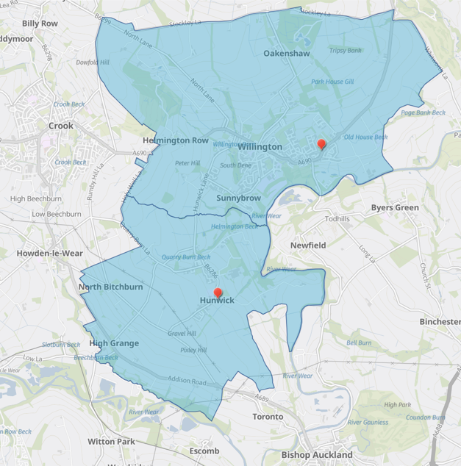

THE PARISH OF HUNWICK

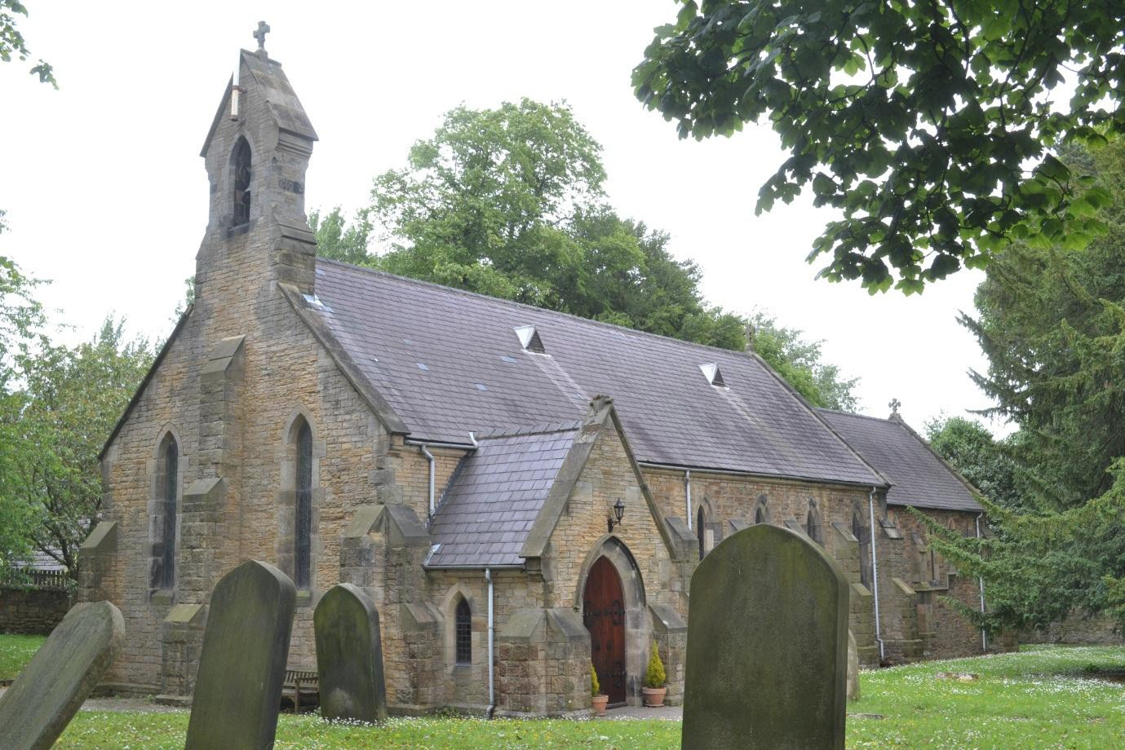

ST PAUL THE APOSTLE

HUNWICK

In the United Benefice of Hunwick and Willington

DIOCESE OF DURHAM

OUR MISSION
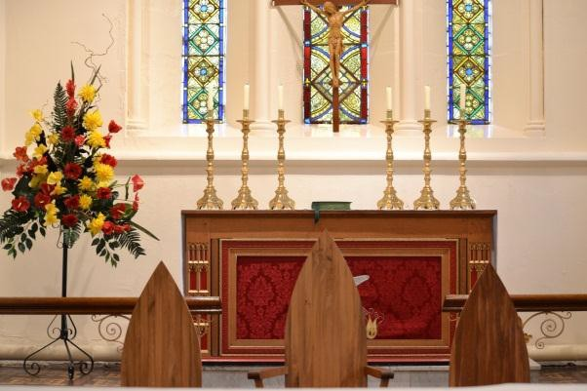
To promote the Kingdom of God and the service of our neighbours and community as a true reflection of the love of Christ for all.

OUR VISION
We seek to continue to grow together in faith so that our church is a fundamental and active part of our community.

OUR NEW PRIEST
Our new Priest will:
- Encourage, guide and lead the Parish in prayerful Going for Growth
- Respond to the future challenges we face and outreaching to the wider community not just bringing them to church but also taking the church to them
- Enhance and develop existing and new links with families, young people and children and local schools
- Be comfortable being the priest of both Hunwick and Willington with their different styles of worship
- Be fun loving with a sense of humour



THE PARISH
The parish is small, with a committed working group of people dedicated to the furtherance of God’s Kingdom in the area. It is an area which is well served by all the major amenities including very good schools, doctors and hospitals, theatres, and recreational facilities. Hunwick sits just on the edge of Weardale an Area of Outstanding Natural Beauty and is an attractive, rural, residential community. There are some sources of employment within the parish, and whilst many people commute to other towns it retains a strong sense of community particularly with the school, pubs, tea house – and church.
There are so many opportunities for our new priest to work with our community and the many young families who have moved into the new housing estates across the parish.

MEMBERSHIP and ABOUT THE PARISH

The number on our electoral roll currently stands at 28 with 50% of our congregation living in the parish. During the past year our visiting priests have presided at 4 funerals, 3 baptisms and 1 wedding.
The parish itself covers three villages and hamlets which are: Hunwick, North Bitchburn and High Grange.

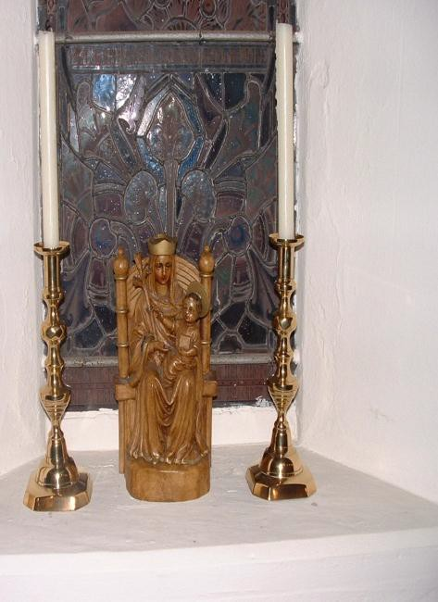
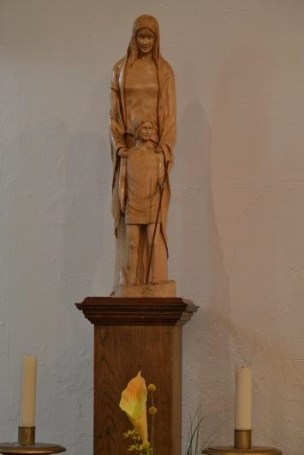
HUNWICK
Situated between Bishop Auckland and Crook, Hunwick is a semi-rural village in County Durham. There are actually two villages that are often referred to collectively as Hunwick, Hunwick and New Hunwick although it is generally accepted that the two villages are now as one.
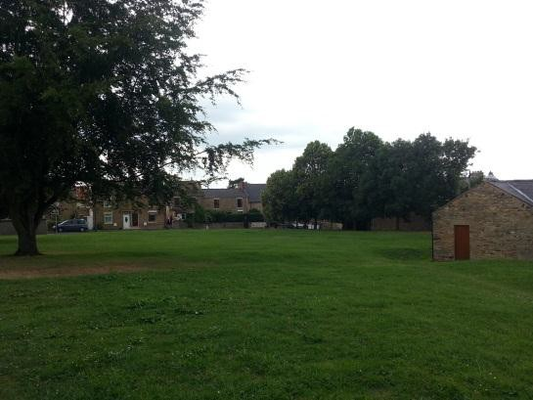
Hunwick is an active community comprising older housing and new build estates which have attracted many new families into the village. There is one public house, the Joiners Arms, together with a Working Men’s Club and the Quarry Tea House, which is a tearoom, all of which feature in village life.

The primary school is an important element of the village and there is a vibrant community association based within the school grounds.

There is a running group for people of all abilities led by volunteers. Alongside this is a popular and successful Cricket Club. A craft group meets weekly on Fridays in The Joiner’s Arms. There is also a singing group, Voices in Bloom, which began as a group of women meeting for social and wellbeing companionship after Covid and this has developed into an important and regular part of the community. They meet in the church once a week.
The Church of St Paul the Apostle and the Community Association often hold events and family days to raise funds for charity as do local residents.

HISTORY

Hunwick has a long history dating from Saxon times when it belonged to the Cathedral Church of Durham. It was later given to the Earls of Northumberland, but it returned to the ownership of the church when Henry VIII re-endowed Durham Cathedral.

The village itself was probably destroyed during the Harrying of the North in the later 11th century and was rebuilt with two rows of houses arranged around the village green.
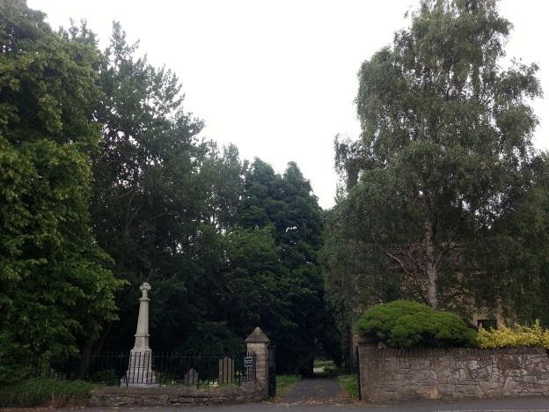
The remains of the medieval manor house of Hunwick is now a farmhouse; its former chapel is now used as a barn, though the medieval east window can still be seen.

Outside the farm gate is the remains of a gin gang, an engine designed to operate farm machinery and worked by horses. Helmington Hall to the north is also a farm, all that remains of a large house dating back to about 1686.

NORTH BITCHBURN
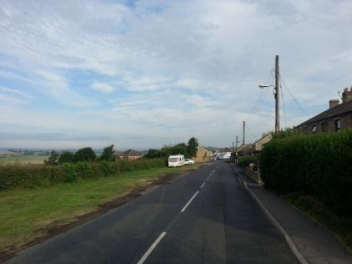

North Bitchburn is a short walk from Hunwick. It is a residential hamlet with stunning views of Weardale. There is one public house, The Red Lion, an ice cream parlour and tea rooms, along with some new housing.

HIGH GRANGE
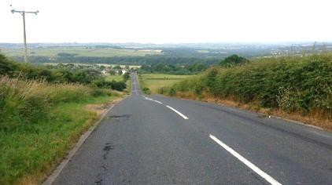

Just along from North Bitchburn is the small hamlet of High Grange, comprising of all terraced residential property and one specialty shop selling fishing tackle and guns.

About St Paul’s
St Paul’s is Anglo-Catholic in tradition but in 2023 the PCC voted, by majority, to accept women priests. It has a core of hardworking committed people and an active PCC which meets each month.
As we are a small rural church there are no other task groups, so the PCC is responsible for all aspects of church life including worship, direction, maintenance and finances. The PCC are a wise, prayerful, Christ-centred group of people with a clear love for God, one another, and our parish. We are keen to work with and support our priest. The PCC comprises 9 individuals including the Churchwarden, Treasurer (not a PCC member), Secretary and Reader (with PTO)
Pastoral Care is provided by all members of the congregation, with the Reader providing home communions.
We have achieved the A Rocha Eco Church Bronze Award and are currently working towards Silver (and hopefully Gold).
An important part of our church life is our charity work, and we respond to the needs of others at home and abroad. We support a wide range of charities such as:

- Local food bank
- Asylum seekers
- Christian Aid
- The Children’s Society


WORSHIP AND HOLY EUCHARIST

Our Parish Mass is held at 9:00am each Sunday. The Mass is undertaken with full vestments and Altar Party, solemn if numbers permit and there are usually around 20 people each week.

A Mass sheet is provided each week with readings and prayers for the week, together with a Communion Book for every member of the congregation.

Our hymns tend to be selected from either Celebration for Everyone or the New English Hymnal.

There is an induction loop and sound system installed and we have a regular organist.

Evening Prayer is held each Saturday at 17:00.

There are no midweek services at present, but we look forward to the re-instatement of these.

Additional services, include the School Carol Service, Parish Christmas Carol Service, also during Lent and in Holy Week we have the full complement leading up to the Easter Tridium. Candlemass, Remembrance and All Souls services are also held

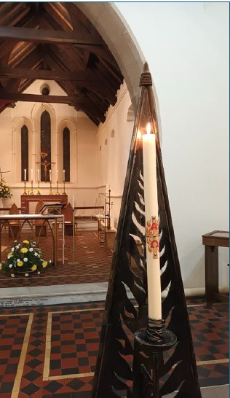
STATISTICS

THE TEAM
Work at St Paul’s is supported by a committed team and includes a regular Churchwarden, a Reader (with PTO). There are also two people licensed to administer the chalice. The congregation is actively involved with the service through:

- Welcoming people
- Readings
- Intercessions

CHRISTIAN EDUCATION
We seek to develop our mission whenever possible, learning from others within and outside our Parish. This includes joint services with St Stephen’s in Willington and also involves other local denominations in our Holy Week service.

FELLOWSHIP AND OUTREACH – INVOLVEMENT IN OUR COMMUNITY
We believe the act of welcoming people to worship is much appreciated and we organise people to undertake this role each week, to give out our service books and make sure everyone feels welcome.
Members of the church are active on our local Community Centre Committees, which are an essential part of the village life and the Church is also involved with local fundraising and groups.
Some of the congregation are school governors (and the Priest is a co-opted member of the governing bodies in our Benefice). The schools welcome the involvement from the church in religious education, assemblies and other events during the school year and some of the congregation assist with reading.
The local school uses the church building for occasional services and teaching purposes. A local singing group, Voices in Bloom have use of the church building for rehearsals.
One way in which the church outreaches to the Parish is through our community events. Some major events which have taken place in the past five years include:

  - A church stall at the annual Hunwick Show
  - Local Exhibitions in the church building
  - Voices in Bloom concerts in the church building
  - Various other musical nights and fundraising events
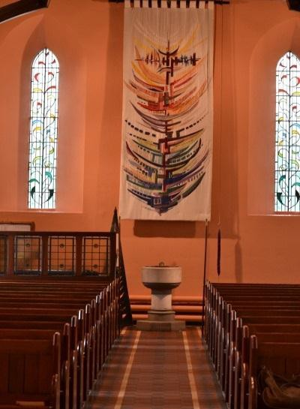
BUILDINGS

Our church is an attractive stone building constructed in 1845, Reordered in 1855 and enlarged to its present size in 1885.

The church now consists of a nave, chancel, sanctuary and a porch at the west end with a bell turret above and another porch on the north side of the chancel used as a vestry. In the sanctuary handsome stained glass was inserted in the east window, the centre panel of which is said to be copied from a window in Salisbury Cathedral. The font is on the south side of the entrance to the church at the west end.

The church is in good order and within the building are various artefacts of beauty and interest. These include our:
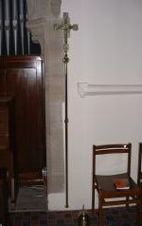
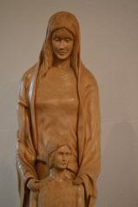
    - Banner - designed and made by members of the congregation

    - Hunwick stained glass window and various other memorial windows

    - Hunwick chalice and ciborium, locally crafted and internationally renowned

FINANCIAL
Donations are given to various local and topical charities, whenever appealed for.
All working expenses are paid, also our contribution to the Parish Share is paid albeit with the usual struggle.

Location

Situated at the beginning of the Wear Valley and North Pennines (AONB) Hunwick can offer many local amenities of walking, cycling, swimming and attractions such as the Weardale Heritage Railway, and the award winning Kynren, a live action show depicting 2000 years of British history and myth.
Hunwick has a direct bus service to Bishop Auckland (which has a railway station connecting to Darlington and then nationwide), Willington with connections to Crook (connecting to Weardale) and Durham (main line station).
It is approximately 30 miles to Newcastle Airport, 20 miles to Durham Tees Valley Airport
There is a hospital at Bishop Auckland with an Urgent Treatment Centre. A&E facilities are at the University Hospital of North Durham and Darlington Memorial Hospital. There are museums in Shildon, Darlington and Durham. The coast is 45 minutes away and it is 90 minutes to the Lake District.

We would be pleased to hear from you, do get in touch…….
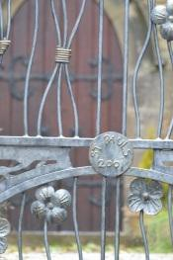

Parish of St Stephen, Willington
Diocese of Durham

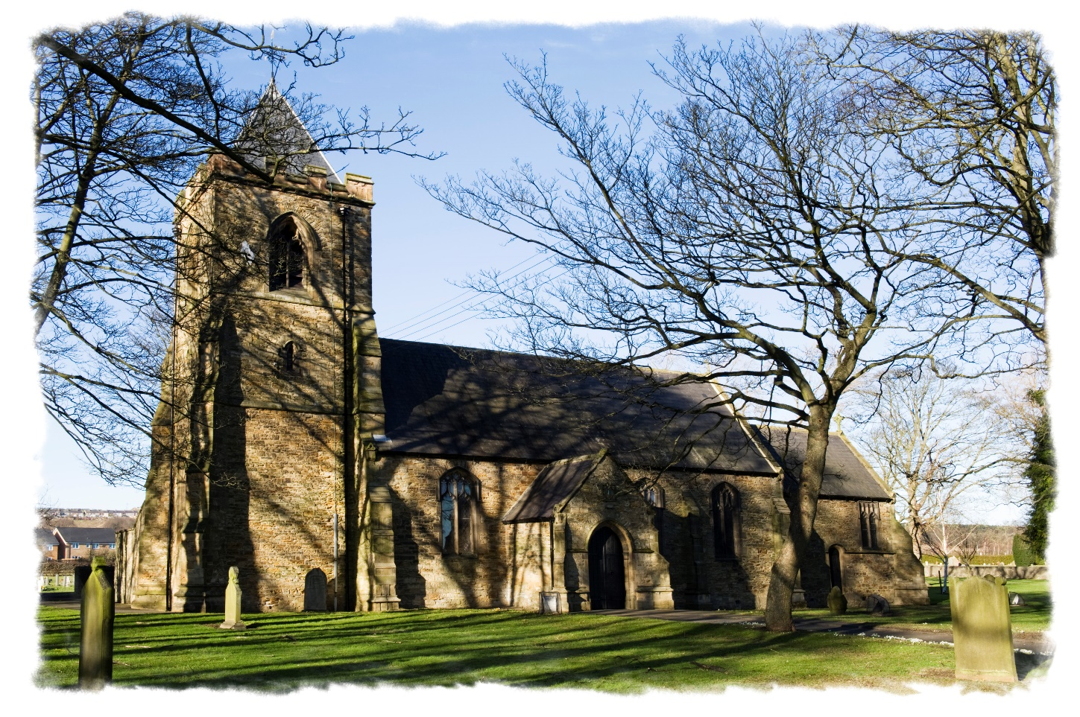

Parish Profile

2025

Welcome

Welcome to our Parish Profile. Hopefully as you read it you will find us an open, welcoming community with an active and vibrant parish life. We find ourselves seeking a new priest to lead us in being more forward looking and helping us to grow in mission, witness and discipleship.

Our church serves a large parish of approximately 9,000 residents who have diverse needs. The congregation welcomes couples for marriage, children and adults for baptism, the bereaved, or those simply drawn to Christ and wanting to grow their faith and worship Him. We are praying for those who may feel called by God to consider becoming our new incumbent.

The map below shows the boundary of the parish around Willington itself.

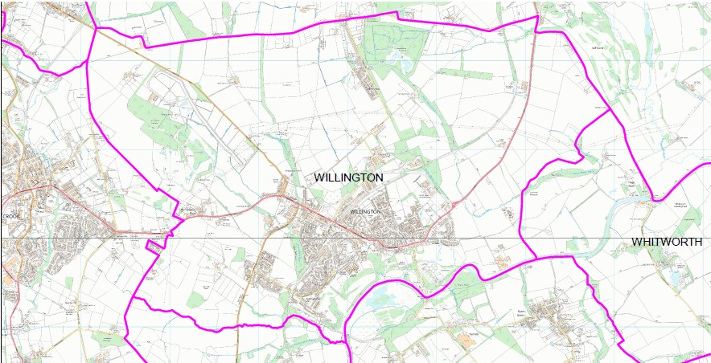

Our Town

Willington is a small ex-mining town in the Diocese of Durham and the Auckland Deanery. The parish church of St. Stephen, Willington is situated on the main A690 spine road, seven miles from Durham City and approximately four miles north of Bishop Auckland. It is set amidst green fields on all sides and to the southern end of the town runs one of the north’s major rivers, the River Wear, which starts in the Pennines and runs into the North Sea at Sunderland. The city of Durham is a World Heritage Site and includes Durham Cathedral and Castle. Durham is also famous for its university, rated third in the country after Oxford and Cambridge. Inland, the A690 terminates at Alston, England's highest market town on the North Pennines.

There are several schools within the parish, these include St Stephen’s Voluntary Controlled Primary School, Willington Primary School, Sunnybrow Primary School and Our Lady and St Thomas Roman Catholic Primary School as well as Parkside Academy which caters for 11–16 year-olds.

There are three council run allotment sites which provide some food to the Food Bank and demonstrate environmental initiatives.

We have a good relationship with the other churches in the town: Our Lady and St Thomas Roman Catholic Church and the Open Door Methodist Church. Before Covid, ecumenical links with both the Methodist and Catholic churches were very positive with certain joint events. However, since Covid these have not been re-established, though some informal conversations have taken place.

In recent years there have been new housing developments bringing many new families into the area, and we see these areas as a key focus for future mission.

Our Parish

We have been told by those who visit us that St Stephen’s is an open, welcoming place. This goes for all people regardless of age, gender, sexuality or race. We seek to tell the Gospel by sharing our story with the community around us. We recognise that the church must breathe; sending out as well as drawing in, and we strive to be outward looking in our attitude and activity.

The church is at the edge of the town and was built in the 1850s with seating for 200. It boasts a Willis organ and cast steel bells, and a stained-glass window which is thought to be unique (see below).

We receive requests from people wishing to play the organ or groups wanting to ring the bells.

The church building requires some work defined in the last quinquennial and is currently in the hands of the architect who has produced a schedule of works and is obtaining quotations. This forms part of what we are calling ‘Project 21 – a Church for the twenty-first Century’ (more on this later).

The accommodation in the parish ranges from social housing to much larger private properties – with a considerable number of private lettings.

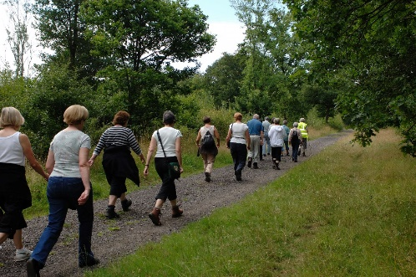
As well as the schools, the town is well provided for with amenities including a medical centre and a dental practice. There is a public library, Cornerstone North – a supported housing and counselling charity which has good links with St Stephen’s, (Cornerstone Supported Housing and Counselling - Northeast – Cornerstone SH) a cricket club, football clubs, a photography club, a Taekwondo club, several walking groups (one from St Stephen’s) and there are cubs and beavers at Helmington Row (an area in the ecclesiastical parish but not in the civil parish), a very short drive from Willington. As the town's economic well-being was primarily linked to the mining industry in the first half of the twentieth century (ceased in 1962), it has taken some time for the community to recover and rebuild. However, all signs of the industry have now been removed and land has been reclaimed into open space and park land. Many of the smaller high street shops have suffered as a result of the economic downturn felt throughout the country and the aftermath of Covid, but there are some positive signs that things may be changing and the regeneration of the high street remains one of the town council's major concerns.

There is a good spread of ages in the population of Willington and Hunwick.
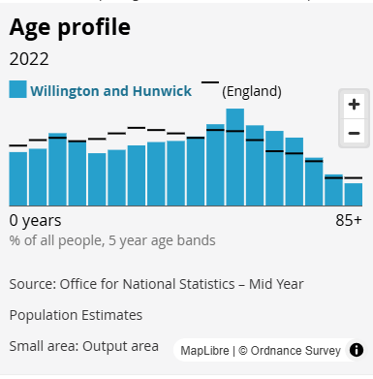
Each of these bring opportunities for the church and are areas that a number of members are keen to explore. Some work is already undertaken with the elderly and housebound in terms of visits and arranging for home communion if requested. There is also a ‘care village’ for the elderly and those with more complex needs and it is open to developing the link with the church further. Willington, in common with the north east of England, is a friendly community.

In the past, acts of worship have taken place from time to time on an ecumenical basis especially around Easter and Christmas, though more work in this area is required. These links we would be keen to strengthen and further develop.

We recognise the need for personal and spiritual growth for the members of our congregation, and seek to discern both individual and group needs, and supply opportunities for learning and the broadening of experience wherever possible. This would be one of the core functions of a Shared Ministry Team, which we hope our new incumbent would consider developing. We would aim to offer groups and courses at different points during the year.

During the time of this interregnum, we have been well served by a retired archdeacon and several retired priests who have officiated at all our services (including occasional offices), and helped wherever they can. We have been extremely grateful for this help in enabling us to continue our ministry.

As a church, we have not stood still and as well as Project 21, our Eco Ambassador group has taken us through to the award of Gold by A-Rocha. Also, through their work we were awarded a gold in the 2025 Northumbria in Bloom competition.

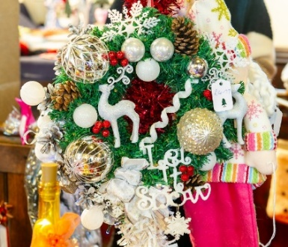
We have also maintained our links with the community in other ways. The annual Craft Fair has continued drawing in local small businesses and members of the community. In addition, this year saw us try a new venture – a Wedding Fair, which was well attended by those offering services for weddings and members of the community. Other ventures in the last few years have included ICHTHUS - a community craft project, a Fish and Chip supper with sea shanty music, an Advent Wreath Festival and an annual Teddy Bears Picnic.

Financial Information

While we are not a wealthy church, we do have funds available. St Stephen’s has for many years always paid the parish share in full and sometimes slightly in excess. The proposed budget for 2026 indicates that income and expenditure will balance. Financial planning is underway to enable the funding of the repair and renovation work needed at St Stephen’s Church.

Figures for 2024 were:

Income £36,936.05
Expenditure (including Parish Share £19,302) £38,110.45
Unrestricted Reserves £41,677.69
Designated Reserves (Building Fund) £11,756.31
Restricted Reserves:
- Parish Hall Fund (For Church Building Improvement Works) £64,305.92
- Curacy Fund (For Religious and Other Charitable Works of the Church of England within the parish) £6,054

The treasurer is very efficient and forward-thinking using technology (MyFundAccounting) to manage and record the resources and; the use of online banking, CollectTin and St Stephen’s website for donations are promoted.

The accounts are audited by an accountant and are available to anyone wishing to view them.

Project 21

Project 21 seeks to raise the profile and develop the potential of St Stephen’s Church.

Following discussion by the PCC a consultant was engaged to undertake a community-wide consultation to ascertain how St Stephen’s can serve the people of Willington in this, the 21st century. This consultation looked at ways in which St Stephen’s can be of service to the community, not only for our regular worship and occasional events, but also to meet the spiritual, social, cultural and educational needs of people of all ages who live in the area. We aim to make it a thriving part of the community!

He produced a very useful report which has had considerable discussion. As a result of these discussions, we identified 6 areas where discussion and work is needed:-
- Worship
- Building
- Mission
- Heritage
- Finance
- A way forward

As well as our involvement with the schools in the parish we already have a number of children and families who engage with the life and worship of St Stephen’s; through Project 21 we wish to develop our range of worship and activities further to meet their needs and broaden the range of activities we can provide. There is good potential for developing work with children and their families.

Through Project 21 we are slowly beginning to see children and young people come to faith and request baptism. The new year will see a small group start their preparation for confirmation.

There is some detail around these, but we would hope a new incumbent would help to take us forward with this exciting project.

Our Values
Faith
We recognise that we are called by God to be His people in this place. We commit to growing in faith together through study, prayer, worship and fellowship. We aim to represent the good news of Christ’s Gospel in our daily lives and provide opportunities to share in a faithful life to all who are called by God to follow Him. We thank God for calling us to Him.

Love
Love must be our central theme. We know that it was God’s love for us that led him to send Christ to us, to be among us, and ultimately to sacrifice Himself for us. We are called to be witnesses to that love in the world. Therefore, all our actions, our decisions, our relationships must be based on love for each other and for God. We, under our previous incumbent, agreed that divorcees should be allowed to re-marry subject to national guidelines. In addition, we support the service of blessing for same sex couples.

Action
There is nothing we can do to earn God’s grace, but we are compelled to react to it. The fruit of our faith must be action. We will bless what is good and seek to bring reconciliation and healing for what is not. We will take His word out into the world and build relationships with the community around us.

Worship

Worship at St. Stephen's has a Eucharistic focus being middle-of-the-road Anglican. Our Sunday morning service attracts a modest congregation of 20-25 and is along the lines of a traditional sung service at which vestments are worn. However, we do have variety as in the last few months we have had a regular small group of children around the age of 9 – 11. Therefore, some services are arranged such that they can take part more fully: hymns may be more modern, activities that the children can be fully employed in, etc.

At our Sunday Sung Eucharist, at baptisms and at special services we no longer use a service book as such but have a PowerPoint presentation of the service piped to 3 large TV screens and 1 computer monitor. The service is followed by simple refreshments.

The Wednesday morning Eucharist is a shorter, said service which has a loyal congregation of 10-15 people. This is followed by coffee and chat and encourages the bereaved and anyone who would like to join in an informal social time to come along. On a Thursday morning we have a Zoom Service of the Word which is led by our Reader. Those worshipping are not all members of St Stephen’s church. Numbers can vary from 7 – 10. All Eucharistic services are based on Common Worship.

Our celebrations of major festivals are usually quite well attended. Holy Week and Easter are observed with the usual ceremonies. An Advent Carol Service is held in St Stephen’s and a Christmas Carol Service in St Paul’s Hunwick. St Stephen’s hosts one or two school Christmas services. A Crib Service is held on Christmas Eve and there is a Midnight Mass. For the Crib Service and, in the past, the Christingle we particularly reach out to the community. Two of the local schools have their harvest celebrations at the church. Religious Education workshops for the various primary school are held in the church from time to time to enable pupils to experience at first hand aspects of the RE curriculum.

As well as following a published course during Lent, and in the past home study groups – such topics being the “I am” sayings of John and a selection of women in the bible – both led by a member of the congregation, and we would like to build on this. Such home groups did suffer from the Covid hiatus and for some time study and fellowship groups were featured on Zoom. We see such groups as a potential platform for developing ideas for mission and ministry.

MUSIC

Music is an important and integral part of worship at St Stephens. The organ was installed in 1898 by Henry Willis and Son and was restored by Harrison and Harrison of Durham in 1979. We are fortunate to have an enthusiastic regular organist for Sundays and other occasions. Several members of the congregation would be interested in exploring other forms of worship and styles of music.

Mission and community

ST STEPHEN'S CHURCH OF ENGLAND VOLUNTARY CONTROLLED PRIMARY SCHOOL
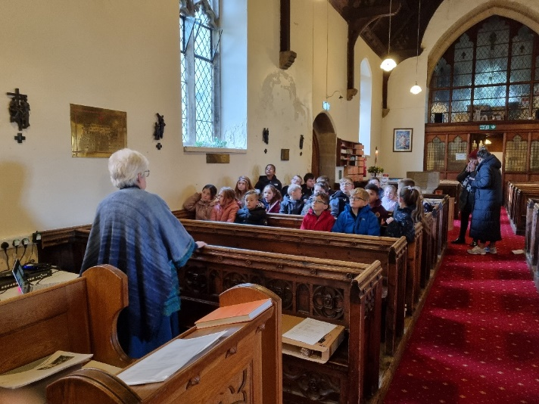
One of the greatest links we have in the community is with St Stephen's Church of England Primary school. Some years ago, the school changed its name by adding “St Stephen's” - which was decided upon by the school itself. In the past, the school would visit a Sunday morning service at least once per term and lead part of the worship. They also have other visits for worship at various times of the year. There is “open worship” at the school once per month to which the church congregation are invited. Some years ago, after spending a day at the school, Bishop Mark confirmed two of the teachers. We see the school as one of our key areas.

The school, which has been serving the local community for almost 100 years, was rehoused around fifty years ago into a newly built, more modern and friendly building.

The school aims to provide pupils with a well-rounded education, focusing on key skills, but with wide ranging arts and sports opportunities. All their work is founded on Christian values. The children often make use of the church building itself, both through regular school services and special events during the year.

The rector of St Stephen's will have ample opportunity to work with the school and will also serve as an ex-officio member of the Governing Body. The church also nominates a further two foundation governors.

During services where the school take part, their families are usually part of the congregation which adds to the sense of community and fellowship we share with the school.

CHILDREN AND YOUNG ADULTS

We seek to welcome people of all ages at St Stephen’s and recognise that children and young adults are not merely the “future” of the church, but a needed and important part of our life together now. We are planning to develop improved facilities for children and their families. Ideally these would be available both during service times and in due course, during the week.

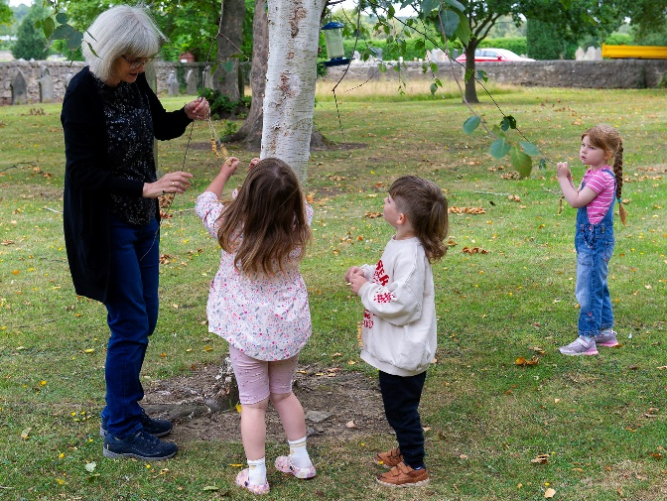
As noted above we have up to about 10 primary school aged children, though several of them have just started senior school. Not all 10 attend every Sunday, but there always some of them. We meet with them on the evening of the first Wednesday of the month. Recent conversations with them suggest that a weekly opportunity to meet as a youth group would be welcomed and as such we are looking at ways to make this happen. Also, during school holiday times (except the Christmas break) we hold Fun Time for primary school children. Numbers can vary from as few as 4 to as many as 22. Craft, music, games and refreshments are available.

PASTORAL CARE

During the interregnum pastoral work has continued informally through the efforts of members of the congregation supported by the retired clergy. It is an area where there is always room for development.

Home communion is available to those unable to attend church and allows people to remain connected to our worshipping community.

There is an annual All Souls’ Service on the evening of the first Sunday in November. This is very well attended and those present appreciate hearing the names of deceased loved ones read out and welcome the opportunity of lighting candles for them.

There is opportunity to develop pastoral ministry within shared ministry team.

MOTHER'S UNION

St Stephen's branch of the Mothers' Union has been a part of our church life for many years. Although small in numbers, members continue to meet each month, discussing topics of interest to its members. They join with other groups helping them with various ventures and continue to support the church in any way possible. Their banner is taken along to the cathedral gatherings of the Mother's Union whenever they occur. They have contributed towards the church linen in various ways with their skills. They feel with the re-invigorating of the church and its mission to young families they will be able to contribute by drawing in and supporting younger mothers in the parish.

The MU had been led by a faithful member for many years. Following her death, the branch kept ticking over quietly but recently it has been re-launched with a new branch leader. A programme of speakers and events is being planned.

COMMUNITY

We are involved in the community in a number of ways, other than with the schools.
There is a very successful charity shop - Charity Shop 4 U - in the town. St Stephen’s nominates one of the trustees. Charity Shop 4 U raises funds to help children and young people (up to 18 years) develop their interests and learning. Organisations and individuals are able to apply for grants.

We had a member of the congregation regularly involved with Parkside Academy, but Covid has caused a hiatus and this is currently being re-investigated.

There are two breakfast clubs a month which members of the church attend as well as some who do not attend church. One is held at Wetherspoons in Crook and the other at the Open Door Methodist church in Willington.

As a result of the work done (and ongoing) for the A-Rocha Gold award (which we received early 2025), a very good relationship has developed with the Town Council which has joined in some of the ventures that have taken place in the churchyard. Indeed, they encouraged St Stephen’s to enter as a special category in the Northumbria in Bloom. Willington overall has done well in 2025 with the town being awarded a small town gold, a gold for overall best town for spring bulbs, the Roman Catholic primary school allotment garden received a silver gilt award and St Stephen’s was awarded gold for best religious establishment. As there are a large number of entrants in this, Willington has done remarkably well and is testament to the hard work that is put in.

During the summer we host afternoon teas which are well attended by members of the congregation and the community.

Basic Statistics

 | 2023 | 2024
Baptisms | 20 | 26
Weddings | 3 | 4
Funerals | 22 | 24

Buildings

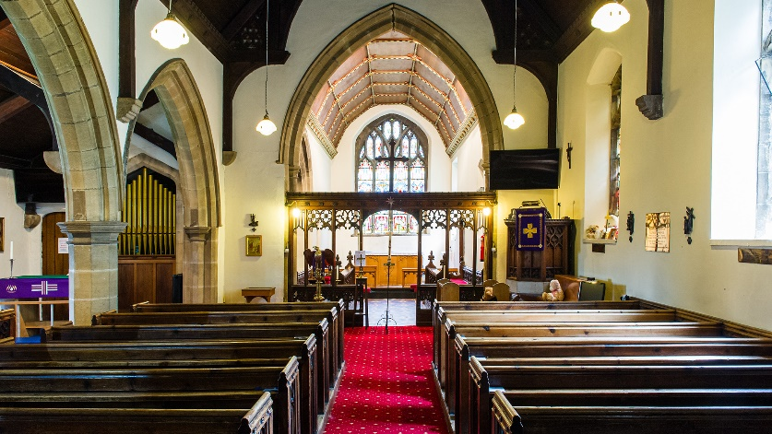
The Church
The church is a Grade II listed building built in mock gothic style. It has a number of interesting features. There is a set of five steel bells which were re-cast and re-hung in 1904 – these are one of only seven sets of steel bells in the country, and the church hosts regular visitors from across the land who come specifically to ring them. The organ was built by Henry Willis & Sons of London and renovated in 1979 by Harrison and Harrison of Durham who continue to maintain it. This organ has seen people visiting specifically to play it. There are also several works of art that have been donated by the artists, decorating the church.

The Rectory
The Rectory is a modern detached four-bedroom house built in the 1980s with attached garage. Built to a high standard and specification it has well-kept gardens and large hard landscaped area. It is situated in its own grounds opposite the church. The house has a high output energy efficient boiler, double glazing and a log burning stove.

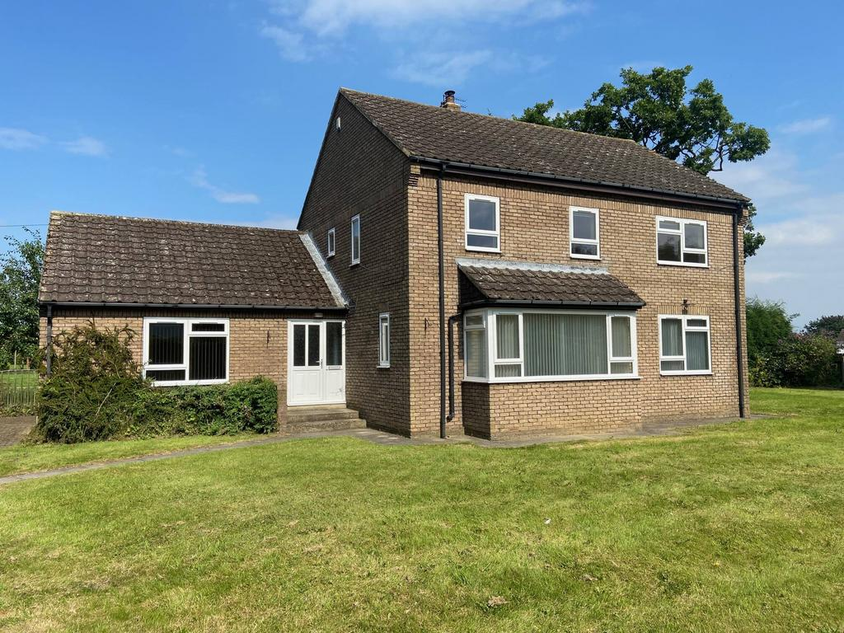

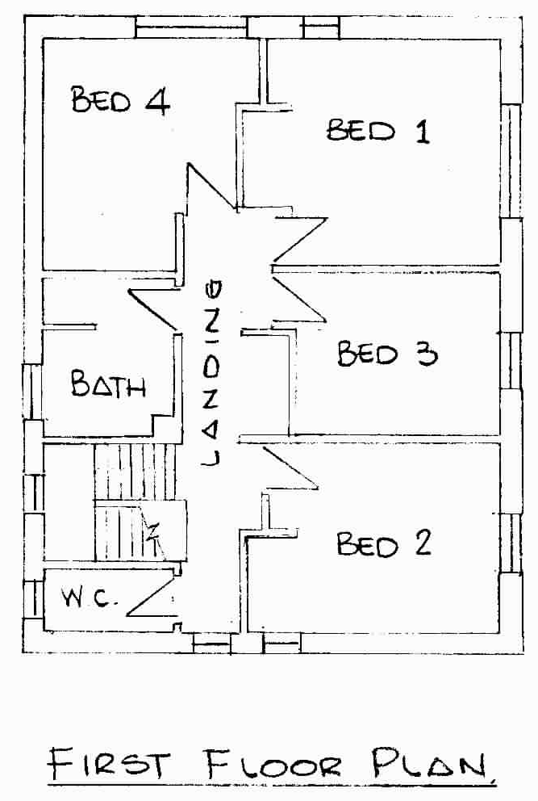
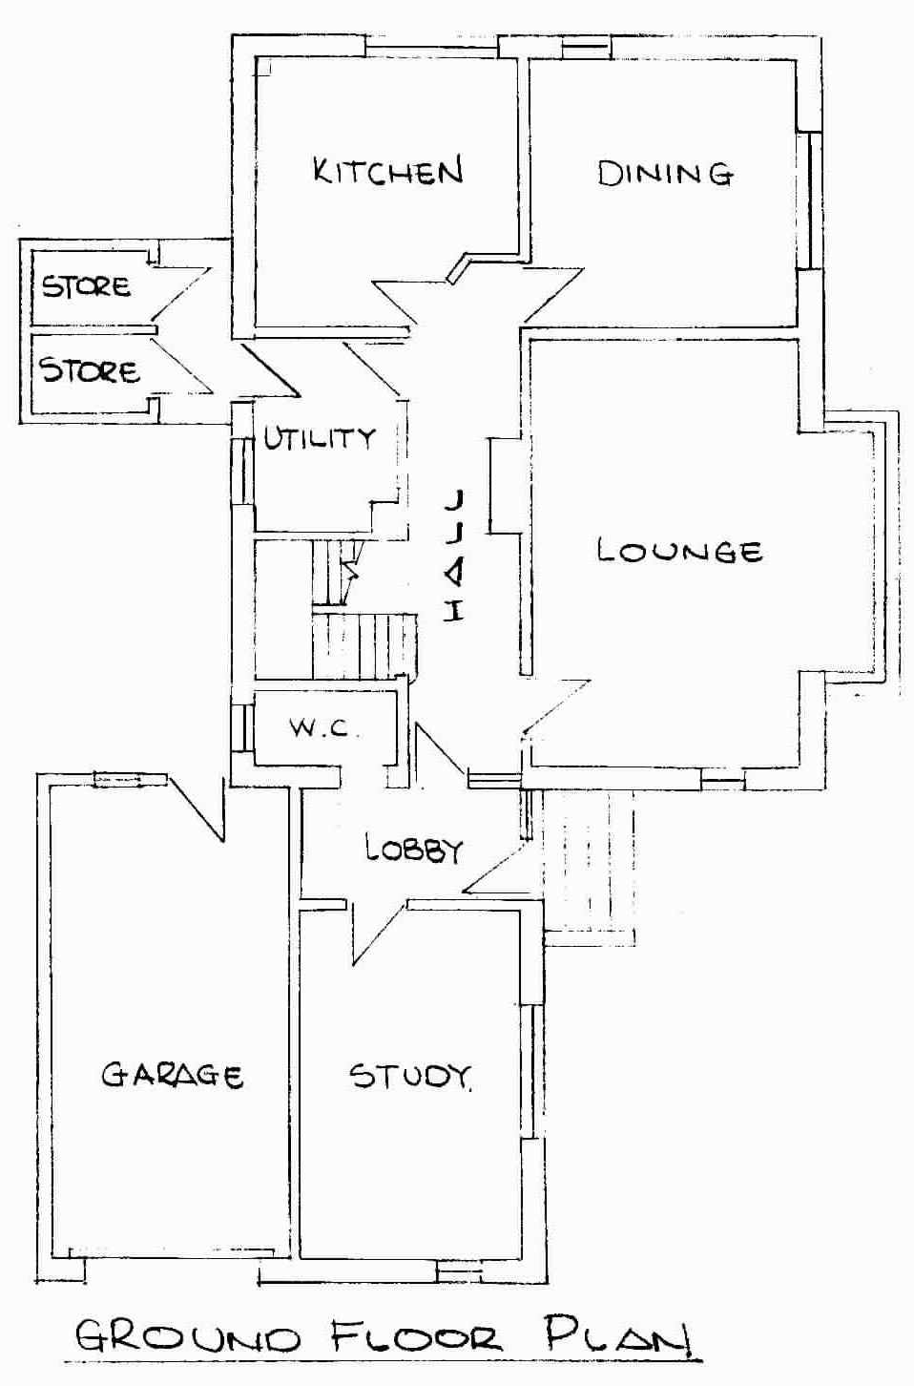

THE PAROCHIAL CHURCH COUNCIL

Our PCC would be chaired by the incumbent and normally consists of two Churchwardens, the Treasurer, two Deanery Synod representatives and elected lay members so that it numbers 11 or 12. PCC meetings are held monthly in the church meeting room and are minuted. We have a full set of officers in post.

The PCC members work well together and with the incumbent. Members support and get on with each other and are forward looking.

As an initial part of Project 21, the PCC agreed that the set of rear pews should be removed to create a larger useful, usable space giving more opportunities for groups and the community at large. The church architect is preparing plans illustrating the options.

Who Are We Looking For?

We hope that as you’ve read our profile, you will have gained a flavour of what we think makes St Stephen’s Willington so special. Like many churches, we are an older congregation, but there is still energy for God’s work in the town. Recently, we have had a small growth in the number of children attending our Sunday worship.

We seek to grow and to continue to reach out into our community, and this means that we are looking for someone with energy and drive. We understand the changing face of ministry and would like our model of ministry to be collaborative. As a candidate you would need to be comfortable working in this way and able to help us develop in this direction. We hope you would be excited about this Shared Ministry and the rewards it could bring to all concerned. You should be able to discern the strengths and skills of members of the congregation and see where they can be applied and developed.

Today’s society is diverse, and we recognise the right of all those God has called to worship Him and enjoy the fellowship and friendship of other disciples. We hope that you would share this accepting and welcoming spirit to people from all sections of our community, regardless of race, gender, sexuality, age or ability.

Whilst the character of worship at St Stephen’s is, in the main, fairly traditional, we hope that you would be open to explore more contemporary forms of worship and different expressions of church, as well as preserving those we currently enjoy. An interest in music and its place in worship would also be an advantage.

Since we see our witness to children and young adults as a major priority, you should be happy working with youth of all ages, from toddlers to teenagers and be ready to build on the relationships with our local schools. You should be prepared to continue to develop a strong working relationship with the staff and pupils at St Stephen's Church of England Primary school also.

As an inclusive church St Stephen’s would welcome application from male or female clergy.

To sum up, we’re looking for a dynamic person who will undertake the role prayerfully and thoughtfully. The right candidate will be committed to growing the kingdom in the wider community. We seek someone with drive who can help us determine and fulfil God’s will for His people in Willington. Oh, and they should have a sense of humour and enjoy the social aspects of parish ministry too! If this sounds like you, we’re looking forward to meeting you.

St Stephen’s wish is to develop a strategic vision and plan for the future, seeking God's grace through prayer. Part of this is contained within the Project 21. To this end, the person we are looking for to lead us, will help us achieve a true vision, strategic goals and achievable objectives and:

    - would nurture us in our faith,
    - help us to grow in holiness,
    - help us in ways to share the love of God with those we meet daily,
    - help us develop our relationships with the schools and other organisations
    - be a team leader and a team player
    - an enabler
    - take us forward with Project 21

We believe St Stephen’s can provide an exciting opportunity to anyone who has a desire to serve God as an enabler and evangelist.

THE BENEFICE OF HUNWICK & WILLINGTON

What Next ?

At St Paul’s Church and at St Stephen's Church we are praying for God's guidance for those who feel called to consider joining us.

For further information on the role please contact the Archdeacon of Auckland in the first instance:

The Venerable Rick Simpson
Holy Trinity Vicarage,
45 Millbank Road,
Darlington
DL3 9NL.

Tel: 01325 480444
E-mail: archdeacon.of.auckland@durham.anglican.org

