**Our Diocesan Vision -** An introduction from Bishop Sarah

This is an exciting time to be exploring joining the Diocesan family in Durham Diocese. We are on the cusp of a fresh chapter in our mission and ministry together. We are currently discerning with the National Church who will be the next Bishop of Durham, called to lead as we seek to make real our vision for the transformation we so desire across our Diocese – and this in all our parishes, including those which look to Bishop of Beverley for oversight. We are deeply encouraged by the award last year of significant national funding, demonstrating real confidence in our vision.

Our strategy for transformation and missional growth (‘Called to Fruitfulness’) is an opportunity and invitation for each of our parishes to step out in faith together, responding practically to our priorities to ***Challenge Poverty, Energise Growth, Care for God’s Creation*** and ***Engage with Children, Youth and Young Adults***. Making this a reality it will look different in every community. In some places it will come about in collaboration with others. Nobody is expected to do everything immediately or alone, but we are all invited and expected to find ways to respond relevantly. The Parish Profiles of the Good Shepherd and St Mary Magdelene make clear how they are engaging with these priorities as they look to the future and seek a new minister.

In praying for a new Priest for this Interim role we are looking for someone excited by the churches’ determination to serve their parishes and see their congregations grow. Together we pray hopefully:

***Loving God****, guiding the people of Durham Diocese faithfully through the years:*

*We thank you for saints who have marked our path,  
young and old, known and unknown, from all places and in all walks of life.  
Help us to find your way in our generation:*

*transformed by your truth, sharing your life, blessing our communities.*

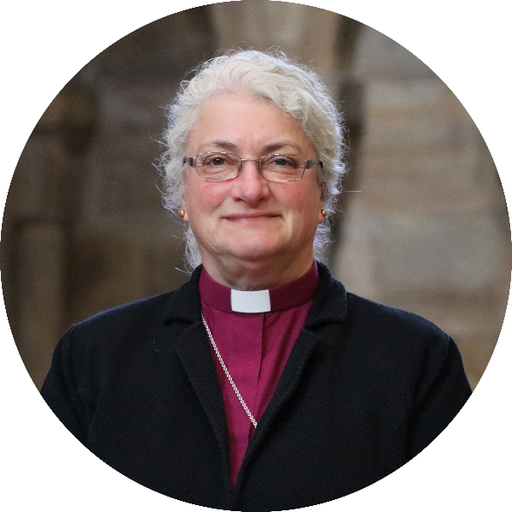*Through Jesus Christ our Lord,*

***Amen***

We look forward to meeting together  
and sharing in this with you.

In Christ,

**+Sarah**

**Bishop of Jarrow**

**Acting Bishop of Durham**