Parish Profile

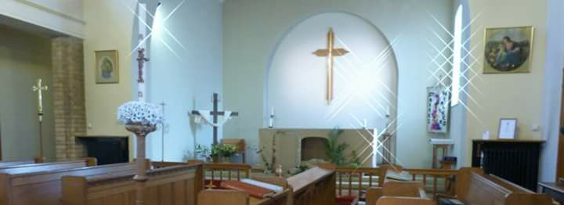
St Mark with St Paul,
Darlington

and
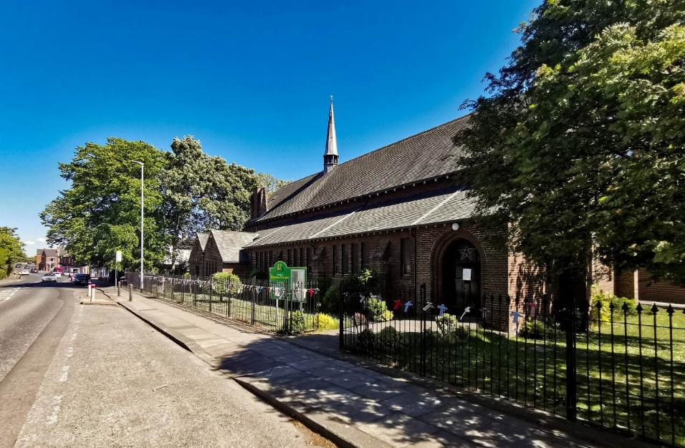
St Matthew & St Luke,
Darlington

Contents:

Page

Introductory Letter from Bishop Sarah 3

St Mark’s 4

1. Introduction 5
Welcome
Our Team
Causes for celebration
Our strengths as a Parish
Our Parish Community

2. Worship and Pastoral Care 7
Our Tradition
Sunday Worship
Occasional Offices
Worshiping God with our wider community: Additional services
Pastoral Care
3. St Mark’s Mission 10
Reaching out to our community - St
Mark’s Health and Well-being Hub
Our Health and Well-being projects
The Friendship Café
Northern Lights Community Choir
Exercise Programmes
Our work with schools
Relationships with local churches

4. Buildings, Finance and Communications 14
The Church building
Our Church Hall
Finance and Fabric
Communications

5. Opportunities, challenges and out next minister 15
Opportunities and challenges
Qualities - the minister we are seeking:
Our priorities for the future
How we would like to support you

St. Matthew and St Luke’s 18

1. Description of the Parish 18
2. Our Church Building 21
3. Church Services 23
4. The Wider Church 23
5. Ministry 25
6. Teaching 25
7. Fundraising and Social Activity 25
8. The Vicarage 26
9. Administration 27
10. Finance 28
11. Willow Road Community Centre 31
12. Challenges 32
13. A New Incumbent 32

Our Diocesan Vision - An introduction from Bishop Sarah

This is an exciting time to be exploring joining the Diocesan family in Durham Diocese. We are on the cusp of a fresh chapter in our mission and ministry together. We are currently discerning with the National Church who will be the next Bishop of Durham, called to lead as we seek to make real our vision for the transformation we so desire across our Diocese. We are deeply encouraged by the award this year of significant national funding, demonstrating real confidence in our vision.

Our strategy for transformation and missional growth (‘Called to Fruitfulness’) is an opportunity and invitation for each of our parishes to step out in faith together, responding practically to our priorities to Challenge Poverty, Energise Growth, Care for God’s Creation and Engage with Children, Youth and Young Adults. Making this a reality it will look different in every community. In some places it will come about in collaboration with others. Nobody is expected to do everything immediately or alone, but we are all invited and expected to find ways to respond relevantly.

In St Mark with St Paul and St Matthew’s & St Luke’s Darlington this feels particularly relevant. We sense the importance of Energising Growth – in discipleship and in the number of people served by and engaging in the life of our churches. The churches are also thoroughly engaged in Challenging Poverty and working to overcome some of the effects of poverty on those in their communities. Both are seeking to actively Engage with Children and Young People, not least through work with local schools.

In praying for a new Priest for these churches we are looking for someone excited by and wanting to be part of this vision and new future. Together we pray hopefully:

Loving God, guiding the people of Durham Diocese faithfully through the years:

We thank you for saints who have marked our path,
young and old, known and unknown, from all places and in all walks of life.
Help us to find your way in our generation:
transformed by your truth, sharing your life, blessing our communities.

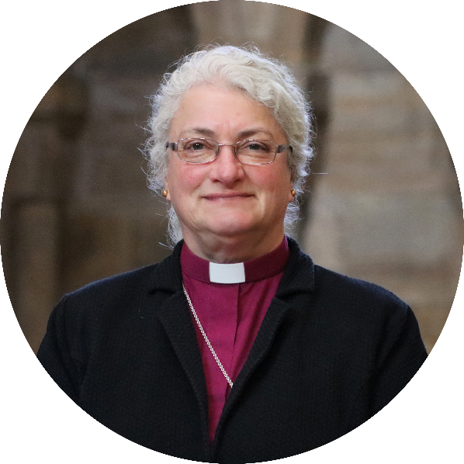
Through Jesus Christ our Lord,
Amen

We look forward to meeting together
and sharing in this with you.

In Christ,

+Sarah
Bishop of Jarrow
Acting Bishop of Durham

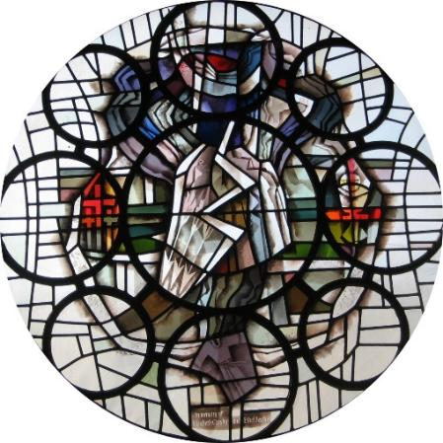

St Mark with St Paul
Darlington

Parish Profile
2025

1. Introduction

Welcome

Thank you for reading our Parish Profile. We are excited about discovering who God is calling to be our new minister and discerning together the next stage of our communal life in Christ. We hope that you enjoy learning about our church and parish and we pray that as you read about us God will guide your thoughts.

The original St Mark’s church was built in 1890 as a mission church in the parish of St Paul. And in the mid-fifties, Revd Alan Burn, the then vicar of St Mark’s launched a building fund and fundraised for 3 years. Thanks to his efforts, the church which we occupy was built.

The two parishes of St Mark and St Paul were combined in 1973, when St Pauls Church was sadly destroyed by fire. Although things have changed in the life of St Mark’s throughout its history, St Mark’s has been and still is at the heart of the community. Throughout these 66 years St Mark’s had been and continues to be a place where people experience God’s love and God’s presence. As we have prayerfully sought to hear God through this vacancy, we have been encouraged to focus on the potential we see in the Church in the heart of the North of Darlington and the opportunity for growth in a number of ways: how we can be more engaged with our faith and how we put that faith into action so that we are more fully and deeply devoted to extending His kingdom. We would like our new minister to share the long-term vision of our PCC , and to lead us in developing a strategic vision for St Mark’s within this. If what you read here resonates with you and you feel God calling you to lead us on the next stage of this journey, we would love to hear from you.

Our Team
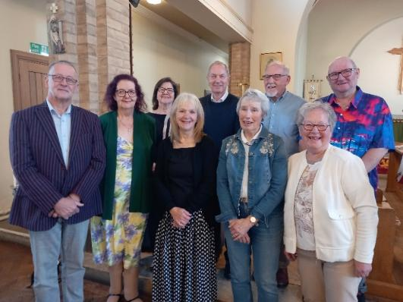
Since our vacancy began, many have come forward to exercise their discipleship and support the continued life and work of St Mark’s. This has meant that the PCC has now grown from 7 to 15 members. Our Churchwarden and Treasurer has worked tirelessly in the vacancy and as a PCC we have organised ourselves into working groups to ensure that the responsibilities are shared collectively.

We have working groups responsible for:

- Liturgy
- Baptisms and weddings
- Maintenance and fabric
- Gardens
- Social activities
Causes for celebration

There are many aspects of our church life to celebrate that are highly valued both by the congregation and the wider community. We are confident in our faith and are committed to being an open and inclusive church. Our doors are open to all, both literally and metaphorically, and we value the contributions of all God’s children. We believe in being an inviting and welcoming church, with a warm atmosphere and a place where many people make lifelong friendships. Although we have just 59 on our electoral roll, those who attend St Mark’s are faithful and committed to growing the kingdom in the North of Darlington. During the vacancy church members have been asked to exercise their discipleship and have become increasingly involved in the day to day running of the church. We have a number of working groups who have taken on responsibility for church fabric and maintenance, the Gardens, Social events and supporting worship.

During the Interregnum the former Curate of St Mark’s, who now has Permission to Officiate, has supported the church to develop its work in the community. There has been a considerable effort by the church as a whole to build discipleship, develop positive relationships with the local community, schools and statutory agencies and this has proved to be extremely successful. So much so that since August, St Mark’s has over 200 people per week attending activities aimed to support our local community.

Our strengths as a Parish

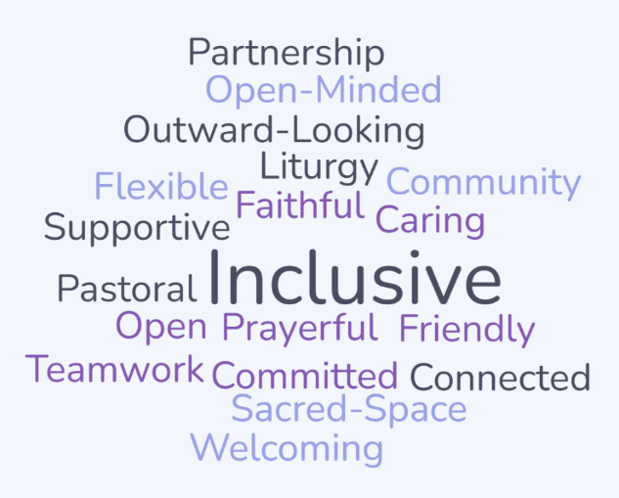

Our Parish Community

St Mark’s parish is based in the North of Darlington and has two distinct areas within it, namely Harrowgate Hill in the north end of the parish and North Road in the South. Harrowgate Hill is considered to be more economically buoyant than the former St Paul’s area of the parish south of the church. The area south of the church has a high level of private rented accommodation.

The parish population is 12421 (source: Census 2021) with 5806 households. This number is increasing due to a number of large housing developments of 700 homes being built at Harrowgate Hill.

Our Electoral roll has remained relatively stable over the past three years:

Year | Electoral roll no
2023 | 63
2024 | 59
2025 | 59

Average Sunday attendance in 2024-2025 is 35.

Our community projects and increased emphasis on welcome has increased St Mark’s presence in the local community. We have seen more members of the community identifying with St Mark’s and discovering a sense of belonging. This has resulted in an increase in people attending St Mark’s intermittently as well as an increase in attendance at services around major feasts.

Within the parish boundaries are 3 schools:
- Northwood Primary
- Harrowgate Hill Primary
- Longfield Academy.
We have three care homes within the parish:
- Elderwood Care Home for the elderly
- North Park Care Home for the elderly
- Ashleigh House a 24-hour residential home for up to 26 adults, supporting people with mental health support needs and learning disabilities.
In the latest Index of Multiple Deprivation (IMD) St Mark’s parish was ranked 1,718 out of 12,178 in England. Within our ward we see significantly worse health statistics than the average for England. Darlington Borough Council and partners produced the Joint Strategic Needs Assessment in 2023 to inform decision-making about health and wellbeing in the borough. This assessment identified that North Road ward has 4% higher instances of limiting long term disability and illness than the national average. Life expectancy is 11.7 years lower for men and 8.5 years lower for women in our area of Darlington. Year 6 obesity rate is currently 30.4 as opposed to England’s average of 17.1. The ward has some of the highest numbers of people suffering from COPD and diabetes as well as child poverty in the town. There is a high prevalence of mental health problems with the ward having the highest statistics in the town for people suffering from depression. 72.5% of older people of pensionable age reside alone and there is significant social isolation and loneliness amongst the elderly.

We have met with local schools, the Primary Care Network, NHS Community Mental Health team and local community representatives. We have also consulted with members of the community to identify needs and support requirements. They have highlighted the need for preventative interventions, opportunities to reduce social isolation and the desire for services on a local level. Our local schools are dealing with the consequences of child poverty, mental health issues and poor physical health amongst pupils and their families. The Primary Care Network concur that social isolation and loneliness as well as obesity and diabetes are significant issues in this parish. There is also high numbers of elderly people in the locality. There is presently limited support on a local level in the north of Darlington

2. Worship and Pastoral Care

Our Tradition

The Church Tradition at St Mark’s is Liberal Catholic and is Eucharistically focused. Most importantly, women’s ministry is fully embraced and supported.
Vestments (Chasuble) are worn by the priest and there are full sets of seasonal Altar Frontals along with Pulpit and Lectern Falls. We have a Crucifer and robed Servers. We have incense at the major Festivals and at regular intervals throughout the year. The Liturgy is enhanced by a very able organist.
St Mark’s has a set of Stations of the Cross which are used during Lent particularly as a Lenten devotion. Holy Week is kept ALL week culminating with the Triduum and Easter Day.

Advent and Lent and other study groups were held during the Church year up until the vacancy.

Sunday Worship

Our main Sunday service is a 10:00am Eucharist, Common Worship, with in-house seasonal booklets. Redemptorist Press reading sheets are used, the back of which contain relevant church notices. The liturgy and worship is ‘informally formal’; that is, the Liturgy is done well but is in no way a staged performance. Laity welcome people each Sunday as they come into church and hand out the books and reading sheets.
We sing The Gloria, the Alleluias (the Gospel is read in the body of the Nave). The Bible Readings (Old Testament, Psalm and New Testament) are read by members of the Laity. The Intercessions are prepared and delivered by a group of laity. A small group of the laity assist the Priest with the administration of the chalices.
At the end of the service the majority of the congregation stay to enjoy refreshments. The fellowship is excellent and a real indication of the Christian love and concern that the congregation has for one another.
During the year at we undertake Charitable collections at specific Sunday services including : Harvest Festival (Food Bank), Toy service (Salvation Army toy collection), Christingle service (Children’s Society), and Christmas Giving Tree (St Teresa’s Hospice).
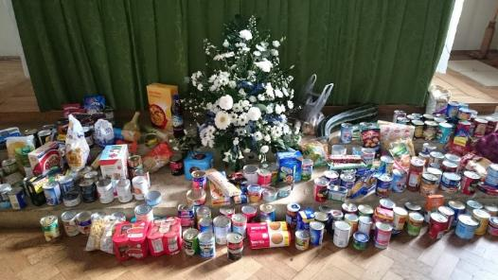
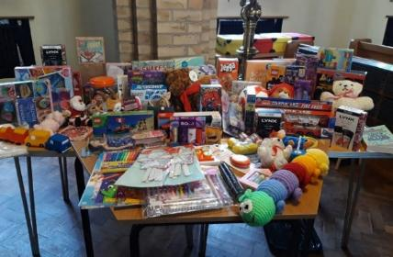

Parish donations to the Toy Appeal Harvest Service donations for the food bank

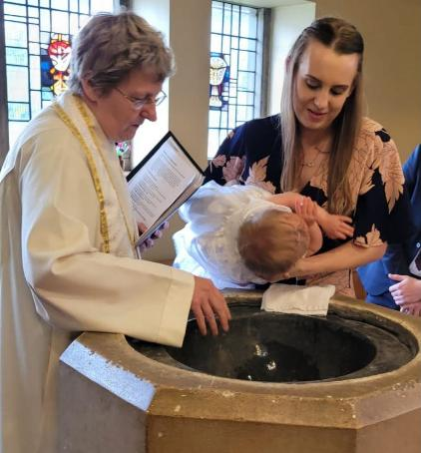
Occasional Offices

St Mark’s has regular requests for
baptisms throughout the year:

2023 – 6 Baptisms
2024 – 16 Baptisms
2025 – 6 to date

Local people have a strong connection
with St Mark’s and requests for Baptisms
remain consistent.

St Mark’s funerals have reduced over the past
few years to an average of 12 per a year.
Funerals have reduced over the past two years
due to the increased use of celebrants in Darlington as a whole.
Weddings are less frequent, having held one wedding in 2024.

Worshiping God with our wider community: Additional services

We hold several special services throughout the year which have excellent support from the wider community. Each year we hold an annual All Souls service where we invite bereaved families to take part.
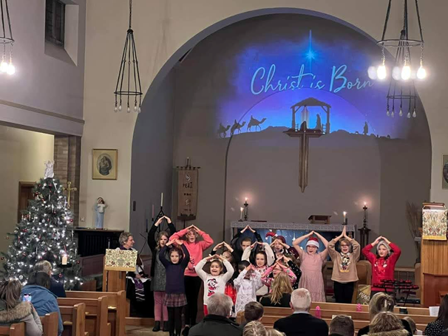
Each Christmas we hold a Family carol service which is supported by Harrowgate Hill School. Attendance at this service has increased over the last two years with over 100 local people joining us for the service.

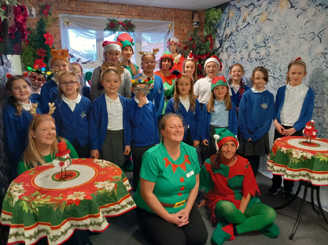

Harrowgate Hill School Choir also
attend our annual carol service at
Elderwood Care Home, which is
attended by over 40 elderly residents.

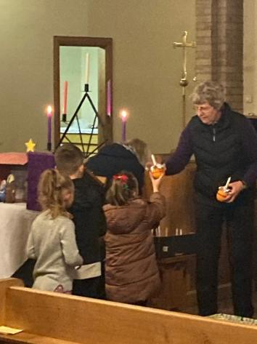
We have
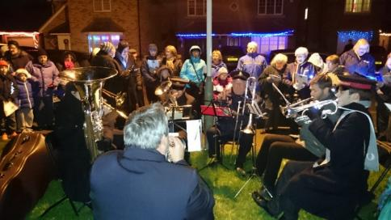
a well-
attended
Christingle
Service
each year.

We partner with the Salvation Army band and take carols into the community. This is well attended and we usually have around 60 people join us to sing carols on Pendleton Road.

Pastoral Care

Sharing the joys and sorrows of people is one of our greatest privileges as it mirrors the love of Jesus for all those whom He met. Thus, the care of members of the congregation and people who live in the Parish is seen as an important part of St Mark’s ministry. We ensure that, where possible, those who struggle to attend worship are offered lifts to church. Church members will also look out for one another and support each other during challenging times in their lives. We always ensure that people are offered visits during illness or hospitalisation and offered home communion. We endeavour to minister to the sick and dying and provide access to a priest at these difficult times.

3. St Mark’s Mission

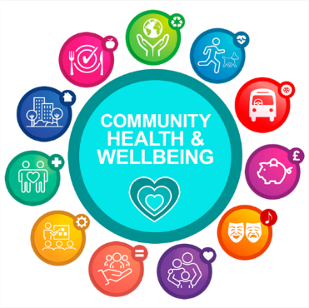
Reaching out to our community – St Mark’s Health and Well-being Hub
Because so many people in St Mark's parish struggle with poverty, ill health, isolation and mental health issues, we have felt called as a parish to respond. In the North of Darlington there are limited opportunities for people to come together and St Mark’s felt it was well placed to improve community cohesion and support local residents.
To this end the PCC decided to set up a Health and Wellbeing hub at St Marks in August 2024. The PCC recognised the need to use St Mark’s for the benefit of the community and to create a place which is vibrant and full of life. After much prayer we felt that the Holy Spirit was calling us to reimagine our place in the community.
In order to do this, we had to not only embrace change but also work closely with other groups to support those around us. The parish has a strong sense of our calling to bring the love of Christ to all in our community.

The Health and Well-being Hub at St Mark’s set out a number of objectives:
- Improve the health and wellbeing outcomes within the local community
- Reduce inequalities in health and wellbeing
- Improve accessibility of health and well-being support and activities
- Provide activities which focus on prevention and health improvement as well as increase peer support and build social networks
- Reduce loneliness and social isolation amongst the elderly
- Improve collaborative working and foster new partnerships to improve the health of those in the North of Darlington
- Empower service users with lived experience to improve their confidence, resilience and engagement in their community
- Enable people in our community to access art and culture
- Encourage people to feel part of our church family and attend services held at St Marks
- Empower members of the congregation to exercise their discipleship through day-to-day contact with people in our community
We have developed a funding strategy and have had several successful funding applications for grants from – Point North - NHS Improvement Fund, Community Fund, Darlington Borough Council including Arts and Heritage Grant and Stronger Communities funding. We have also received grants from the Diocese of Durham as well as contributions from local businesses. All of the project funding not only funds activities but covers over-heads, enabling us to generate income from our hall use.

Our Health and Well-being projects:
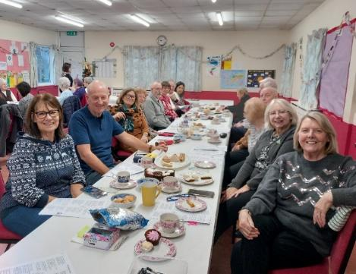
The Friendship Café

We currently run a Friendship Café project
which was set up in 2018 to provide support
for the elderly and reduce social isolation.
This is now self-sustaining and is well supported
by the local community. It is supported by v
volunteers and has also received been funding
from Darlington Borough Council’s Stronger
Communities fund.

Northern Lights Community Choir

We set up the Northern Lights Community Choir in January 2025, which now has 54 members from the local community. 37% of its membership have long term health problems. The impact the choir is having upon local people’s lives is phenomenal. One member gave this feedback upon their experience so far:

“The warmth and inclusivity of this community have meant so much to us, making us feel truly welcome and supported. We are deeply grateful for the opportunities this choir provides and the positive impact it has had on our lives. Thank you for making this possible.”

The choir continues to go from strength to strength and had its first concert in July 2025 at St Mark’s Church.

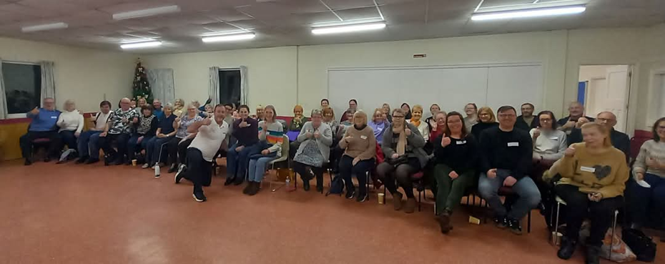

Exercise Programmes

We have a programme of weekly activities aimed at improving the health of local people including:
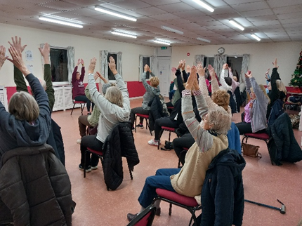
- Move – gentle Exercise for older people
- Fit in 45 – a programme aimed at
improving fitness
- Family exercise – to enable parents to
exercise with their children
- Art Workshops – to encourage creativity
and promote relaxation through art
- Dance Classes – to promote fitness
through dance

The Project Leader, Revd Caroline Ferguson,
member of St Mark’s PCC and PTO priest, is a former director of a large charity in the North East which specialised in providing support to disadvantaged people and communities. She has over 40 years’ experience of working in collaboration with the NHS, Primary Care Networks, Local Authorities and charities. She managed budgets of over £12M. She has extensive experience of managing and developing volunteers, community engagement and co-design. The Hub is working towards activities becoming self-sustaining and recruits volunteers to support this.
We have formed relationships with local health service providers, charities and the community to maximise the opportunity for partnership working and to ensure that our project compliments existing work and meets local need. We have formalised a partnership with the NHS Diabetes Prevention, who run sessions from St Mark’s as well as other local charities. We are currently working with Tees, Esk and Wear Valleys NHS Foundation Trust to explore ways of supporting local people to improve their mental health.

As a church we want our building to be a place which is vibrant and welcoming. To this end we have organised a full programme of concerts throughout the year. This provides us with an opportunity to invite people to St Marks, particularly those who are isolated or lonely. The Hub has also enabled the church to be viewed positively by local people and as a result a number have started to attend St Mark’s Sunday services.
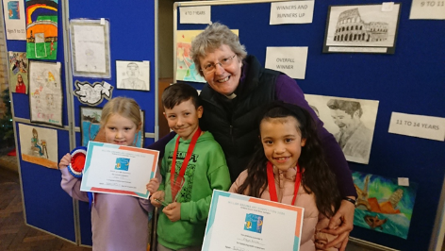
Our work with schools

St Mark’s PCC sees work with school as
an absolute priority to support mission in
future years. We have developed new
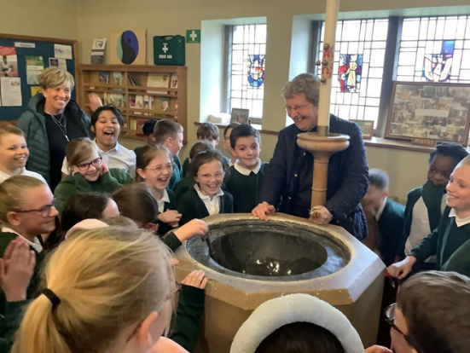
relationships with our local schools over
the last 8 months. To renew our relationship
with schools we arranged and invited schools
to exhibit art in an art competition at St Mark’s
in November 2024. This resulted in 4 schools
exhibiting art works which told of their hopes
and dreams for the future - for their family,
community or the planet. Over 120 young
people exhibited and the event saw around
200 visitors including the MP for Darlington
and the Mayor. This event has proved to be a
catalyst for further work with our local
primary and comprehensive schools.

In April 2025 Northwood Primary spent time at St Mark’s
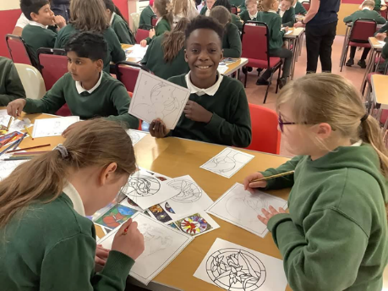
learning about the Christian faith and the wonderful
stained glass we have in our sacred building.



The children spent the afternoon
producing a new stained glass
window design for the church,
which captures the beauty of God’s creation.

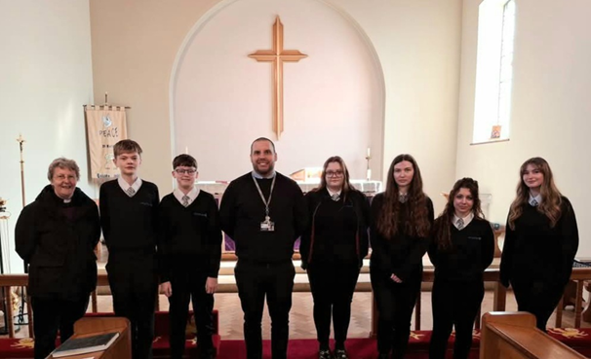
We have also had visits from Longfield Academy this year to support students studying for their GCSE in Religious studies. We are committed to supporting students long into the future.

Relationships with local churches

St Mark’s is part of the 4M’s Locality group consisting of St Marks, St Marys (Cockerton), St Matthews (Brinkburn Road) and St Michael’s (Heighington)
The group meets on three occasions during the year. At each meeting, representatives from the four churches give an update on their situation and events. Various group events were held, including:
• Marriage preparation day
• Joint service for Christ the King (St Matthew’s)
• Adult confirmation classes

Due to Deanery re-organisation, there are now two groups of churches in the Deanery: the Northern Group includes the 4M’s group and also St Andrew’s Haughton, St Andrew’s Sadberge and St James the Great.

St Mark’s also has a positive relationship with our local Roman Catholic Church, St Thomas Aquinas. Sadly, Harrowgate Hill Methodist church closed in 2024.

4. Buildings, Finance and Communications

The Church building

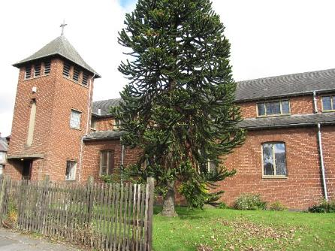
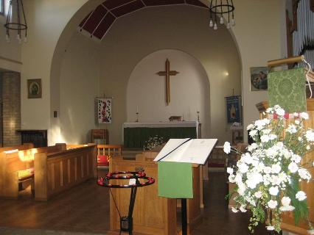

The church building is in a good state of repair and well maintained. A small roof repair was recently carried out and the required annual service checks (e.g. PAT testing and ice and fire equipment servicing) are all up to date.
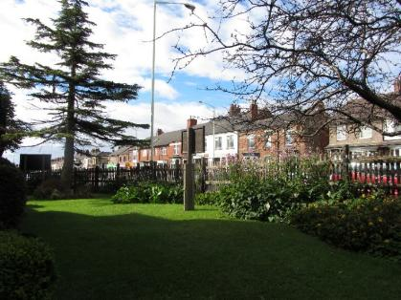
The Church grounds front, side and rear are well
maintained by a group of volunteers, with
regular grass cutting and maintenance being
carried out. A professional gardener visits
St Mark’s once a year to trim down high-level
hedges and bushes.

Our Church Hall

Over the past year we have made extensive improvements to the hall. Lighting has been improved and improvements to the heating system have made it a warm and welcoming environment. We have also been successful in a funding application to provide additional funding to make the church hall roof watertight. We will aim to improve the roof in the second quarter of 2025. PAT testing and annual Heating Certificate were actioned as usual.

Finance and Fabric

Despite vacancy, the PCC and congregation have prayerfully taken steps to ensure that we have continued to thrive. Our finances are in a relatively healthy position due to the continued generosity of the congregation. Regular giving i.e., standing orders and envelopes were the same as last year, but Gift Aid had increased by £1,351. We had a Parish Gift Day which resulted in the congregations donating £1,260 to support the church. These funds helped to increase our Charity Tax rebate by £1,279. We continued to honour our Parish share for £20,048 in 2024. Repairs & maintenance on our properties was at a minimum in 2024. Service upkeep and Church expenses remained static.

Prior to August 2024 income from Hall use was extremely low. This however has been addressed due to new partnerships and projects utilising the hall premises. Hall rental now generates a significant amount of income which will enable the hall to continue to be an asset to both church and community.

St Mark’s own a residential property (formally the curate’s house) in Thompson Street which is rented out to tenants and maintained by St Mark’s.

Communications

A decision was taken to cease production of the monthly Parish Magazine in 2024. We now utilise social media and our website as the main communication platforms for St Mark’s. We do recognise that many older members of the congregation do not have access to IT. Therefore, we produce parish updates which are distributed at services when required. The PCC are also keen for the congregation to embrace the positive changes made over the past 6 months. We have therefore ensured that the congregation are updated every 6 to 8 weeks on progress.

We have a well-developed website which is updated regularly. Our website is visited by 130 people on average per month. We also have a Facebook page. This is updated on an ongoing basis and we ensure there are posts on a daily basis. This is proving to be an excellent tool to connect with the wider community. In the past 6 months our followers have increased from 450 to 620.

5. Opportunities, challenges and out next minister
Opportunities and challenges
Much missional groundwork has taken place in the vacancy to provide sound foundations for future growth and development. Our relationship with the community, schools and voluntary and statutory agencies are now well established, and have born much fruit. There are significant opportunities to continue to develop our links with schools further and this provides St Mark’s with optimism and hope for the future. There is significant scope to continue to build upon the Health and Well-being Hub and support each project to become self-sustaining. Additionally, there is considerable scope to offer new and creative worship aimed at families, who don’t necessarily attend traditional Sunday services. We do feel that the wider community would be open to new and creative forms of worship, given their strong commitment to St Mark’s. Historically St Mark’s has not spent time or resources on developing relationships with those in the south of the parish. This area presents a vast range of opportunities for mission and growth. New housing estates being built at the North of the parish also provide scope for growth.

There are however a number of challenges currently facing the parish namely:
- We have an ageing congregation
- Failure to grow significantly has left the parish short of volunteers and resources
- A shared post with St Matthew’s an d St Luke’s will limit the resources available and will require a clear realistic vision about what can be achieved.

Qualities - the minister we are seeking:
During the vacancy we consulted those who worship at St Mark’s about the qualities they would like their new minister to possess. They said:

- Dynamic and energetic;
- Deeply rooted in the community and focused on mission;
- Keen to seek the will of God and to shape our minds and hearts to serve God in mission;
- Possess a deep, prayerful Christian spirituality and creative intelligence;
- Clear thinking, wise and collaborative in your approach to leadership;
- Inclusive in approach, reaching out to all and valuing the contributions of all God’s children;
- A thoughtful preacher and teacher who will help us understand the Scriptures better and help us translate our faith into a vision for our community;
- A good communicator with the ability to relate to the diverse range of people who live in the north of Darlington and a desire to provide leadership within our wider local community;
- A great team leader who can guide and encourage both lay and licenced ministers and volunteers;
- Is grounded and meets people where they are
• Pastoral in outlook - listening deeply, comforting and nurturing
relationships in Christ;
- Have a heart for all ages and work with schools and families;
- Enable us to grow disciples of Jesus and develop our prayer life.

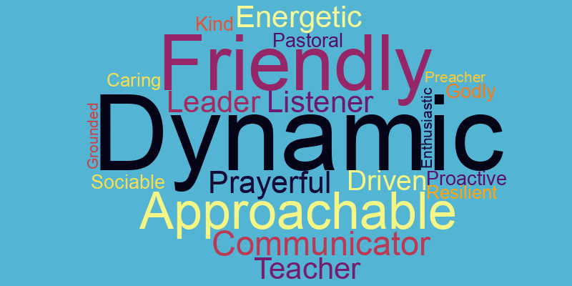

Our priorities for the future
St Mark’s consulted with its PCC and wider congregation as part of the Vacancy Audit Process. We sought their opinions on future priorities for St Mark’s as the parish looks towards the future. The PCC and congregation feel it is critical for the new incumbent to take time to get to know us before implementing change. The congregation is open and flexible to new ideas and it is important to work collaboratively in order to facilitate change.

Additionally, we would like our new pastor to value and treasure our Liberal Catholic liturgy whilst exploring with the PCC and congregation the introduction of new forms of worship, to enable us to engage with the wider community.

We see as our main priorities for the coming years:
- Growth – work with schools and families
- Engaging with the wider community
- Worship - exploring new additional ways of engaging the wider community in worship

How we would like to support you
We are committed to:
- Working with you with energy and enthusiasm – we have a reinvigorated and engaged PCC and congregation, eager for growth and creativity whilst valuing tradition;
- Providing an enthusiastic team of staff and volunteers who will use their gifts to support you and your ministry;
- Supporting you in your development with time for learning and reflection
- Sustaining your wellbeing so that you have time for both work and relaxation
- Praying for you often and supporting you so you can fulfil your calling to St Mark’s

Further Information
We hope you have enjoyed reading about us. This Parish Profile was written after prayerful discussion in the PCC and after gaining the views of the wider congregation via a questionnaire.

Our website:
https://stmarksdarlington.weebly.com/

Our Facebook can be accessed using the following URL:
www.facebook.com/StMarks Darlington

ST. MATTHEW & ST. LUKE’S CHURCH PROFILE

‘God loves us all and we all have a place in his family’

- DESCRIPTION OF THE PARISH

What’s great about our town, in which our Parish of St. Matthew and St. Luke’s sits? Well, Darlington is a contemporary market town with a pioneering railway heritage, 200 years old this year, set in the Tees Valley and in the beautiful North East of England. Transport links are first class, whether by road, rail or air with easy access to the Yorkshire Dales, Lake District and to the coast. The church is on a bus route and has a stop right outside, so we always take full advantage of promoting events.

Darlington has a compact town centre with a pedestrianised heart, offering market stalls, modern shops, ancient yards and friendly faces. The town centre offers an extensive programme of festivals and activities, including activities for children during the school holidays. The Dolphin Centre offers a range of sports facilities along with a swimming pool.
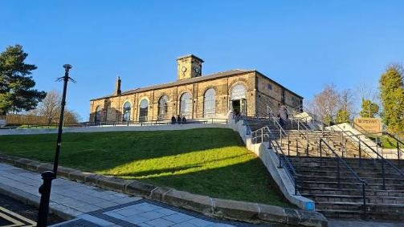
Our railway heritage is show-cased in the local
railway museum, Hopetown, on the site of the
first passenger ticket office in the world.

Bridleways and countryside are easily accessible,
as are the delights of the 91 acre South Park and
the length of our parish has “the Denes” – a series
of linked parks – which we actively support.
We attend their three annual family events and the North Lodge Park events.

Darlington has an Edwardian Hippodrome Theatre which attracts high profile names and the town centre offers a varied menu of cultural events including Darlington Community Carnival, where our youth participate in the parade and the church always holds a stall in the park following this.

Education standards are of a high standard from pre-school nursery (including several CofE supported schools) through to Sixth Form College or a Further Education College offering vocational routes
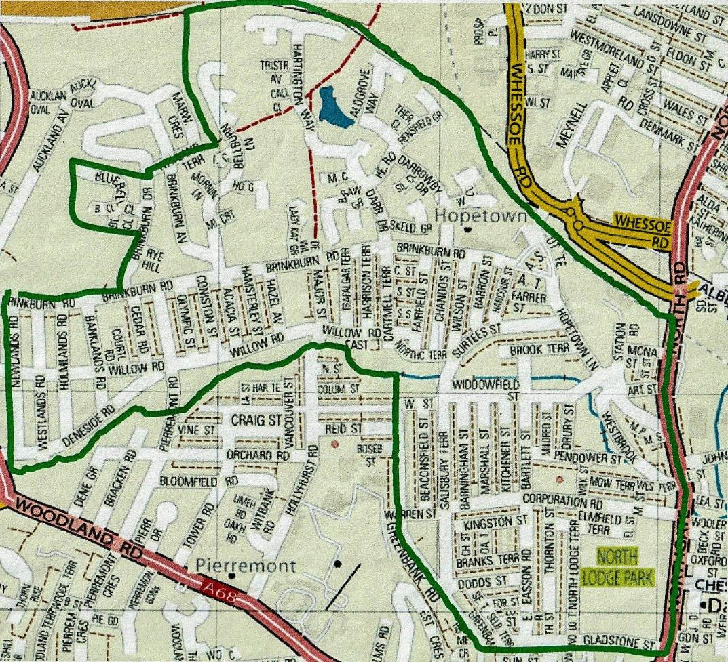
To the north of this eclectic vibrant town centre and spreading westwards is the Parish of St. Matthew and St. Luke’s, originally two separate parishes amalgamated in 1978. In the late nineteenth century the town’s population more than doubled. In 1868 a chapel was built on the site which later became St. Luke’s Church – later replaced and sadly closed in 1978. In 1908, as more and more housing was built to the north of the Cocker Beck, so emerged the Parish of St. Matthew and a mission church, which was destroyed by fire on Maundy Thursday night 1921. From the ashes of that fire the present church building emerged; it was consecrated on 21 September 1936 and has been lovingly cared for ever since.

The population of the Parish is 7,600 and it ranks 1037 out of 12,178 in the Index of Multiple Deprivations score, and is therefore among the most deprived 10% of areas in the country.
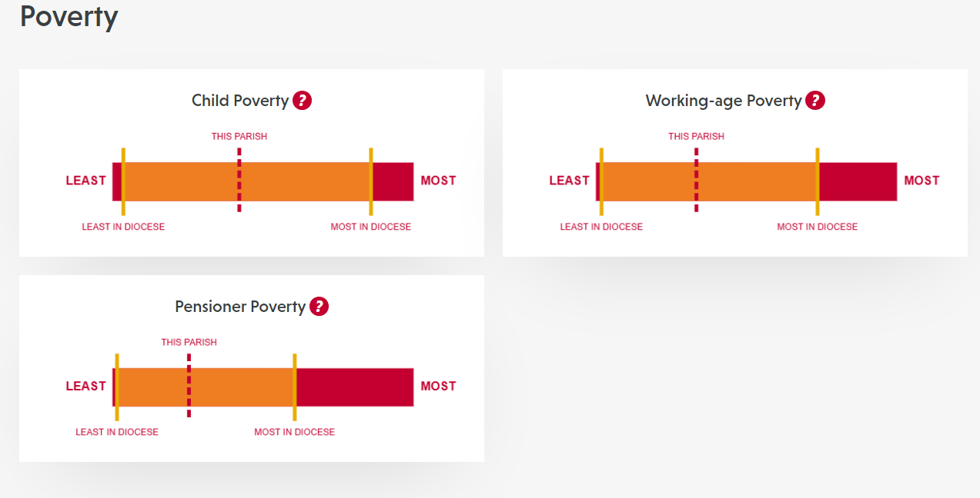
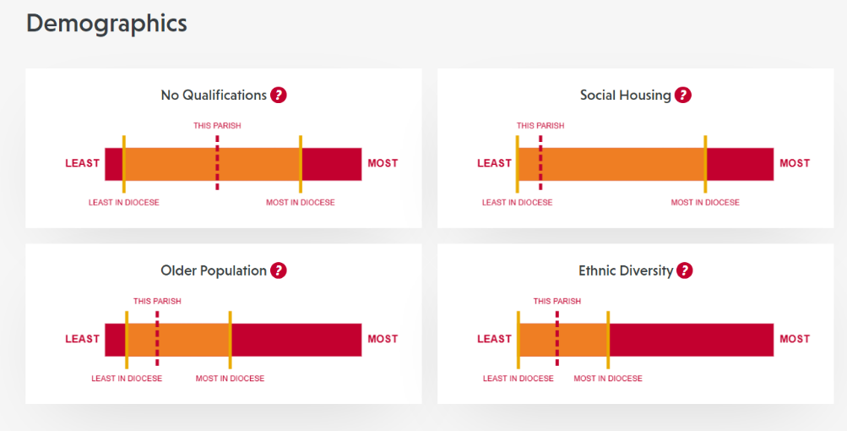

(Source: https://cuf.org.uk/parish/130238 )

The parish consists of approximately 5,000 residential properties. Housing is a mix of terraced, semi-detached and detached residences and the last twenty years has seen a huge growth in private development with Bellburn and Oakfield Lodge estates. They are in the main semi-detached and owner-occupied, although some are rented and the Vicarage is situated on the latter.

Corporation Road Nursery and Primary Schools lie within the Parish and it has a very informative web site (www.corporationroadschool.co.uk). The last Ofsted Report, September 2023 judged it to be a good school and the report can be read online.
Our previous Vicar and Curate delivered assemblies and we continue on a monthly basis to deliver bible stories using “Open the Book”.

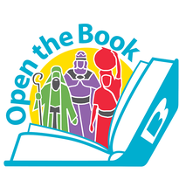


In Corporation Road there is a Baptist Church and also the Word of Life Christian Centre which is housed in the old St. Luke’s Church. We also have a Bangladeshi Community, mainly resident in the South end of the old St. Luke’s Parish, many of whom attend the local mosque in North Lodge Terrace for worship. Just outside of the Parish and next door to Reid Street School is Darlington Memorial Hospital in Hollyhurst Road. This is one of the major employers in the area, as is Railpen, a large railway pensions office, employing about 200 staff, in Brinkburn Road directly opposite the church.

There are two workingmen’s clubs within the Parish, together with several public houses, one being opposite the Church (The Brinkburn).

- OUR CHURCH BUILDING

The church was built in 1936 and stands on a corner site in a pleasant lawned garden with a sensory garden to the rear maintained by church volunteers. It is open access so anyone can enjoy. We also use this area for our annual summer fair and have occasionally held services outside.

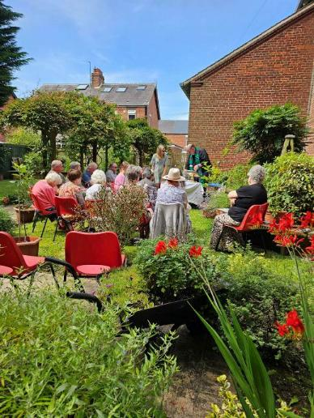
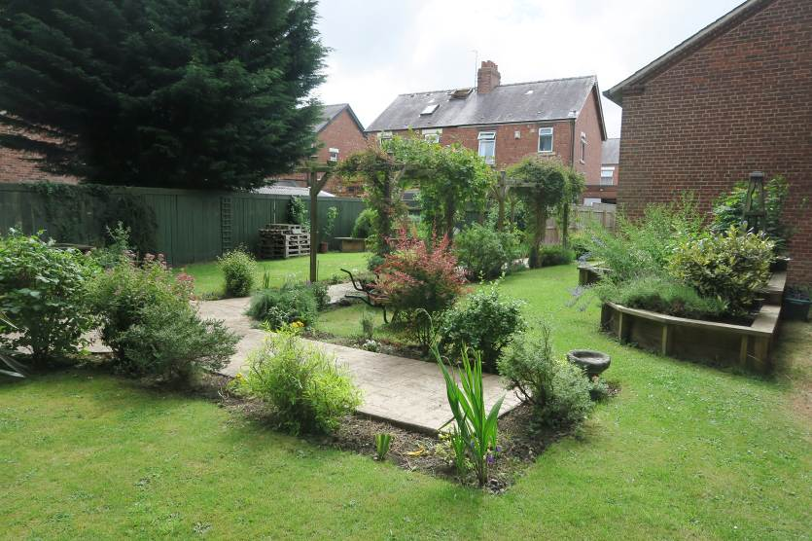

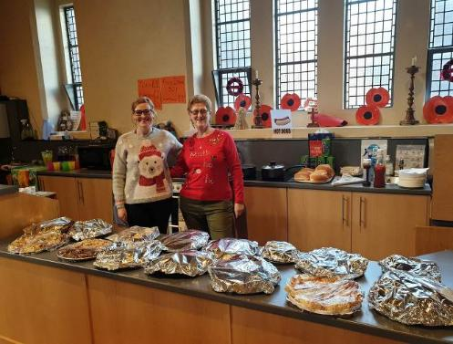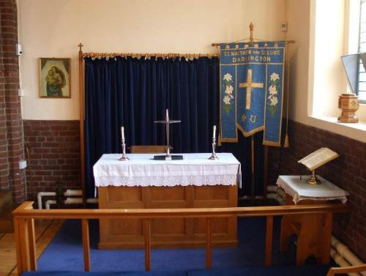
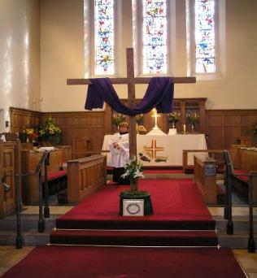
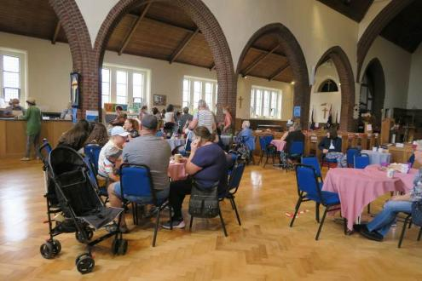

comfortable, informal stackable seating and tables making the rear of the church more usable for social events. Additionally, a kitchen/servery area was installed which ensures we can easily provide refreshments for events and after services and making the church
building more flexible.

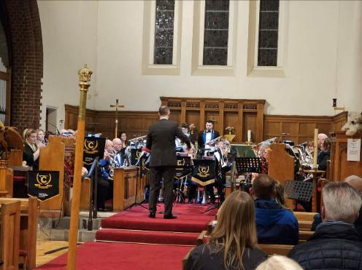
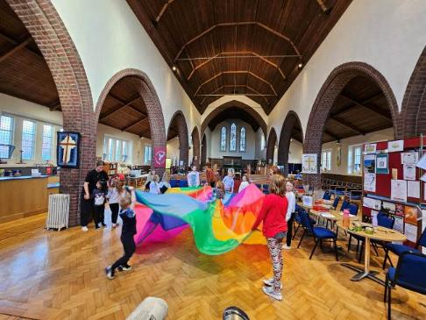

- CHURCH SERVICES

1st Sunday of the month | 11am | Holy Communion with Healing
2nd Sunday of the month | 8.15am | Holy Communion
 | 11am | Family Service with baptisms
3rd Sunday of the month | 11am | Holy Communion
4th Sunday of the month | 11am | Café Church Communion
Every Wednesday | 10am | Holy Communion (BCP)
Every Thursday | 7pm | Phone Church

Attendances at Sunday services average 25 in total. There are 70 members on the Electoral Roll. Pastoral visiting is undertaken by our two Lay Pastoral Ministers to those who are housebound or in hospital. Additionally, our Pastoral Care Team offer a buddy scheme.

We have a Shared Ministry Team and this seeks to find ways of encouraging evangelism and vocation from within the congregation and an opportunity for a more reflective approach to our spiritual growth. The team is nominated by members of the congregation and is elected by the PCC.

- THE WIDER CHURCH

Over the last seven years we have hosted over a two week period “The Christmas Journey”, where over 1000 children from Year 2 across the Deanery and their teachers experience the true meaning of Christmas. This has been very well received by the schools and has grown year on year.

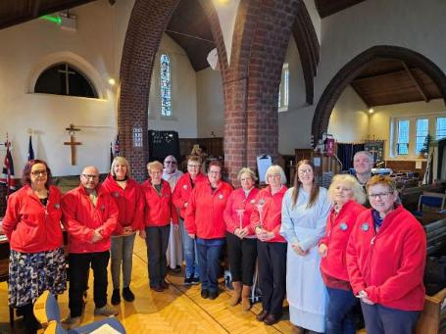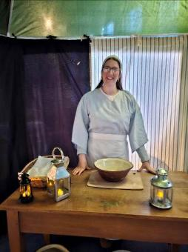

Over the last ten years we have run on average four free Children’s Clubs a year during school holidays either over a day or two mornings in church. These have been very popular and include bible stories, crafts, outdoor and indoor activities.

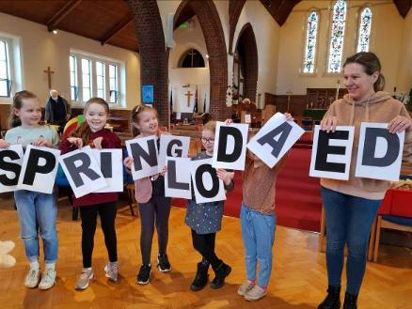
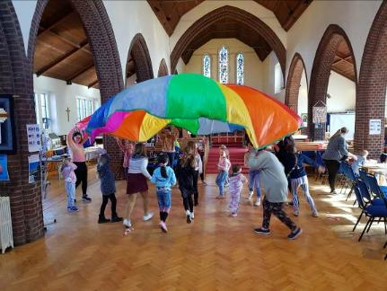
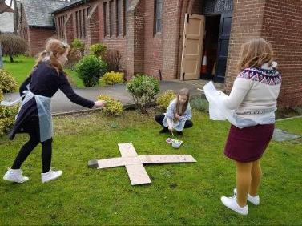
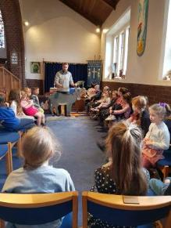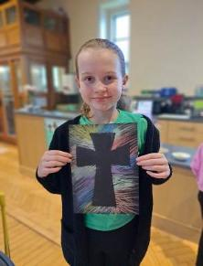
We support St. Mary’s Church Food Bank and drop donations on a monthly basis.
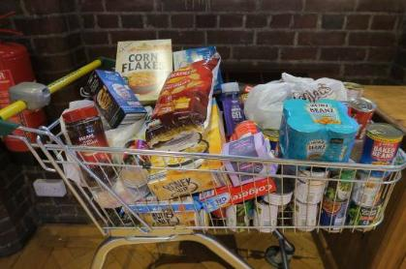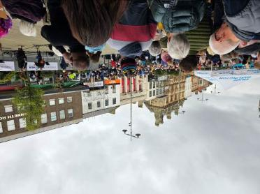
We are a weekly collection hub for the Credit Union.

We are a generous church and raise funds for the Children’s Society with money collection boxes and our annual Christingle Service. We supported Water Aid as an alternative to sending Christmas Cards to other parishioners, hold coffee mornings jointly to raise funds for our brickwork appeal and also raised monies for The Listening Post, St. Teresa’s Hospice and North Air Ambulance recently.

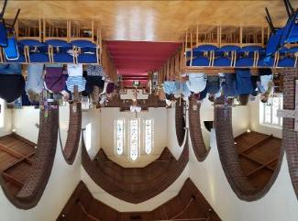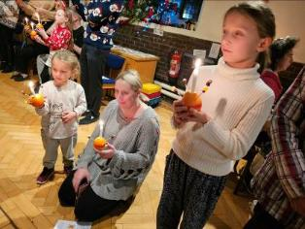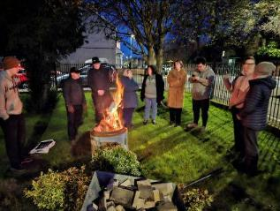
5. MINISTRY

- We work with three other churches of the Deanery in a locality forum called the 4Ms. We occasionally hold joint services and meetings are held quarterly.
- We also attend St. Michael’s Church, Heighington on a monthly basis for their Evening Praise service.
- Worship style is middle church and mixed/varied with lots of lay participation eg. prayers, readings and preaching.
- We participate in the annual town Peace Walk and town centre Good Friday witness
- We belong to Darlington Churches Together
- We have hosted Iftar celebrations in a local venue with our Muslim friends
- We supported the Darlington Secret Santa Appeal for many years, following on from many years participation in the National Shoebox Appeal.
- We hold an Annual Christmas Tree Festival where all the church groups decorate trees with a different theme, e.g. 12 Days of Christmas, Colours, Pantomimes, Hymns, etc.
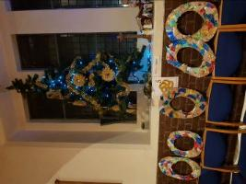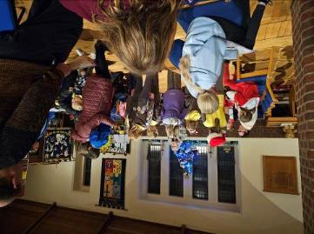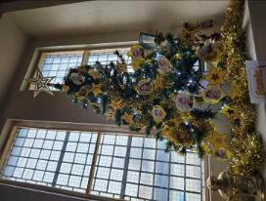

- TEACHING

Teaching for most of our congregation is given through sermons and we offer Bible Study, which is lay-led, on a fortnightly basis following our weekly coffee morning. Study groups also have been run including Alpha, Retreat in Daily Life, Christianity Explored, various Pilgrim Courses, Lent and Advent groups.

- FUNDRAISING AND SOCIAL ACTIVITY

Three main fundraising events are held each year (Spring, Summer and Christmas Fairs) and these provide fellowship opportunities and a way of bringing the community into our Church life. Other social and fundraising events have included: monthly raffle at the Brinkburn Pub, Murder Mystery, Cockerton Silver Band Concert, Community Choir Concerts, Family Quiz Nights and weekly Coffee Mornings.

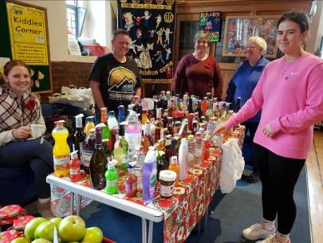
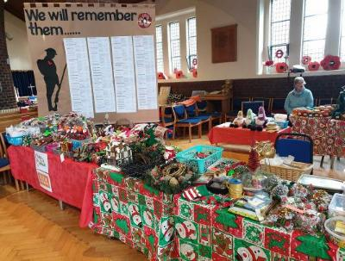

Additionally, we have a presence at Friends of the Dene Teddybear’s Picnic, Summer Fun Day and Christmas Fair. We also attend Lets Talk Fairs, North Lodge Park events, and Brinkburn Green Space events. Rainbows, Brownies and Guides participate in Darlington Community Carnival and the church has a ‘Stall in the Park’ (at Stanhope Park).
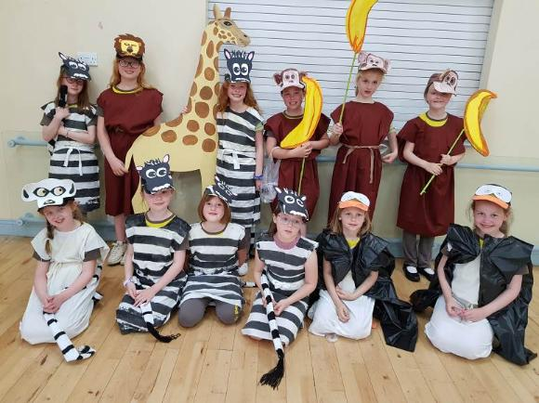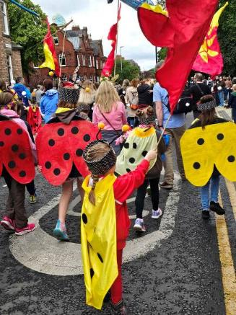

- THE VICARAGE

The vicarage is within walking distance of the Church and is about 30 years old. It is situated within Oakfield Lodge estate and comprises a ground floor entrance hall and cloakroom, study, lounge, dining room, breakfast room, kitchen and utility room. On the first floor there are 4 bedrooms, the main bedroom being en-suite. There is a detached garage and garden to the front and rear.

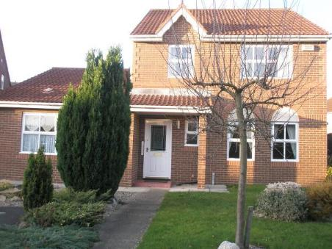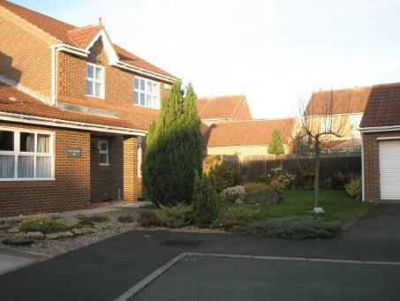

- ADMINISTRATION

There is a Church Office which is run on a volunteer basis, through which secretarial help is available for the incumbent.
The Parochial Church Council meets on a monthly basis. Committees of the PCC are currently:
- Finance Standing Committee
- Shared Ministry Development Team
- Communication Group
- Pastoral Care Team
- Safeguarding Team
- Fundraising and Social Group

- There is a Communications group who ensure events are promoted, provide a presence on Facebook, Instagram, TikTok and YouTube. They produce the Church Monthly Magazine and update via an email newsletter.

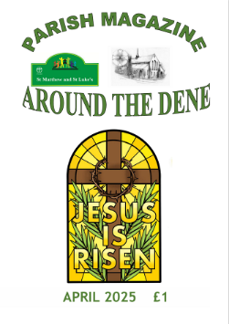

- FINANCE

We are blessed in having loyal and generous givers at St Matthew and St Luke’s. A majority of members use the Parish Giving Scheme for their planned giving; we also take cash collections at services, with online giving and a card reader also available.

The Treasurer presents a breakdown of monthly receipts and payments to each PCC meeting, together with a report listing issues of interest or concern. Questions and discussion are always encouraged, with the aim of fostering transparency and accountability. A reserves policy is in place and a draft budget is presented each autumn. The Treasurer regularly participates in training courses in order to stay up to date and ensure the finances are handled correctly.

We are currently part way through a £25 – 30K buildings maintenance project to repair the external brickwork. This is a large amount of money for a small congregation in our area to raise and PCC took the reluctant decision to pay less than our Guided Pledge in order to ensure we have a church building that is safe and secure for years to come. We do, however, pay in full what we have pledged, by monthly standing order. Our intention is to pay our full contribution in future yearsA copy of the latest accounts for 2024 is found below.

The main financial challenge we face is balancing the books, given the costs of high energy bills and the current brickwork repair project, against a fall in receipts from planned giving.

We hold a variety of fundraising events, as detailed above, to supplement our income. We also hold an annual Gift Day to which people respond generously.

Our church hosts the annual Christmas Journey event (again, described earlier). This costs around £3.5K each year and is funded by the Deanery and by appeals to churches across the town and to other charities. The principle is that it is free of charge to the schools and their students and we have always achieved this.

The vital role of the Willow Road Community Centre in our involvement with and provision for the community is described below. It is linked to the Church by means of the Church Hall Trust, a charity which has the incumbent and the PCC Secretary and Treasurer as its trustees.

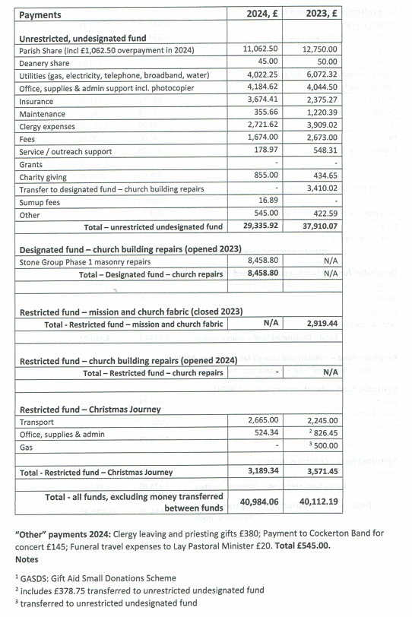

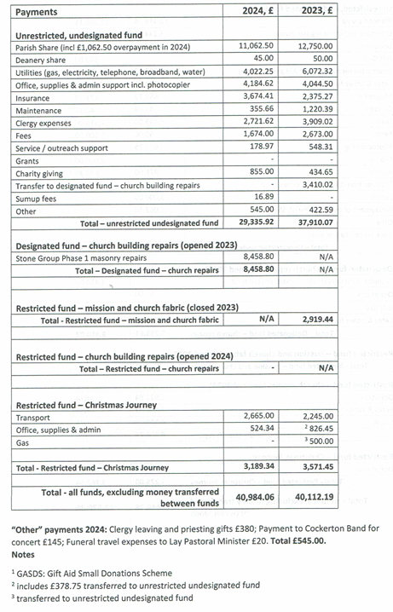
11. WILLOW ROAD COMMUNITY CENTRE
.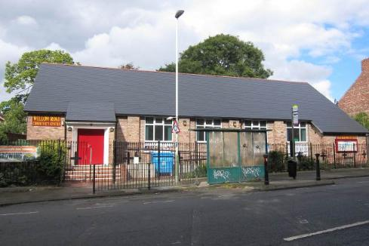
Registered Charity No. 1094571
11.

The Willow Road Community Centre (WRCC) was formed 25 years ago out of the then very run-down Church Halls. The centre is made up of two halls, one large and a smaller hall suitable for meetings. Since its inception, it has been highly maintained and is a vibrant centre for community outreach. It has a wide range of activities, including the following groups some weekly others monthly and is used 7 days a week, 8.30am – 10pm.
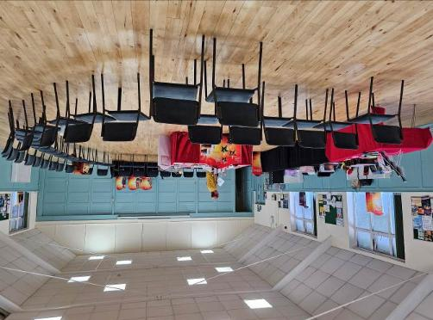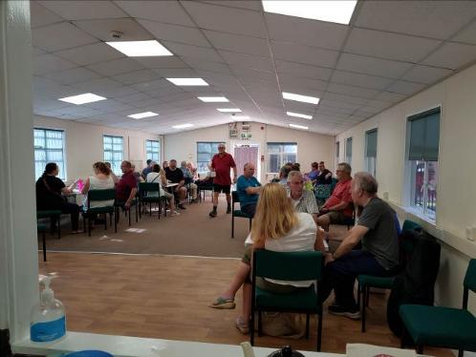

Large Hall: Rainbows and Brownies, Taekwondo, Yoga, Judo, Karate, Slimming World, Trefoil Guild, South Durham U3A, Link, Pimm’s and Needles, Darlington WI, Darlington Amateur Gardening Club, Church Parent and Toddlers, Peak Dog Training, Low Impact Fitness Training, Age UK Weekly Lunch Club, Friends of the Denes, Darlington Sugar Craft Guild and Saturday and Sundays it is used extensively for children’s birthday parties. The larger hall has been used for fundraising events, concerts, quiz nights, murder mysteries, pre-weddings and wedding receptions.
Small Hall: Is currently used by Alcoholics Anonymous (every evening), Recovery Connections (5 days a week), Indian Drumming Group, Ukelele Band, Let’s Talk (Mental Health) Group, Guides and Church Knit and Natter Group. The WRCC is run by a group of church volunteers who undertake all the bookings, cleaning and maintenance, but is wholly owned by the Church but run as a separate charity.

- CHALLENGES

- There is still much work to do in building links with the local community and giving the Church a higher profile.

- The Church is welcoming and friendly with a nucleus of committed people, but this needs to grow as we are currently reliant on the same small number of people to co-ordinate and run services/events/fundraising.

- We lack young people.

- We want to be able to do what we are doing better and do more of it and not be restricted by finances or a lack of volunteers.

- A NEW INCUMBENT

We would like our new incumbent to:

- exercise effective, strong and loving leadership.

- be a good communicator with a sense of humour.

- be forward-thinking and visionary, with teaching skills to encourage spiritual growth and discipleship.

- encourage and work with us.

- support lay people.

- be a training incumbent (so that it would be possible for the Bishop to place a trainee curate here).

- be flexible and be happy for us “to play all the right notes, but sometimes not necessarily in the right order”.

- be open to change

The people of this parish have always shown love and support for their clergy!

