St. Thomas’ Church
Eighton Banks
Gateshead
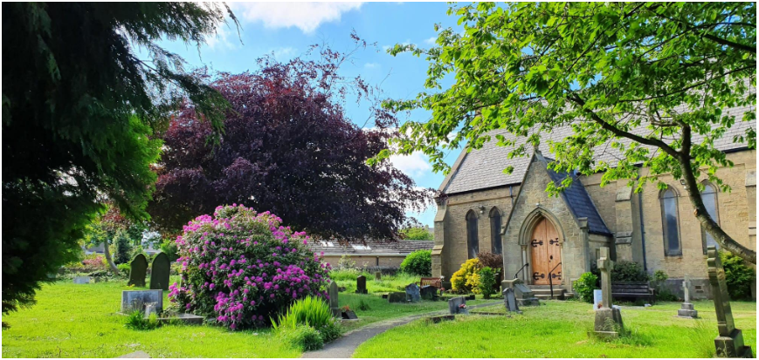

Parish Profile
2026

Contents
Our Diocesan Vision - An Introduction from Bishop Sarah 3
Welcome from St. Thomas’ Church PCC 4
The Parish and Local Context 5
Our Church Building and Grounds 7
Worship 13
Community Links and Outreach 16
Fundraising 19
Finances 20
Our Main Hopes for the Future 20
Our Ideal Priest 21
Housing 21

Our Diocesan Vision - An Introduction from Bishop Sarah
This is an exciting time to be exploring joining the Diocesan family in Durham Diocese. We are on the cusp of a fresh chapter in our mission and ministry together. We are currently discerning with the National Church who will be the next Bishop of Durham, called to lead as we seek to make real our vision for the transformation we so desire across our Diocese. We are deeply encouraged by the award this year of significant national funding, demonstrating real confidence in our vision.
Our strategy for transformation and m issional growth (‘Called to Fruitfulness’) is an opportunity and invitation for each of our parishes to step out in faith together, responding practically to our priorities to Challenge Poverty, Energise Growth, Care for God’s Creation and Engage with Children, Youth and Young Adults. Making this a reality it will look different in every community. In some places it will come about in collaboration with others. Nobody is expected to do everything immediately or alone, but we are all invited and expected to find ways to respond relevantly.
Making this a reality it will look different in every community. In some places it will come about in collaboration with others. Nobody is expected to do everything immediately or alone, but we are all invited and expected to find ways to respond relevantly.
In praying for a new Priest-in-Charge for St Thomas’ we are looking for someone excited by and wanting to be part of this vision and new future. Together we pray hopefully:
Loving God, guiding the people of Durham Diocese faithfully through the years:
We thank you for saints who have marked our path, young and old, known and unknown, from all places and in all walks of life. Help us to find your way in our generation:
transformed by your truth, sharing your life, blessing our communities.
Through Jesus Christ our Lord,
Amen
We look forward to meeting together and sharing in this with you.
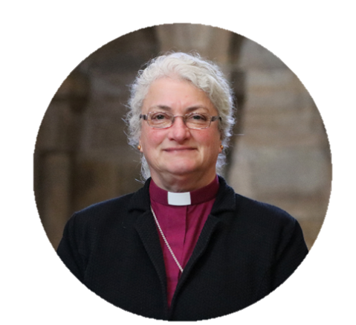

In Christ,
+Sarah
Bishop of Jarrow
Acting Bishop of Durham

Welcome from St. Thomas’ Church PCC
Building on God’s Actions and Blessings in our church and community
(Our Mission Statement}
The PCC of St Thomas Church Eighton Banks Gateshead would like to offer you a warm welcome. We hope that you enjoy reading this profile of our beautiful church and its journey as a place of worship in this parish. We have been told many times that we have a lot of potential and we hope that this comes through in our profile and that it will inspire you to want to become our next incumbent.
We work within the current four main initiatives of Durham Diocese 2020-2026
‘Blessing our communities in Jesus’ name’
Energising growth, Engaging children youth and young adults, Challenging poverty and Caring for God’s Creation. You will see how these four initiatives thread through our work in the profile.
Safeguarding is given the highest priority and in our commitment to safeguarding the PCC has ‘due regard’ to the House of Bishop’s Guidance on Safeguarding and Promoting a Safer church.
We look forward to you working alongside our PCC who work very well together as a committed team and joining us on our continuing journey as we move forward in Christ.
The PCC has a full complement of members which includes two churchwardens, a treasurer, a secretary, an electoral roll officer and a safeguarding team. Every member of the PCC is fully trained in safeguarding at the appropriate level on a three year rolling programme.
Other important roles undertaken in the church:
We have a lay Reader who has also taken services during the vacancy, and a Lay Pastoral Minister who also leads intercessions during the Sunday Eucharist usually on a monthly basis. Both the Lay Reader and Lay Pastoral Minister have the Bishop’s Licence to administer Communion by Extension. We have a funeral verger who also cleans the brasses and a wedding verger. We also have a full rota of sides persons, a full rota of readers, several people trained to administer the chalice, a full rota of offertory counters and a gift aid administrator, a fully trained pipe organist, a floral arranger, a rota coordinator, and a Facebook administrator. We also have two deanery synod representatives. Other members of the congregation willingly volunteer to help throughout the year.

The Parish and Local Context
The village of Eighton Banks grew with the development of local industries during the 19th century where there were several local coal mines and quarries. The quarries produced sandstone of the highest quality. The world famous Bowes railway 1826 – designed by George Stephenson and the first inclined plane railway in the World, which took coal from local collieries to the River Tyne passed through the village and employed local men. Part of the preserved section of railway passes through the parish and still has open days today. The Bowes Railway was accredited with Museum status in 2017
The increased population in the 19th century resulted in the creation of Saint Thomas’ parish which was formed from part of Lamesley parish. The parish included the village of Eighton Banks which was then in County Durham and Wrekenton which was in the borough of Gateshead. Eighton Banks has always had a village feel whereas Wrekenton has links with the town.
There was great change to the parish in the 1950s when one of the post war housing estates was built in Wrekenton. This is known as Springwell Estate and has a high proportion of those living in poverty. Unemployment, drug abuse and low qualification attainment are of a significant level although this has improved over the years.
The parish has an IMD ranking of 365 out of 12178 (with 1 being the most deprived and 12178 the least), and an IMD score of 44.2, making it among the most deprived parishes in the country. However, even this ranking is slightly skewed by the contrast in deprivation between Wrekenton and Eighton Banks. In terms of deprivation, the village of Eighton Banks is around average in comparison to other Lower Layer Super Output Areas (LSOAs) whereas the Springwell Estate in Wrekenton contains one of the most deprived LSOAs in the country (413 out of 32844). The church was built in the 1850s to serve the village of Eighton Banks and until the slum clearances in Gateshead, and subsequent development in the mid-20th Century, Wrekenton was a small adjacent village. This results in a parish of two very distinct population centres. This picture is further complicated by the Springwell Estate having the feel of its own community separate from the rest of Wrekenton.

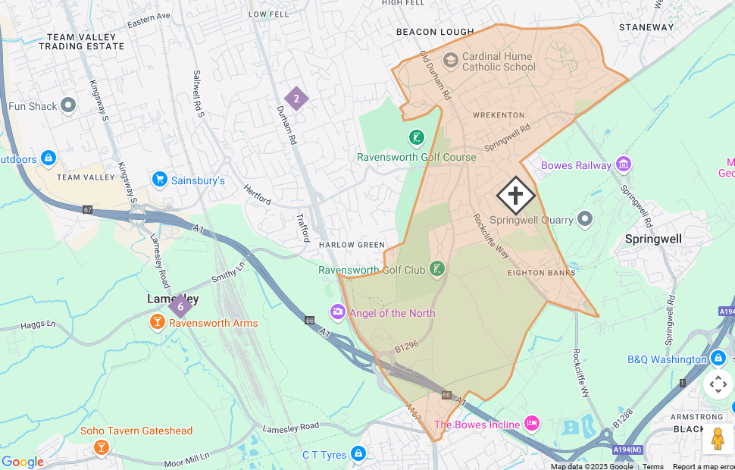

St.Thomas’ is a diverse parish with little public transport in Eighton Banks although there is a good transport service from Wrekenton. There are no shops in Eighton Banks although there is a wealth of shops and amenities in Wrekenton and the surrounding area.
St. Thomas’ Church is situated in a beautifully peaceful and tranquil setting on the edge of the rural part of the parish. Like the church many of the nearby houses are built with high grade sandstone from the local quarry. There is a housing estate behind the church built in the early 70s. The parish is one of the few in Gateshead that has a combination of rural and urban areas. It has a range of top end housing right through to local authority and housing association dwellings.
Although St. Thomas’ Church is situated in a quiet semi-rural setting the following list shows some of the excellent amenities for all age groups within an average ten-mile radius of the church.
Shops The following shops can be found in Wrekenton: A Post Office, three large supermarkets, Aldi, Lidl and Farm Foods along with a smaller SPAR supermarket and another convenience store. There is a furniture and white goods shop and a newly refurbished St Vincent’s de Paul’s Charity shop.
Services There is a dentist and an optician, two hair salons and a barber’s shop, a health Centre and two chemists. There is a funeral directors and chapel of rest. The Queen Elizabeth Hospital, Saltwell Crematorium and Birtley Crematorium are all within two miles. There is an Auto Care repair garage and a car accessory shop. There is a recycling plant serving Gateshead and Sunderland. There are two old peoples’ care homes and sheltered accommodation. There is also Bryson’s Animal Welfare Sanctuary and a dog grooming parlour.
Hospitality There are several fast-food outlets, three pubs and a Working Men’s club. There is a clubhouse and separate, bar and restaurant at the golf club, several country pubs two which have accommodation. There is also a Greggs and a café.
Churches As well as St. Thomas’ C.E. Church there are two other churches - Wrekenton Methodist Community Church and St. Oswald’s R.C. Church.
Transport There is a well serviced bus interchange at Wrekenton with buses to Gateshead, Newcastle, Sunderland, Chester-le-Street and Peterlee, along with a free bus to Sainsbury’s supermarket at Team Valley and School buses. Buses travelling North feed directly to the main Gateshead bus and Metro Interchange three miles away. The Metro links to North Tyneside and the popular coastal resorts North and South of the Tyne. The Metro also leads directly into Newcastle Central Station one stop away with National Rail links via the LNER East Coast Railway, and the Cross country line along with several local lines. The metro also goes directly into Newcastle International Airport twelve miles away. The parish is served with good roads leading to Team Valley Industrial Estate and Retail World Shopping Centre, The Washington Galleries shops and the Metro Centre. Taxis are readily available.
Schools There are three schools Fell Dyke Community Primary School, St. Oswald’s R C Primary School and Cardinal Hume R.C. High School along with a private Nursery.
Sporting venues and Leisure There are Community football pitches on two separate sites and a golf club within the parish. Gateshead International Stadium, Gateshead Leisure Centre and swimming pool are both within two miles. There is a Women’s Institute and a Townswomen’s Guild, two community centres each offering many activities and a community hub which also houses the local library.
Famous Landmarks The Angel of the North, Penshaw Monument, The Tyne Bridge and Durham Cathedral World Heritage Site which is ten miles away.

Our Church Building and Grounds
St. Thomas’ Church, built in 1853 is universally regarded as beautiful both inside and out. It has been described as ‘A simple building of quiet dignity built with local sandstone and a Welsh Slate roof.’ The church has many spectacular stained glass windows including some by William Wailes. The village war memorial is situated in the churchyard.
War Memorials The church has two war memorial plaques inside the church and the village cenotaph is in the church grounds.

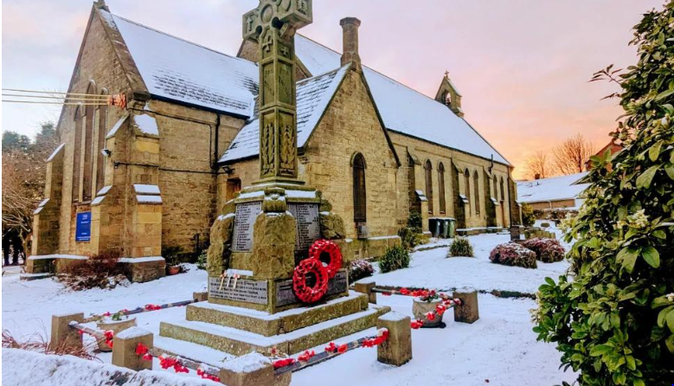
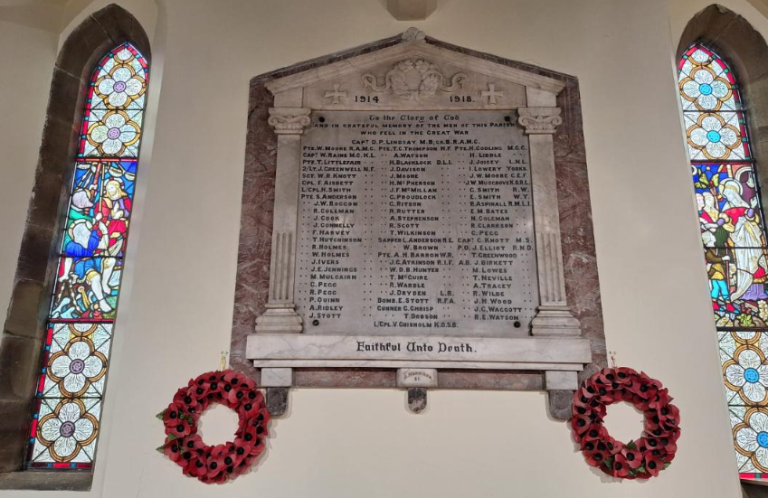

The Eighton Banks War memorial was listed as Grade 2 in 2019. In June 1920 the War memorial committee decided to replace the wooden cross within the church with a memorial in the churchyard. The memorial is a Celtic wheel cross on a plinth, with a wreath on each side and holding granite tablets with names, with a three stepped base. The memorial stands on a plot edged by low iron railings. It was erected to commemorate 77 fallen local soldiers from the First World War. The words ‘Pro Patria’ (for one’s country) were inscribed on it. The names of the fallen from the first world war are recorded on the four sides of the monument. The names of the fallen from the second world war were later recorded on the base of the west elevation. Recently the name of a soldier fallen in the Afghanistan War has been added. The War memorial is situated in a prominent position facing out over the boundary wall of the churchyard.
There is a plaque at the main gate referencing that there are also Commonwealth War Graves in the churchyard. We have 6 Commonwealth War graves.
Annual Service of Remembrance. This outdoor service takes places on Remembrance Sunday at the war memorial. Members of the church and local community attend along with parish councillors and anyone who wants to lay a wreath. During the vacancy this service has been taken by members of the church.
Internally - Over the years there have been a number of modifications aimed at maintaining simplicity and harmony.
The church is very well maintained and is kept in an excellent state of repair. The nave has wooden pews on each side. The Church was fully decorated and re carpeted in 2019 to include the central aisle. There is a small well-resourced children’s area at the back of the church. There is an open area at the front of the nave giving some flexibility in use, especially for various functions such as the spring, summer and Christmas fairs, concerts and coffee mornings.
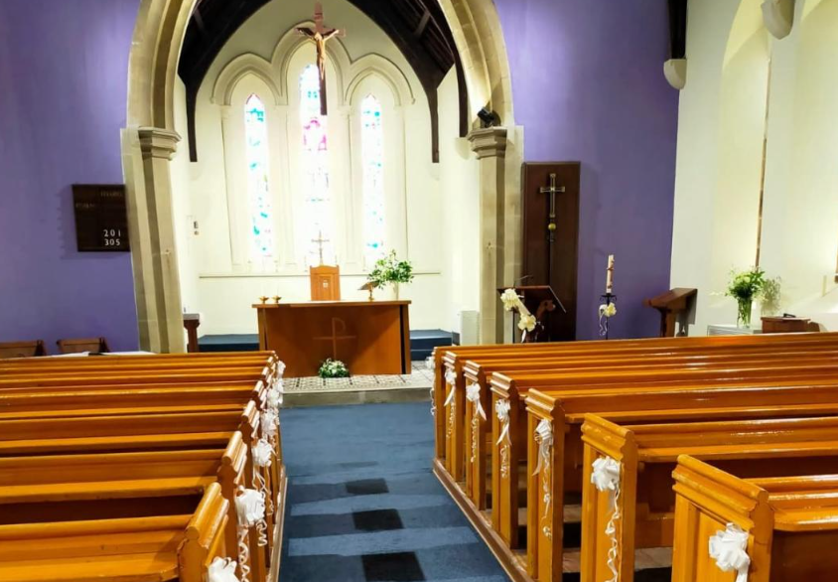

The church has eco-friendly upgraded lighting. The PCC partially started the Bronze eco award with the previous incumbent and it is our ambition to achieve this in the near future. We also have a sound system and loop system and multimedia equipment. It is also our ambition to develop our understanding of the use of this equipment with the aim of projecting the words of hymns in large lettering on the wall.

The chancel has a striking floor with original tiles.
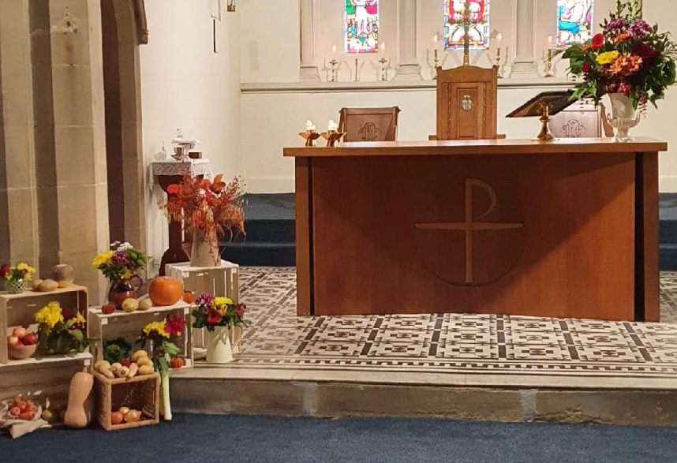

The windows of the church have beautiful stained glass. These are spectacular when the Sun shines through them and also at night when the lights of the church are on.
There is a beautiful stone font at the rear of the nave.
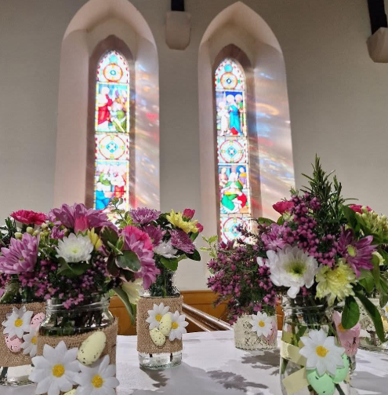
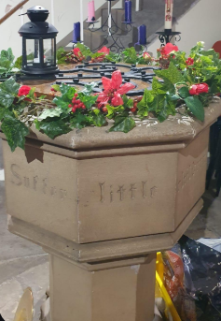
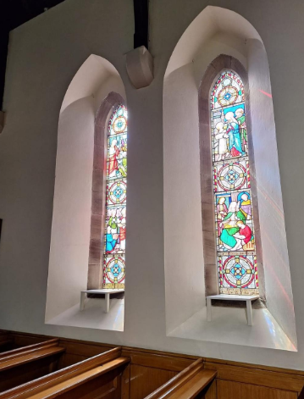

Stone steps lead up to a gallery where the magnificent, piped organ is situated.
The carpeted children’s area at the back of the church can also be adapted for a variety of uses including coffee mornings and fairs.
There is also a room at the back of the church used as a back vestry and an office. This area also has storage for vestments and other church linen. It is fully carpeted with comfortable armchairs. There is also a useful small kitchen area. There is a porch off this room with a toilet and storage area. The external door leading off this room is used for disabled access and there is a portable ramp which can be used for wheelchair access.
The church has full gas central heating which allows us to always ensure that the church is kept warm especially during very cold weather. The heating is serviced annually. We get many comments on how warm and comfortable our church is.
Quinquennial Report
We had our last Quinquennial, inspection in Jan 2023 and to date the PCC has fulfilled the main priorities including roof repairs and checking the electrical system. Both the roof and the electrical system have ten year guarantees although the PCC will arrange for the inspection of the electrical system every five years.
Church Bell We have a church bell which worked well for many years and was enjoyed by the whole community. It needed a repair in 2011 and an electrical ringing device was installed at that stage rather than using the original bell rope. The bell then continued to work for a number of years. The local council gave the church a grant when another repair of the bell was needed but in spite of this the bell is still not working. Members of the local community often comment on how much they miss hearing the bell which has always been a prominent feature of the local community. Another of our ambitions is to explore ways to re-instate the working of the church bell.
The churchyard is now closed for burials but if there is a family grave, interments of ashes may be made. The maintenance of the churchyard now comes under Gateshead council’s responsibilities. However, there is an area in front of the church and a small area at the rear which is lovingly maintained by church members. This area is planted and the grass is mown and passersby often comment on how beautiful it looks. There are also 3 wooden benches near the main door which are dedicated to local people with links to the church. There is also a special rose bed with two roses dedicated to the life and reign of HM Queen Elizabeth II and one to commemorate the Coronation of HM King Charles III. The churchyard is well used by many people, including volunteer dog walkers from Bryson’s Animal Refuge situated opposite the church which is housed in the old school building. There are always bowls of water available for the dogs. Many people maintain family graves with year-round flowers which further adds to the attractiveness of the churchyard. We also planted a cherry tree as part of H.M. Queen Elizabeth II Platinum Jubilee Celebrations.

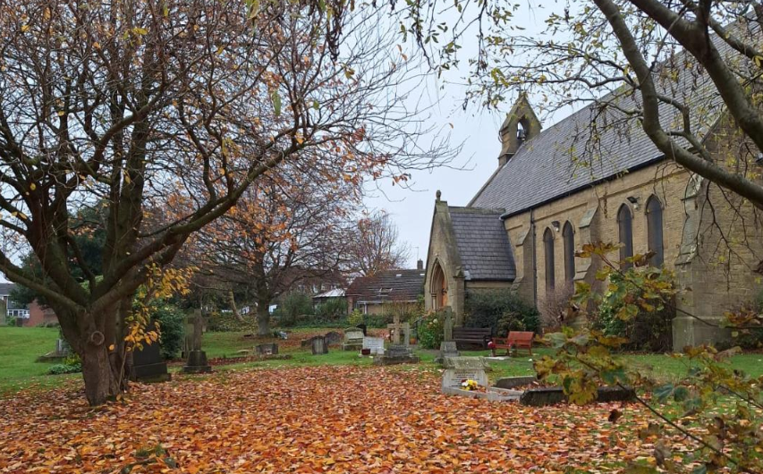
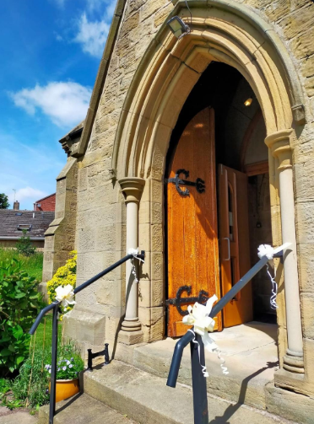
Despite its age the building is not listed.

Two members of the local community have given tremendous support to the church, giving up a huge amount of their personal time. One man has repaired and restored the large heavy metal double gates at the south perimeter of the church and painted them. He has also repaired the main double gates which were damaged by heavy council grass cutting machinery. He also tends several graves, cuts areas of the grass and strims areas inaccessible by council machinery. We are very grateful for his valued support. Another parishioner has erected bird boxes in the church grounds which we also very much appreciate. Other members of the congregation also give valued help in the churchyard including looking after the flowerbeds and plant containers.
By successfully applying to Gateshead Exchange, we were linked with SUEZ at the local recycling plant. Through their outreach service we benefitted from several months of work in our churchyard. Several men cleared some overgrown bushes and helped with tidying our pathways. This was all heavy work too difficult for our congregation to manage. We are very grateful for this support.
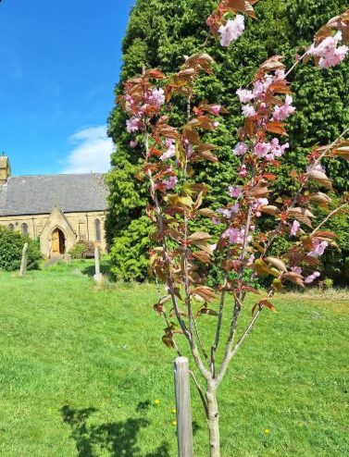
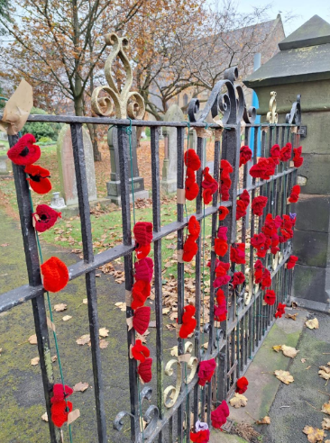

Worship
Our style of worship is middle to high catholic with Common Worship used for all of our services, especially Eucharistic ones. Communion is central to the worshipping community along with a deep sense of prayer.
The main service is the Sunday 9.30 a.m. Sung Eucharist using the setting Mass of the Bread of Life (other settings have been used in the past). Our incumbents have always worn vestments for this service. The hymns tend to be traditional Ancient and Modern, but these are often interspersed with more modern songs (although not, as yet, the latest ‘hits’).
Every Wednesday there is a much more informal Said Eucharist at 11.00 a.m. This is held in the back vestry rather than the body of the church. During winter months especially, it is a warm and cosy space just right for the faithful core of regular attendees.
Visitors to either of these weekly services are warmly welcome, something which is regularly commented upon by those who visit.
Baptism services are held on the 3rd Sunday of each month at 11:30 a.m. although times can be varied. These services are for individual families. We do under certain circumstances conduct baptism services at other times if the standard time is not appropriate. Last year there were 11 baptisms throughout the year. Some years we have a lot more and some we have less. Parents attend baptism preparation prior to the service and godparents are encouraged to attend also. The Lay Pastoral Minister (LPM) offers this preparation and also assists at baptism services. Baptisms are also available during the 9.30am Eucharist Service.
Weddings are conducted as requested and again the couples are encouraged to come to church to make arrangements and also to hear the reading of the Banns. They are supported by the wedding verger. We are open to the marriage of divorcees following the standard procedure of the Church of England and after written intention being made to the Bishop. Married couples make full use of the beautiful church grounds for their wedding photographs.
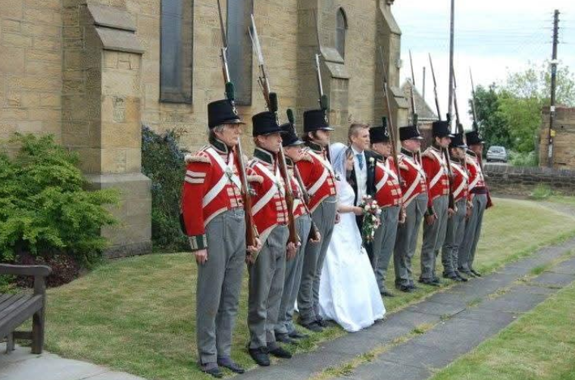
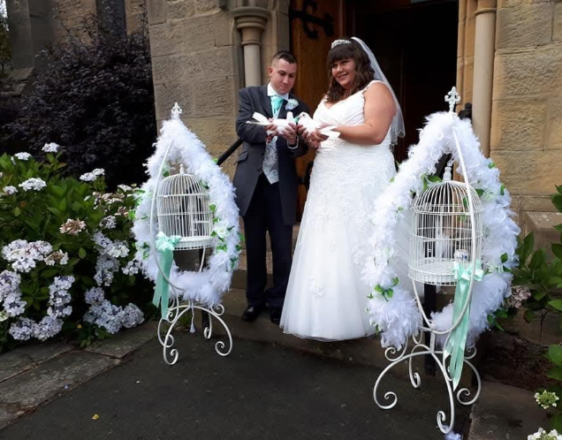

Funerals are held throughout the year when requested. The funeral verger prepares the church for the presiding clergy and assists as necessary during the service.
Other Services
There are also annual services at Christmas, Ash Wednesday, Holy Week and Easter and All Souls to which families of the recently bereaved are invited. One attendee recently commented: ‘Thank you all for the lovely All Souls’ Service, you always make everyone feel very welcome’ There is also an annual animal service held on the Saturday closest to Saint Francis’ Day. This is always well supported by Bryson's animal refuge. There is also a service of Remembrance. After the Carol Service, at which there is always mulled wine and a mince pie, our annual Christmas Draw takes place. Another attendee commented: ‘This is always a fantastic service with a lovely atmosphere.’
During the vacancy the PCC, in the absence of any available clergy, has organised Good Friday services, All Souls’ Services and Sunday morning Services using Morning Prayer. Sunday morning services and midweek services without clergy are led by the church Lay Reader and the Lay Pastoral Minister.
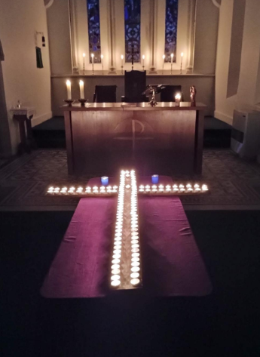
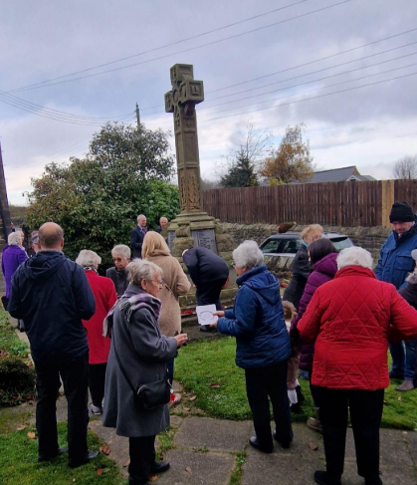
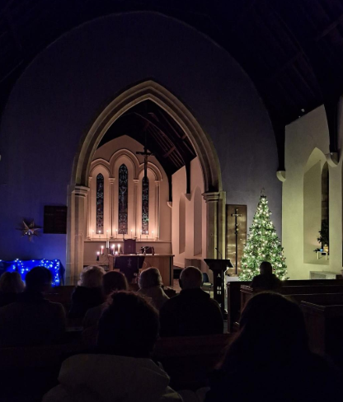

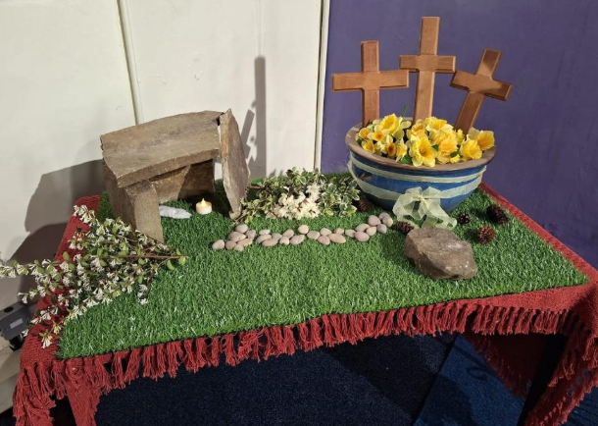
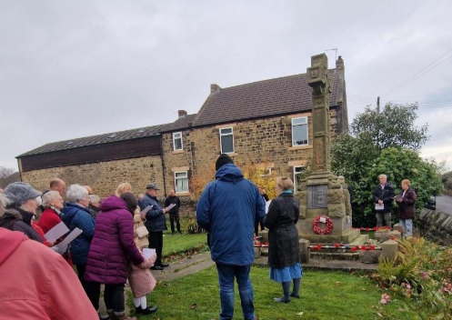

In the past we have had lay led Advent and Lent courses. We have also had Bible studies jointly led by the incumbent and lay people. We hope to restart these again. Our congregation is made up of a wide age range of committed church members including children. Most congregation members live within the parish, but several come from outside the parish.
Pastoral visiting Our local pastoral minister (LPM) and Reader regularly visit the housebound and infirm in the parish and the LPM gives home communion to regular members who are no longer able to come to church and those who are temporarily unable to attend.
Church Organ Our singing is accompanied by our very talented organist on our magnificent, piped organ housed in the gallery. The organist also has a rich baritone voice much admired by everyone. This sounds beautiful especially when our young children members join in with their crystal-clear voices. The organist, now a grandfather, has attended church since childhood and learned to play the organ with lessons from a previous organist and choirmaster. The organist often plays requests at church fairs. Currently the organ whilst still useable needs some repairs to one of the pedals and pipework. We regard the organ as one of our main assets. We are working hard to raise enough money to ensure the long-term maintenance of this very special piece of equipment.
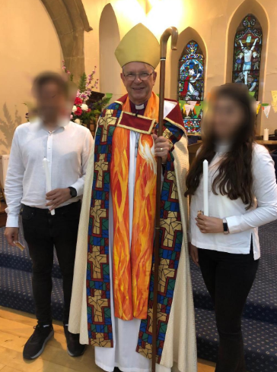
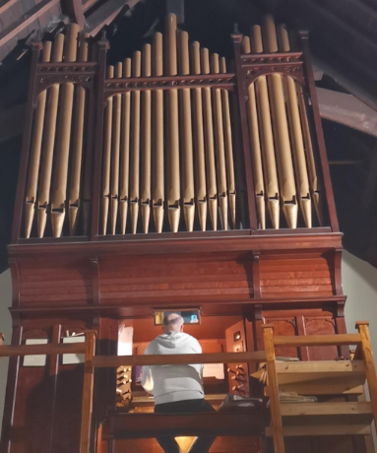

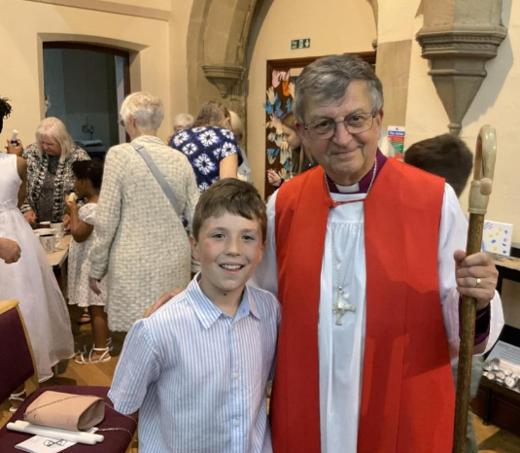

Confirmations Over the last four years four members of the church have been confirmed. Two asylum seekers who attended church for over two years were baptised in church and then confirmed by Bishop Paul at St. Alban’s Church Windy Nook. In 2024, one of our children was confirmed by Bishop Frank White also at St. Alban’s Church and in 2025, a relatively new member of the congregation was confirmed at the Church of The Holy Spirit Crawcrook by Bishop Frank White.

Community Links and Outreach
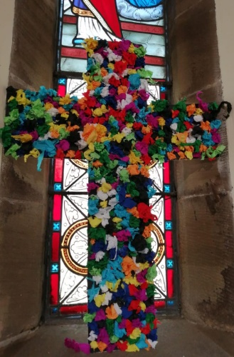
In the past we had links with Fell Dyke Community Primary School. It is our hope that links can be resumed again. The links were unavoidably stopped as a result of Covid and later a change of personnel. In the past the school children used to come to church to experience Christmas and to take part in Easter activities. The children have also been in church to learn about the Christian faith with mock baptisms and marriages. We have also performed whole school Christingle services in school. There were also times when the incumbent visited individual classes in school and taught the children about Christian beliefs and Saints. We are soon to have a visit from the scouting group of one of the children who attends St. Thomas’ in order for the group to achieve their World Faith badge. We hope to do more in the future with other youth groups. It is our hope to reconnect with St. Thomas’ Brownies and Rainbow groups in the near future.
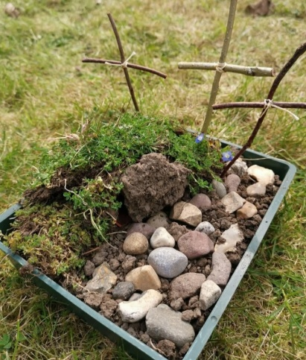
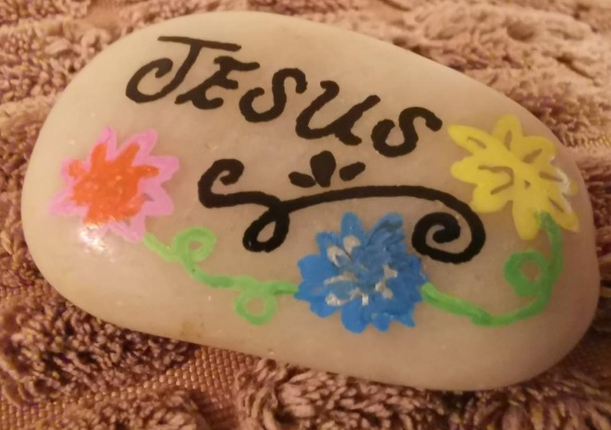

Part of the parish is an area with a high amount of social housing with many single parents and high unemployment, and some people are prime targets for loan sharks. To help families to save and borrow in a more sustainable way we helped to establish a credit union savings collection and loan repayment point in conjunction with NE 1st credit union and Fell Dyke school. Church volunteers met in school fortnightly in term time to collect savings with parents at coffee mornings. This was initially established and managed by members of the church congregation, along with the school community teacher. Parents were encouraged to be involved in the hope that moving forward they could sustain it themselves and allow us to step back and look to other
areas of need. Church members took deposits to the post office until parents eventually were able to pay in their deposits online.
Partnership for Missional Church (PMC)
The church completed a three-year cohort of partnership in missional church (PMC) run by the Diocese in partnership with Christian Missions. It is hoped that this experience will direct our thinking in looking to see the needs of the parish and continue looking for new ways in which to connect more with the local community.
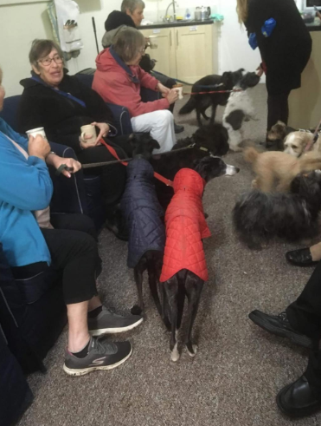
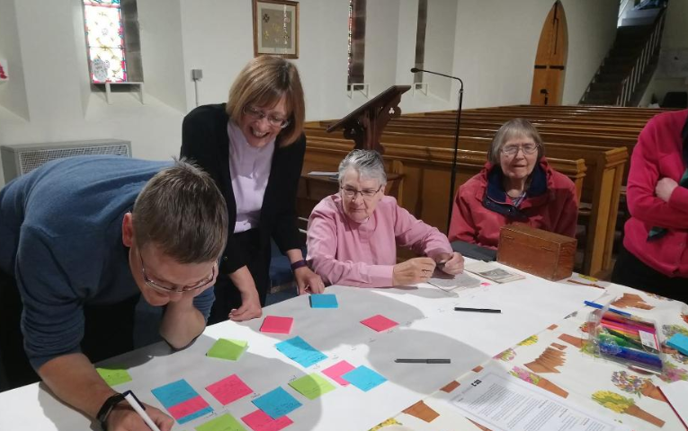

The congregation are involved in many aspects of the community and know the immediate area well. Church members support other churches and community organisations. Several members attend ‘Two soups’ at Wrekenton Methodist Community Church. Several members support work in Eighton Banks Community Centre and the Mount community centre as well as supporting fundraising at Bryson’s animal refuge. Another member volunteers at church fairs at another church and a friend from that church helps out at our fairs. It has proved difficult to reach some areas of the parish and build up a relationship, this is partly caused by the Springwell road which runs through the middle of the parish and also because the church is situated on a road where there is little public transport.
The church is very keen to restart a Sunday School. One member of the PCC is taking the lead on this and has established links and has held meetings with an enabler in the Diocese with a view to starting in the very near future once all of the necessary training and resources are in place.
Facebook page An important feature of our communication with the community is through our well-established Facebook page. This has links to the Wrekenton Resident’s page and the Mount community hub. A member of the PCC keeps the Facebook page updated with interesting stories from the church and upcoming events and also many photographs some of which appear in the body of this profile and in our gallery at the end. Members of the public often respond with kind messages. Some examples are “It was lovely to share time again,” “I had a lovely day and made some new friends,” and “Wow what a show of beautiful flowers!”
Charitable work
The church has collected for the Gateshead food bank for many years. Members of the congregation donate items, especially those requested by the foodbank. Two members of the PCC take storage boxes full of food regularly to the foodbank. Contributions at our annual Harvest Festival are also taken to the Foodbank.
The church has supported Operation Christmas Child – Samaritan’s Purse for many years and is a local ‘drop off’/ collection point for gift filled boxes.
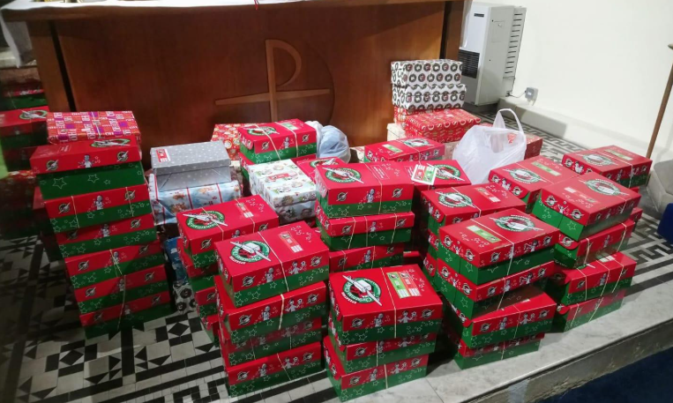

The church also collects for the Children Society and Christian Aid and The Leprosy Mission and regularly responds to crisis appeals as they arise.
In recent years we have supported two asylum seekers who were baptised in the church and also confirmed at St. Alban’s Church by Bishop Paul Butler. They relocated to London after gaining residency status and still keep in touch with us.
The previous incumbent worked with families at the community centre on Springwell Estate.
For many years the church supported global poverty through working with ‘World Vision’ by sponsoring three children from early years to teenage years – one child in India, one child in Africa and one child in Armenia.
One of our congregation has been a Street Pastor for several years. He is one of several Christian volunteers who give up their time on Friday and Saturday nights between 10.00pm and 4.00am offering help to anyone who needs it. This is vital work as is shown by his involvement in this thank you letter received by the service.
‘On Saturday night last, my son was in Newcastle city centre at his Prom and became unwell after too much alcohol. I received a call from his friends asking me to come and get him. When we arrived he was lying on the ground passed out and was being looked after by a number of street pastors. I had never heard of you before and was blown away by their caring and kind support. The service you give to the young and vulnerable in Newcastle is quite simply outstanding and we wish to thank you from the bottom of our hearts for looking after our son so well. We are shouting about your amazing work to everyone we know and will be making a donation. Many thanks again.’

Fundraising
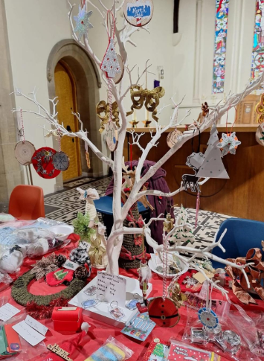
Encouraging community engagement is very important to us and throughout the year we hold three very well attended church fairs in Spring, Summer and Christmas and an Annual Christmas Draw. We also hold monthly coffee mornings. The coffee mornings serve also as a means for people to catch up with friends on a regular basis and are very much looked forward to. As well as being lovely social events for the community they also raise much needed funds for the work of the church and also help to pay some of the bills. We also run a ‘200 club’
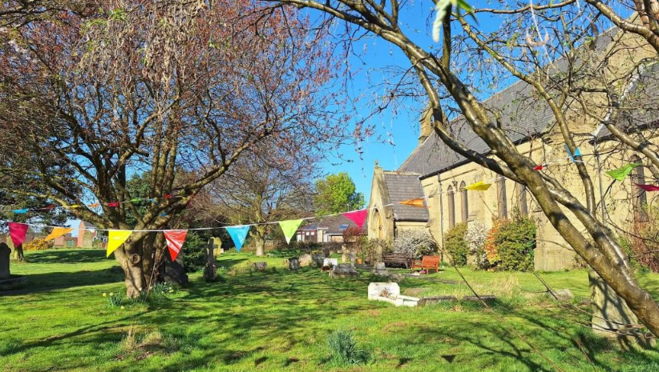

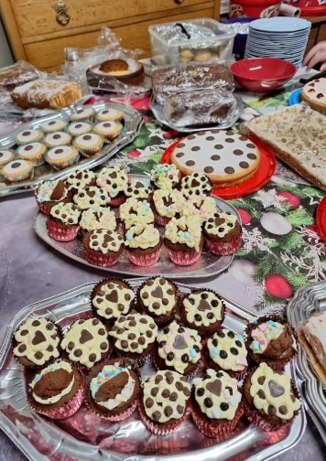
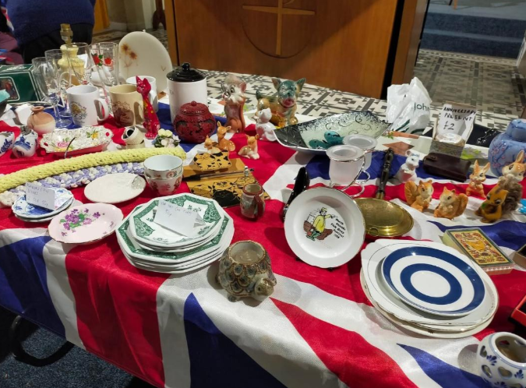

Finances
Thanks to regular giving and some donations for specific items e.g. flowers, from the congregation, our finances are kept in the black. Every year, the PCC gives prayerful and careful consideration to the Guided Pledge as suggested by the Diocese and make our decision to pledge what we can afford based on our deliberations. In this way we have been able to pay the full amount of Parish Share that we pledge in all but one of the last 10 years. A monthly standing order is set up every January to help us spread the cost of this, our biggest expenditure, throughout the year and we top it up most months to avoid a large outlay at the end of the financial year.
The Treasurer produces a financial statement at every PCC meeting with each member being given a copy. Receipts and payments are explained, although most are self-explanatory and questions are always invited. Another member of the congregation records the weekly planned giving and deals with the Gift Aid Small Donations Scheme (GASDS) which is reclaimed from HMRC. This is of enormous help to the treasurer. Our day-to-day current account banking is done with Virgin Money and we have a deposit account with CCLA This is reserved as our Building Fund on which we can draw for any repairs other than minor ones.
We have not had a Stewardship campaign for some time so last year, one of the churchwardens was in contact with a member of the Diocesan Generous Giving Team and we thought someone was going to come and speak to the congregation one Sunday morning. However, this never happened but we can try again this year.
Fundraising does play an important role in helping to keep our finances healthy. Apart from this, our fairs and events throughout the year, encourage the wider community to cross our threshold. It is amazing how generous people can be. The congregation itself works hard with a willing attitude and a generosity of time to bring about these regular fundraising events. We are truly blessed.

Our Main Hopes for the Future
Our main targets for the future to help us to reach our full potential are:
To establish a new Sunday School and resume links with the local Primary School
To restart our Advent, Lent and Bible Study courses
To develop our use of and understanding of multimedia
To continue our work on the Bronze Eco Award.
To continue and increase our presence in the community.

Our Ideal Priest
Our ideal priest would be someone who was welcoming, prayerful, compassionate and at ease working with a wide range of people.
Someone who can communicate the word of God and to help the congregation and where appropriate the wider community to grow spiritually by helping them to apply the teachings of the Bible to modern life.
Someone who could with help from our PCC lead, develop our intergenerational worship, particularly in helping our church in re-establishing a Sunday school after a break of many years.
Someone who is open to looking at new ways to reach out to the community and be an active and visual presence for our church.
The PCC is committed to supporting the wellbeing and development of any new incumbent. We will always expect them to take agreed holidays and days off and we will support them in their training, reading and personal development as well as paying reasonable clergy expenses.
We thank you for reading our church profile and the photographs of our church and activities and hope that they will inspire you to consider applying for our post of House for duty priest covering Sundays and two other days of the week.
St. Thomas’ Church Eighton Banks Gateshead PCC

Housing
Naturally, this post comes with suitable housing provided for you. An appropriate property will be purchased for this role, please discuss your requirements with the Archdeacon of Sunderland and we will try our best to facilitate them.

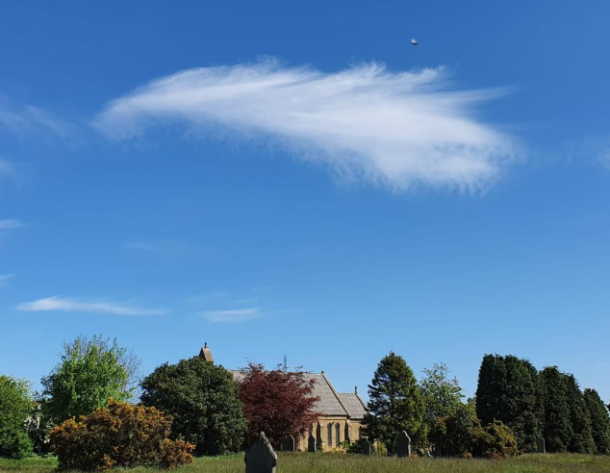
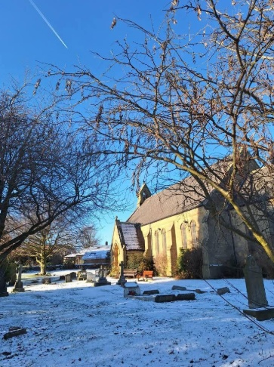

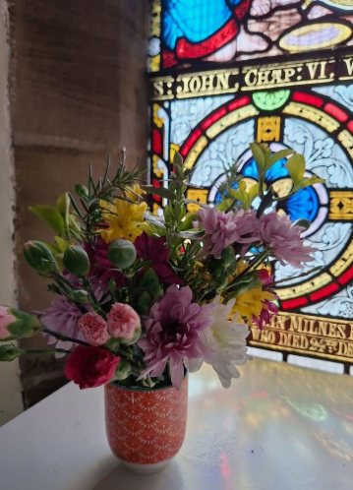
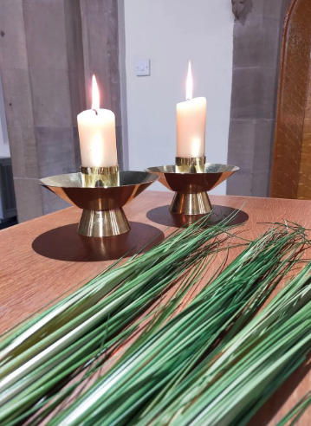

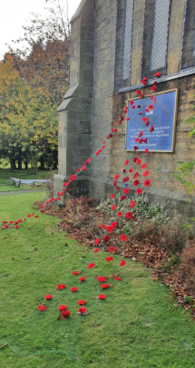
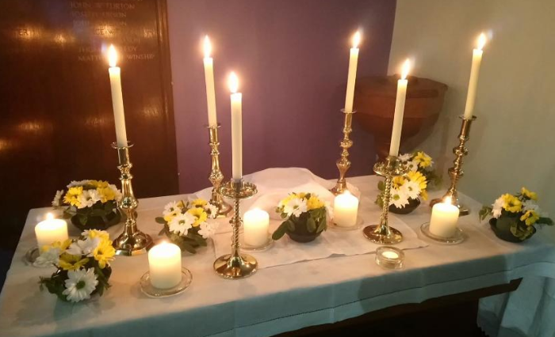
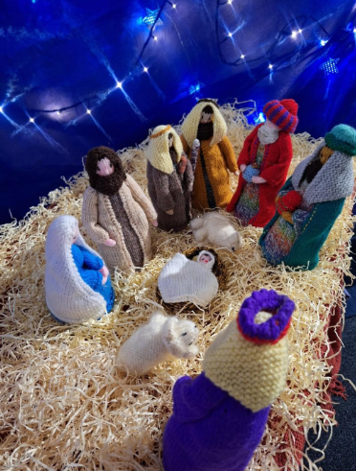

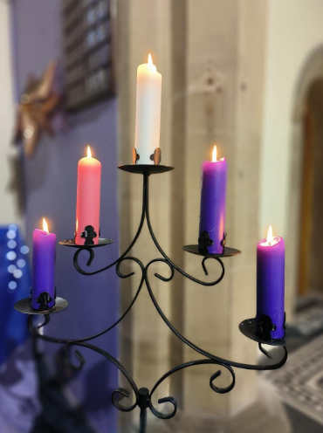
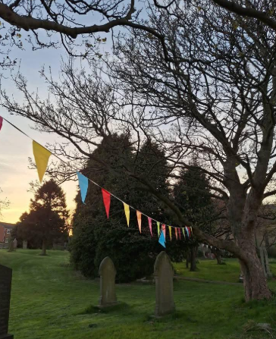
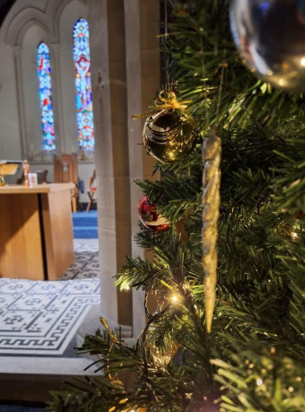
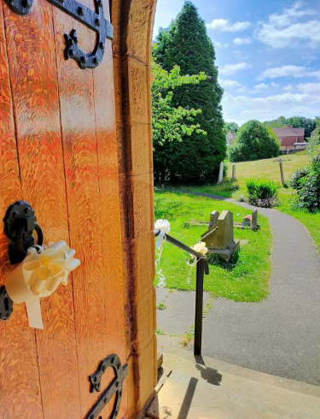
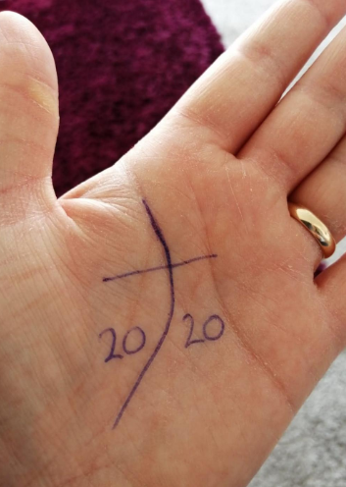
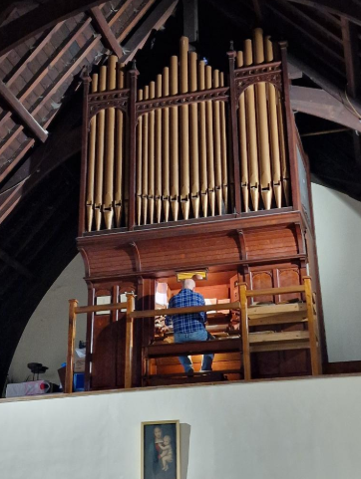
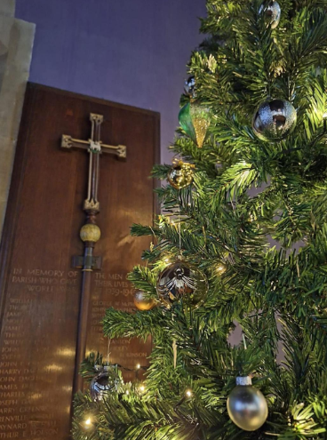
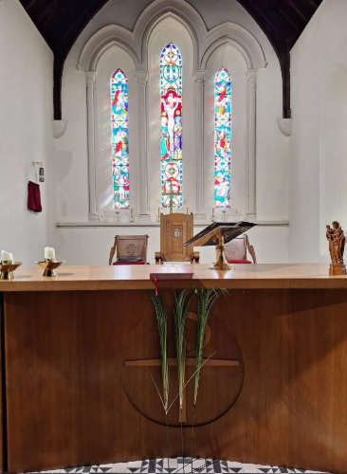

LSOAs are small geographic areas of around 1000-3000 people/400-1200 households. England is divided into around 33,000 of these Census 2021 geographies - Office for National Statistics
GeoDS Mapmaker: Deprivation Indices (IMD) (GeoDS Harmonised 2019 IMD)

