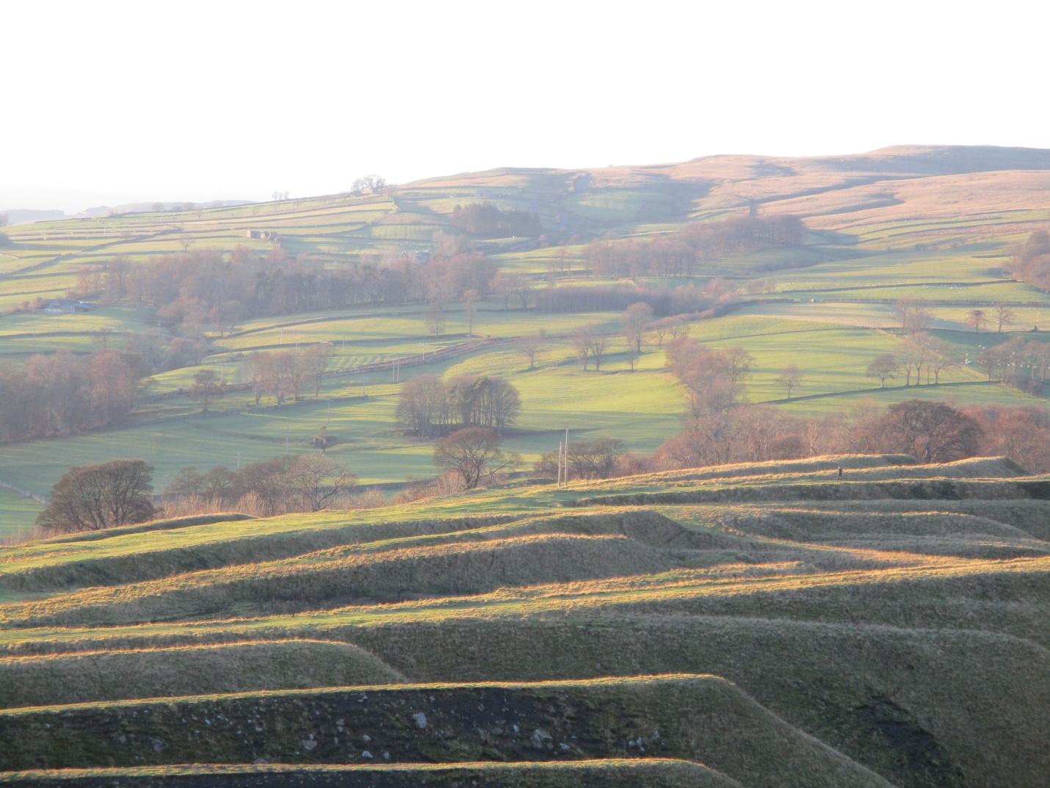

The United Benefice of Upper Weardale

Comprising the parishes of
West Weardale,
Eastgate,
and
Stanhope with Frosterley and Rookhope

Benefice Profile, 2025

Our Diocesan Vision - An introduction from Bishop Sarah

This is an exciting time to be exploring joining the Diocesan family in Durham Diocese. We are on the cusp of a fresh chapter in our mission and ministry together. We are currently discerning with the National Church who will be the next Bishop of Durham, called to lead as we seek to make real our vision for the transformation we so desire across our Diocese. We are deeply encouraged by the award last year of significant national funding, demonstrating real confidence in our vision.

Our diocesan strategy for transformation and missional growth (‘Called to Fruitfulness’) is an opportunity and invitation for each of our parishes to step out in faith together, responding practically to our priorities to Challenge Poverty, Energise Growth, Care for God’s Creation and Engage with Children, Youth and Young Adults. Making this a reality it will look different in every community. In some places it will come about in collaboration with others. Nobody is expected to do everything immediately or alone, but we are all invited and expected to find ways to respond relevantly.

In Upper Weardale this feels particularly relevant. We sense the importance of Energising Growth – in discipleship and in the number of people served by and engaging in the life of our churches. We also sense the importance of Challenging Poverty, Engaging with Children and Young People and Caring for God’s Creation in an area with lots of families, with some significant pockets of poverty, and with deeply rooted communities that still look to, and are open to, the local church.

In praying for a new Priest for Upper Weardale we are looking for someone excited by and wanting to be part of this vision and new future. Together we pray hopefully

Loving God, guiding the people of Durham Diocese faithfully through the years:
We thank you for saints who have marked our path,
young and old, known and unknown, from all places and in all walks of life.
Help us to find your way in our generation:
transformed by your truth, sharing your life, blessing our communities.
Through Jesus Christ our Lord,
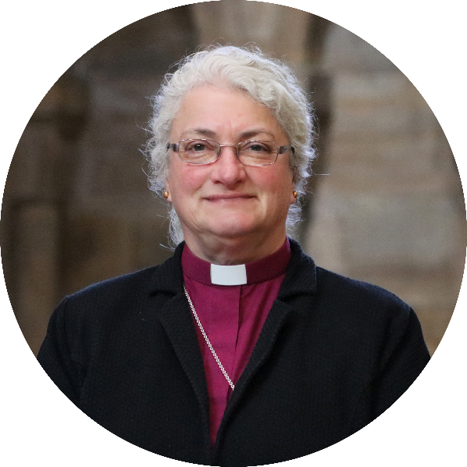
Amen

We look forward to meeting together
and sharing in this with you.

In Christ,

+Sarah
Bishop of Jarrow
Acting Bishop of Durham

Table of Contents

Page number

The Communities we serve 4

Future Hopes 4

Challenges 5

Three Parishes, One Benefice 6
The Parish of West Weardale 6
The Parish of All Saints Eastgate 8
The Parish of St Thomas Stanhope, Rookhope & Frosterley 9

The Pattern of Services across the Benefice 12

The Benefice JPCC 13

Who do we seek? 14

The wider communities we seek to serve 15

The House 17

Upper Weardale Benefice Profile
February 2025

The Communities we serve

The benefice of Upper Weardale covers a very beautiful, rural and remote area of County Durham, from the borders of Cumbria and Northumberland to the west, down the A689 to Frosterley in the east, and includes hamlets and villages north of this road.

The Main villages are:
- Lanehead, Cowshill, Wearhead, St John’s Chapel and Westgate (which together form the parish of West Weardale),
- Eastgate (a parish in it’s own right served by the Festival Church of All Saints),
- Stanhope, Rookhope and Frosterley (all served by the Church of St Thomas in Stanhope).

Future hopes

After a period of what has felt like ‘hard pruning’ (including the closure of 2 churches in the past 5 years and the decision recently taken to close a Church hall), we are hopeful now of a time of growth, of which green shoots are currently emerging.

We are developing a ‘culture of invitation’ across the Benefice, looking at points of contact with the wider community, and developing programmes of events that will build on those points of contact (for example ‘Activity days’ for children following on from school visits and major festivals). This model has been in operation over this past year in Eastgate, and is already bearing discernible fruit.

We are keen to engage with the A Rocha ‘Eco Church’ award programme, and indeed one parish has already achieved the Silver Award.

For the first time in many years, each parish has a Mission Plan, and we are making headway in the implementation of those plans, augmenting and reviewing those plans regularly as we discern what the Spirit of God is drawing us into in these changing times.

At Stanhope we look forward to the completion of a major reordering project, which will enable the Church building to be used for wider community activity more easily, as well as addressing the damage done through a dry rot outbreak. These plans are at an advanced stage as we work with the Diocesan Buildings team as well as the QI Architect to move these forward.

We hope to build on the Pilgrimage initiative that is underway across the Benefice and beyond to tie a new pilgrimage route – ‘The Way of Hope’ – in with the existing recognized pilgrimage routes that lead to Durham Cathedral. The ‘Way of Hope’ would join the ‘Way of Life’ at Bishop Auckland). We are preparing our buildings to receive pilgrims over the coming years with material available that will speak of the faith we seek to share.

Challenges

Over the last 15 years, 3 church buildings have been closed, another has become a festival church, 2 further PCCs have become 1, and the Parish of Stanhope has recently decided to dispose of its Church Hall after the discovery that significant works are needed on that building, on top of the major works needed on the Church building. A narrative of decline (echoed nationally) had set in, exacerbated by long interregna, and the last 2 clergy having suffered significant ill health necessitating long periods of sick leave (one of them ultimately dying in post). This has not been easy. The prolonged period of instability led to issues around governance, as well as sapping missional energy.

A Vacancy Audit (which took place in late 2023, reporting back to the parishes May 2024) identified a number of issues in terms of governance and a lack of mission. The PCCs across the Benefice have been keen to address these concerns and challenges, and with support from a member of the Diocesan staff team, 2 curates, a group of local (predominantly retired) clergy, and drawing on other Diocesan expertise, a corner has been firmly turned. The restructuring of the Benefice makes this post a much more ‘doable’ role, and over this past 8 months, a significant amount of attention has been given to issues of governance, bringing PCCs up to date with policy and financial reporting requirements. We face the not uncommon challenge of having aging congregations, whose members lack confidence in sharing the faith in an increasingly secular society. However, there is here a willing team, keen to support the mission of the churches and enable growth, with energy for the task at hand.

Three Parishes, One Benefice

The Parish of West Weardale
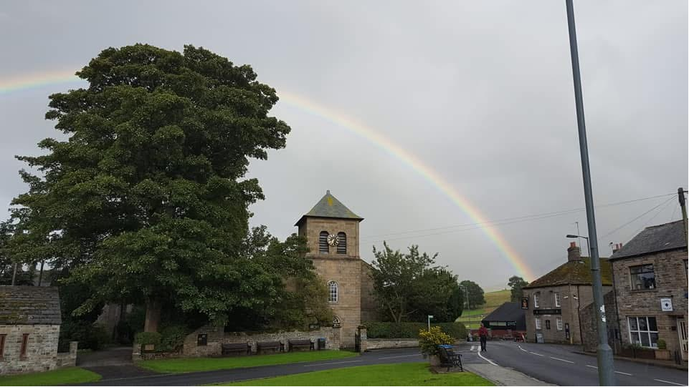

Population: approximately 1481
Age: 0-17 15%, 18-64 62%, 65+ 23%

The newly named West Weardale Parish covers an area of villages and hamlets from Lanehead (in the west) through to Westgate, with two church buildings (in Cowshill and in St John’s Chapel). Westgate church closed and the remaining parishes combined in October 2024. The PCCs had already been working together, and the pattern of services remains the same: Sunday services alternate between the two remaining church buildings and are Eucharistic. In each village the village hall is close by and is used for coffee and socializing after services. The elderly and vulnerable have regular Communion or pastoral visits throughout the dale with phone calls to the housebound who don’t wish to have a visit but enjoy a conversation. Folk Nights are held in St John’s Chapel Barrington Hall every two months, usually with a full hall, and refreshments served by church members.

The clergy visit weekly coffee mornings as a visible presence and mingle with all who attend. New residents are visited in their homes and welcomed; these visits have led to four baptisms, a wedding and regular church visits. Heatherycleugh church is open at all times and many people visit to sit in silence and pray or appreciate the building; St. John’s Chapel opens on request. There are good links with the local communities, although the recent Vacancy Audit Process (VAP) Report noted that there is not really a missional mindset. However, since the audit work has been done there is now a mission plan which is rooted in the Four Diocesan Priorities, applying them appropriately to our deeply rural local context.
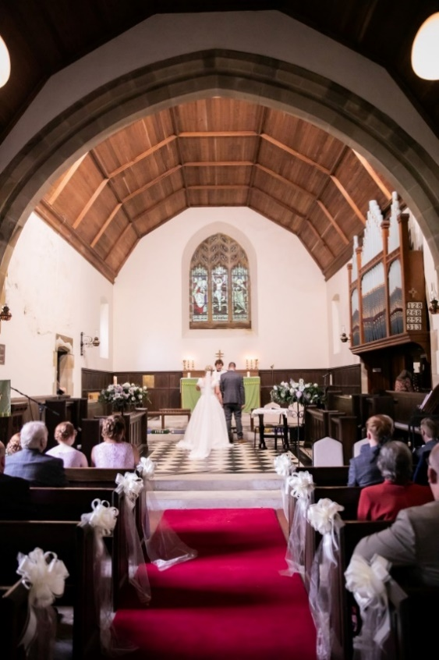
Having been challenged by the VAP findings, we have
now developed a calendar of events that seek to build
on the connections we have within the communities,
including children and young people – a demographic
we hadn’t previously engaged with locally beyond
schools work. Our deanery recently joined with Barnard
Castle and since October 2023 Rev’d Heather has led a
monthly service in Forest-in-Teesdale to forge links with
the new deanery. A retired clergyperson compiles a weekly
e-newsletter and sends it to all who wish to receive it.

Heatherycleugh Income and Expenditure 2024:
Opening Balance 10,321.44
Income 12,493.35
Expenditure 8434.54
Excess of receipts over payments 4,058.81 Wedding in St Thomas’
Closing Balance 14,380.25 Heatherycleugh Church
(with kind permission of Andrew and Gemma)
The Treasurer notes that we did not carry out any church
maintenance or repairs this year. Ground work was mainly
paid for by this and last year's council grants. Much of our
increased income this year is from funerals and weddings.

St John’s Chapel Income and Expenditure 2024:
Income £13,100
Expenditure £12,700
Reserves held as at 31st December 2024 £ 12,940
Restricted Funds held as at 31st December 2024 £17,050

The treasurer notes that the reserves could easily be spent on building works needed over the next couple of years as listed on the QI report. These works are being costed at time of drafting the profile.

West Weardale’s Diocesan Share for 2024:
Guided Pledge (suggested figure from the Diocesan Board of Finance, combined): £21849
Full Year Pledge for 2024: £8100
Full Year Pledge for 2025: £10200

The Parish of All Saints Eastgate

Population: approximately 146
Age: 0-17 11%, 18-64 67%, 65+ 22%

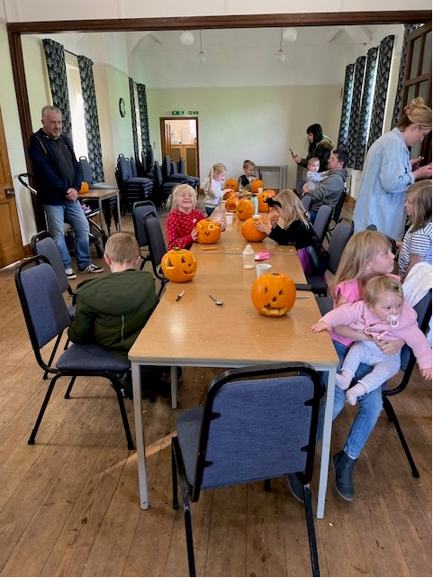
Situated in the village of Eastgate, All Saints Church is a beacon of worship, community, and kindness. Surrounded by the countryside, the church is deeply rooted in a farming community where generations of families have lived, worked, and
worshipped. This heritage shapes the congregation,
creating a strong sense of belonging and tradition that
unites both long-standing members and newcomers.

As a designated Festival Church, All Saints is the heart of
seasonal celebrations and key moments in the Christian
calendar. Its doors open wide to mark baptisms, weddings,
funerals, and other significant milestones, fostering
connections within the village and beyond. The church
values its role as both a spiritual home and a gathering
place for Eastgate’s close-knit community.

Kindness and community are at the core of All Saints’
mission. Services blend tradition with a welcoming,
modern touch, ensuring relevance to people of all ages.
The hardworking PCC is always exploring new ways to
involve more people, knowing that while not every idea
succeeds, the effort to try is key to growth and engagement. Their creativity and determination reflect the church’s commitment to thriving in an ever-changing world.
Guided by faith and fueled by compassion, All Saints Church seeks to grow and thrive while honouring its farming roots and the families who have supported it for generations. It remains a cornerstone of Eastgate life, fostering spiritual growth, cultural enrichment, and a profound sense of belonging for all who enter.
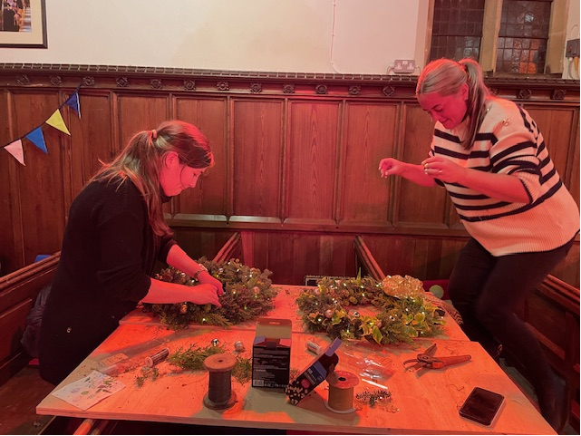
The Weardale Neurodiverse Support Group was
set up in April 2024 to support the parents and
guardians of local children who are identified by
parents and schools as needing additional
support. Where better to meet than in the safe
controlled environment of our churches?
It can be overwhelming when a family realises
that their children see the world differently.
We presently meet every two weeks in Eastgate
and Stanhope Church for a coffee and children’s
crafts and safe play. This gives parents and children a chance to meet and make friendships groups with likeminded adults and children, who are able to point them in the direction for additional help and support on request.

Eastgate Income and Expenditure 2024:
Income £16496.83
Expenditure £12,700
Reserves held as at 31st December 2024 £ 24723.77 of which £9008.64 is reserved.

Eastgate’s Diocesan Share for 2024:
Guided Pledge: £10,583
Full Year Pledge 2024: £1881 with £1884 given.
Full Year Pledge for 2025: £1950.

The Parish of St Thomas Stanhope with Rookhope and Frosterley

Population approx 2955
Age: 0-17 16%, 18-64 60% 65+ 24%

The parish of Stanhope, Rookhope and Frosterley is served by the Church of St Thomas Stanhope. There is a 10.00am Eucharist each Sunday, a weekly Wednesday said Eucharist also at 10.00am and a short morning prayer at 9.00am each Monday, Tuesday and Thursday. There is also a monthly lay led afternoon service in the church hall on the first Sunday of each month.

The VAP facilitator stated (in May 2024):
“Stanhope occupies an important position as the largest community in the area and (in the deep history), the largest and best resourced church, and as the original centre of mission historically. Well located at the centre of the village, St Thomas has the profile, position and people for mission and ministry (with the right leadership) to be quickly rejuvenated. Renewal, even with good leadership, is however threatened by:
1. A lack of evangelistic focus
2. Dysfunctional relationships and processes in the PCC
3. An unhealthy preoccupation with the church hall.”

Since the VAP, the PCC has set about addressing these issues.
A mission plan rooted in the Diocesan Priorities has been drawn up by a sub group of the new PCC and adopted by the PCC.

The Church hall now has a new management group, taking responsibility for bookings via an agreed hire agreement, invoices and receipts as well as ongoing small maintenance issues, though the decision has now been taken to dispose of the Church Hall due to the larger maintenance issues that have been identified, on top of the issues in the Church building.

After lock-down in 2020, on re opening the church building, dry rot was discovered. Addressing this has taken up a lot of time and energy. The parish now has Diocesan help from the Church Building Support Officer, and Rev Michael led a reordering group looking carefully at what changes we need to make to the building to make it viable for the future as a flexible space for a variety of different types of services and for community use. The recommendations were put to the full PCC and agreed and have been forwarded to the Church Building Support Officer and the DAC. Initial advice from the DAC has been positive.

In January 2025 the PCC decided to explore sale of the church hall. This difficult decision was made carefully, in the light of feasibility study of the church hall, an estimate of necessary repairs to the Hall of £115,000, a careful examination of church finances and the consideration of proposals to reorder the church. We have sufficient funds (with a loan from the Diocese using the Church Hall as collateral) to go ahead with phase one of the church reordering project, and are proceeding.

At this PCC meeting it became clear that Stanhope PCC has come a long way since the VAP. There is increasingly a culture of clear reporting at PCC meetings, such that all members are now more confident to discuss difficult issues equally, confidently and respectfully and make important decisions. A public consultation event on the future of the church hall has happened, the reordering of the church will begin in the autumn and the PCC is beginning to address the noted lack of evangelistic focus.

St Thomas’ Stanhope also had a separate financial audit by Samantha Amsden (Durham Diocese), with 27 governance recommendations made. A follow up to monitor progress on the financial audit has happened, and excellent progress has been made, with all recommendations now actioned. A major restructure has taken place in relation to financial processes in Stanhope, including the appointment of a new treasurer (with a background in corporate audit accounting). The PCC are committed to addressing of the recommendations.

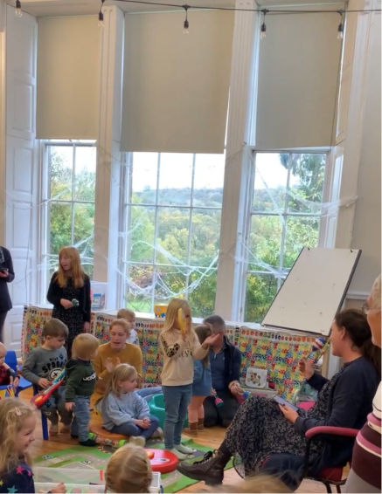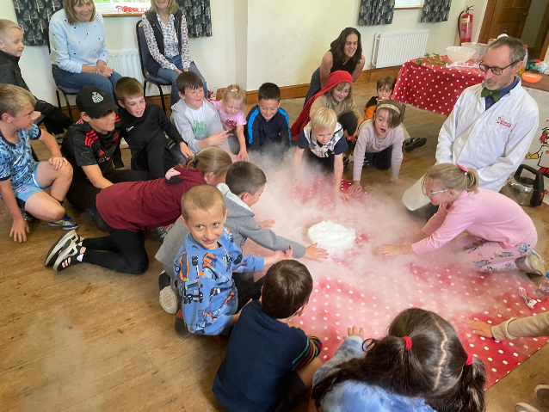
Weardale Toddler Group Weardale Neurodiverse Support Group
Missional Activities that happen in Stanhope:

Mothers Union
There is a well established Mothers Union with monthly meetings, whilst smaller in number
than in years gone by its current membership are dedicated to the MU and its causes.

Bread Church
Established during the last vacancy, this initiative aims to reach those in the community
not involved in church life. It is advertised as a chance to make bread and an opportunity to
reflect during a simple bible study and short prayer time while the bread cooks. We then share a simple meal as a time of fellowship. Bread Church happens one evening every month.

Boxing Church
Our current training curate has introduced this weekly event for school age children. It operates very much as bread church in that the activity is boxing but it includes some time for spiritual age appropriate reflection. This is held in a local community centre.

New Family Focused Services
We are moving towards planning family focused services at special festival times. The plan is always to have such a service invitation ready to give school children and their families at events where our church building is being used by the school as well as taking opportunities to invite the families from the toddler group. The first of these has happened, and drawn in a number of children. A group of the PCC are due to attend an event looking at ‘Growing Faith’ to build on the relationships with the local school, and to seek to build up the focus on ‘growing younger’, placing children and families at the centre of our mission strategy.

A member of the congregation at Stanhope has recently begun training for Licensed Lay (Reader) Ministry. A small group of parishioners have recently engaged in a project knitting angels, which have been distributed around the town with messages of invitation to an All Age Christmas service.

St Thomas Stanhope Church Income and Expenditure:
St Thomas Church:
Income £120,136
Expenditure £ -56,238
Income over expenditure: £63,897

St. Thomas Church Hall:
Income £31,352
Expenditure £- 35,899
Income over expenditure: £- 4,547

Restricted Funds: £28,883
Unrestricted Funds: £93,541
Cash in Bank £257,162
Operating Cash Reserves -£20,000
Funds Available £359,586

Funds set aside for reordering project, Phase one: £270,000
Funds needed for phase two; approx.: £300,000

Phase one of the Church reordering will wipe out most of these reserves. By the time this is completed, it is anticipated that the finances in Stanhope will not be dissimilar to the other villages in the Benefice.

Stanhope’s Diocesan Share
Guided Pledge: £23,609
Full Year Pledge: £13,000 which was paid in full
Pledge for 2025: £15000
The Pattern of Services Across The Benefice

This is the Sunday Service Rota for February 2025:

2 Feb | Presentation of Christ in the Temple  (Candlemas) | SJC  10am Eucharist  Stanhope 10am  Eucharist  Church Hall 3pm EP
9 Feb | 4th Sunday before Lent | H’Cleugh 10am Eucharist  Stanhope  10am Eucharist
16 Feb | 3rd Sunday before Lent | SJC 10am Eucharist  Eastgate 10.30 Plough Sunday followed by lunch in the Village hall  Stanhope 10am Eucharist
23 Feb | 2nd Sunday before  Lent | H’Cleugh 10am Eucharist  Stanhope  10am Eucharist

On top of weekly Sunday services in Stanhope, there is also a weekly midweek Eucharist every Wednesday. Services in the West Weardale Parish alternate between St John’s Chapel and Heatherycleugh churches, with a Eucharist every Sunday at one or other church in the parish. Eastgate is a Festival Church with 11 services each year focusing on seasons relevant to a rural farming community. They arrange the special services for Plough Sunday (Jan/ Feb) with lunch in the village hall, Mothers’ Day, Easter, a Pet service, Ascension Day, Lammas Tide, Harvest, Remembrance Sunday and Christmas.

Rev Heather Ross, Associate Priest (SSM) prepares three-monthly rotas. We are fortunate that we have a number of retired clergy (with PTO) as fully committed members of our worshipping community who are happy to preside on a regular basis. Rev Kate Bruce, RAF chaplain with a home in the benefice, also happily assists on our rotas.


Weardale Boxing Church
The Benefice JPCC

Early in 2019 the Upper Weardale JPCC came into being. It seeks to work co-operatively in service to the churches and to the local communities. Its initial aim is to offer support to its member parishes and to inform and assist in shaping policy for mission and, on a very practical note, to hold one bank account from which to pay clergy expenses. The JPCC is the forum within which the proposed Pilgrimage route is being discussed.

The JPCC is a legal body enabling this cooperation, while each of the three parishes still has its own PCC and remains responsible for its finances, Parish Share, church building(s), preparation of annual reports and accounts, and local mission.

Matters devolved to the JPCC from the PCCs include:
- Clergy expenses
- Occasional office fees
- A policy for funeral collections (this with the exception of Eastgate)

We usually have JPCC meetings bi-monthly and have recently developed a pattern of inviting speakers from the community. This is proving very useful: we learn from them and also seek to find out how we can better serve them.

Recent speakers have been the local funeral director, the leader of the Diocesan Multi-Academy Trust, the Parish Nurse, and a local farmer. Plans for meetings going forward include:
- A Diocesan office to speak about the Growing Faith Award
- Someone from Durham Constabulary

The JPCC is now a well-established part of benefice governance and shared church life across the parishes. The VAP facilitator noted:
“All express appreciation of their shared connection – they speak warmly of one another and in a manner that demonstrates mutual interest and affection”
And:
“Across the benefice members of each of these PCCs are generally committed to working with one another collegially and through the joint PCC.”

Who do we seek as our next minister?

After a period of significant change and restructuring in the Benefice, we seek a Priest with a call to rural ministry. Ideally, we are looking for a person who has a track-record in reaching out in culturally-appropriate ways to communities where there are populations with deep roots in the place, living alongside a more transient population who come here for refreshment and renewal (there are many caravan parks and other kinds of tourist accommodation in this beautiful part of the world).

Each PCC has recently completed a new Mission Plan, rooted in the Diocesan Priorities that Bishop Sarah has outlined in her opening letter. We seek someone who will help us build on those plans, which we are already implementing, and to enrich our vision with new insights gleaned from experience.

We have recently been through significant changes, as we have sought to free ourselves to be ready to embrace the missional challenges we face. We would therefore be keen to appoint someone who can help us consolidate these new ways of working, attending to any issues that may emerge as we seek to embed the changes that we have already made, and to help us to see and to explore the opportunities for mission.

We are keen to appoint someone who is a collaborative leader, who can draw upon the gifts of those working and worshipping alongside them in the service of God. Our new minister will need to be supportive of shared ministry (lay and ordained).

We seek to appoint a prayerful priest, who will encourage us in our prayer lives, and our relationship with God.

We seek a priest who is inclusive in their approach, with a willingness to work with the grain of the sacramental traditions of the parishes, whilst not being afraid to create other spaces for encounter with God that push the envelope (like our existing ‘bread church’ and ‘boxing church’ initiatives).

The occasional offices are important points of connection with our wider community here. We seek someone who will do these well, enthusiastically, and with compassion and hope, embracing the ‘culture of invitation’ we seek to create across the Benefice.

The PCC at Eastgate have summed up well the character needed for this post:

“We are looking for an inspiring and approachable vicar who can:
- Bring energy and enthusiasm to our church community.
- Grow church attendance by welcoming people of all ages and backgrounds.
- Create engaging and lively services that combine tradition with a modern touch.
- Build relationships across the community with warmth and kindness.
- Develop creative outreach programs to connect with those outside the church.
- Be comfortable working with children, youth, and families to inspire the next generation.
- Encourage participation through fun, inclusive activities and events.
- Take bold and imaginative steps to bring faith into everyday life.
- Be a good listener, open to new ideas, and willing to take risks.
- Lead with a sense of humour and joy while fostering spiritual growth.
- Work effectively with a PCC that has 'opinions'—strong ones—but is willing to bend for the good of all.

So, if you can balance determination with diplomacy and bring laughter as well as leadership, we’d love to hear from you! “

N.B. The post-holder will also need to have the skills to develop good practice for rural and multi-benefice ministry and be able to share this, as Rural Mission / Multi-Benefice Lead in the diocese. Please see the Role Description and other supporting documents for this important element of the role.

The Wider Communities we seek to serve

Across the Benefice, there are a range of other groups with whom we work and engage. Below are a few examples of those groups, alongside more information about the wider communities in which we are set.

Schools and Education

Within the benefice there are four primary schools, at Wearhead, St John’s Chapel, Stanhope and Frosterley.

The Stanhope Barrington School is a Church of England Academy with church places on its governing body, one set aside for the incumbent.

There are church links with all the schools. Stanhope Barrington school comes into church each term, and our mission plan builds on this relationship with an Open the Bible Assembly weekly led by two of our clergy, a Methodist team, and volunteers from Eastgate and West Weardale parishes.

Associate priest Rev Heather Ross continues to build relationships with the Upper Dale schools, with end of term services in St John’s Chapel Church and visits to the school. Wearhead pupils recently attended a wedding in Heatherycleugh Church to sing for the congregation. Rev Michael Baldwin (training curate) has developed relationships with Frosterley school as well as currently taking the incumbent’s position on the governing body at Stanhope school.

There is a weekly toddler group run by church members in Stanhope Church Hall (benefice members), and also a weekly toddler group in the school at St John’s Chapel.

Secondary School Education
Children travel to Wolsingham or Alston, a small secondary school over the border in Cumbria, but nearer for the Upper Dale villages and preferred by some who want a small secondary school.

Further Education
Young people travel to Durham City.

Food Bank
There is “hidden poverty” here, and about 5 years ago a Food Bank was set up by church members working out of the church hall at Stanhope. It still operates from there but now is independent with no connection with the church (however, some church members are still volunteers).

This is a proud community and very, very few people collect their food; it is delivered to homes. This is also a consequence of distance: the Food Bank covers the whole dale, and many would not be able to access it without deliveries.

Currently there are about 25 deliveries each week.

Health and Social Care
There is a small community hospital in Stanhope. Currently the chaplain is the Methodist minister, however our clergy visit local patients on request.

Crosshill Care Home is in Stanhope. Rev Heather Ross holds monthly services and makes regular visits whenever there is a need. She has developed good relationships here and is well loved and respected by all.

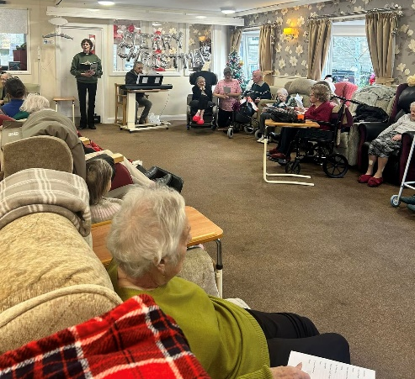
Crosshill Care Home Carol service Dec 2024

The Weardale Practice serves the whole dale and is situated in Stanhope.
For hospital treatment people travel to hospitals in Darlington, Durham and Bishop Auckland. A&E is at Durham some 24 miles away. More specialist services are at Newcastle and Middlesborough.

Local Transport is provided by a local transport company, Weardale Motor Services. There is a service Between Stanhope and Cowshill and between Stanhope and Rookhope via a small bus. The last bus leaves Stanhope for Rookhope at 3.30pm. The main service is between Stanhope and Bishop Auckland, the last bus leaving the terminus at Bishop Auckland at 5.55pm. Services run from Monday to Saturday. There is no public transport on Sundays or in the evenings.

Agriculture
This is still a farming community; there are two well established annual agricultural shows. The Weardale Show (locally known as the St John’s Chapel Show) is held every year on the last Saturday of August in St John’s Chapel, with a show service on the following Sunday in St John’s Chapel church. The Stanhope Show is held on the second Saturday of September and the following Sunday, with a show service held in a building on the show field on the Sunday evening. Both Shows and show services are served by the Stanhope Silver Band.

There is also an Auction Mart at St. John’s Chapel with livestock sales periodically across the autumn/winter.

Ecumenical connections
As a Benefice we work closely with the Methodist Chapel in Stanhope, sharing joint services on 5th Sundays of the month when they occur, and sharing with them in a presence at the Agricultural Shows in the Dale. There is also a Vineyard Church at St John’s Chapel.

The House

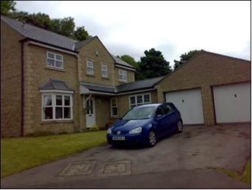

The Rectory is located at 12 Kirk Rise in Frosterley, and is a modern 4 bedroom, 3 reception room, and 2 bathroom house, with a double garage, which is not overlooked, backing onto woodland, and with views from the front over the village and onto the dale beyond. The village has a Coop, Fish and Chip shop, and a pub, as well as a Primary school within walking distance. The Secondary school is in nearby Wolsingham.

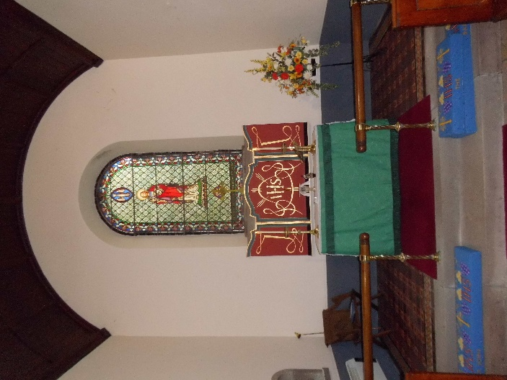
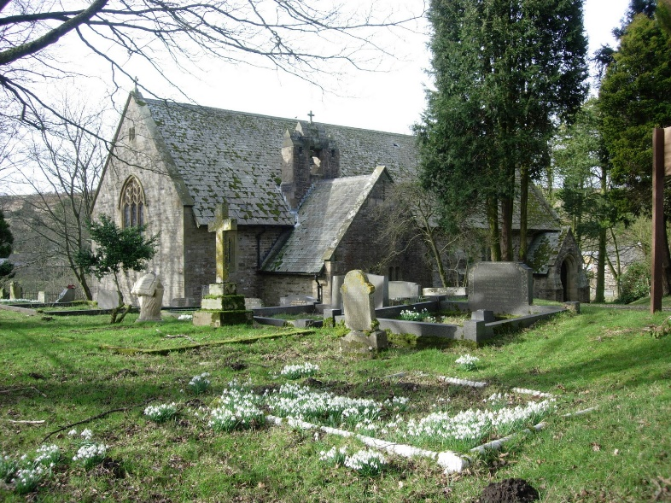

St Thomas Church, Heatherycleugh

St John the Baptist, St John’s Chapel

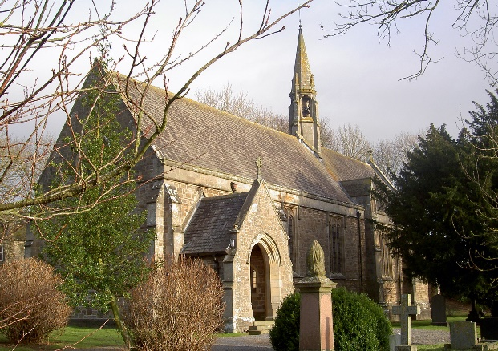
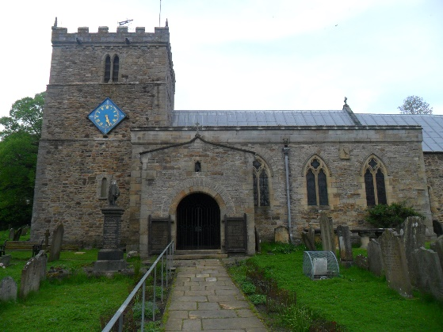

All Saints Eastgate St Thomas Stanhope

